**Automotive class a chance for hands-on learning**

Created on Wednesday, 16 November 2016 | Written by [Seth Gordon](http://www.pamplinmedia.com/component/contact/contact/) | [Print](http://www.pamplinmedia.com/nbg/241-education/332408-212106-automotive-class-a-chance-for-hands-on-learning?tmpl=component&print=1&page=)

[inShare](javascript:void(0);)

[Share](http://www.facebook.com/share.php?u=http://www.pamplinmedia.com/nbg/241-education/332408-212106-automotive-class-a-chance-for-hands-on-learning)

**Newberg is one of a handful of schools to sign on with World of Speed**

Newberg High School doesn’t have its own auto shop, but students are getting their hands dirty under the hood this year nonetheless.

That’s because administrators have partnered with both Newberg Rotary clubs to send students to a Clackamas Community College dual-credit automotive program at the World of Speed auto museum in Wilsonville.

GRAPHIC PHOTO: SETH GORDON - Clackamas Community College instructor Les Blahuta shows Newberg High School students how to balance a tire at the World of Speed auto shop in Wilsonville.


GRAPHIC PHOTO: SETH GORDON - Clackamas Community College instructor Les Blahuta shows Newberg High School students how to balance a tire at the World of Speed auto shop in Wilsonville.

The collaboration between CCC and World of speed began with one class from the West Linn-Wilsonville School District in fall 2015, but it has grown steadily in just a year.

The local rotary clubs provided $18,000 to get Newberg High School started with one 22-student section this fall and new principal Kyle Laier and new school-to-business coordinator Mona Lau are working to make it a permanent program.

“It’s enough to get you interested and show you if you would like this or not,” senior Juli DuBois said. “And the shop work helps so you know if you’d be able to do it. It’s definitely helped me out a lot and it’s free.”

Since NHS uses block scheduling, students are bussed to the World of Speed auto shop twice or three times a week for a two-hour class that provides both high school and college credit.

So far, the Fundamentals of Automotive class has split time between the classroom and the shop, but moving forward CCC instructor Les Blahuta will do more and more hands-on learning. Juniors in the class will then have the opportunity to return for the engine repair portion of the course next year.

Newberg is one of a handful of schools to sign on with World of Speed and if that’s where the program ended, it would still be a fruitful partnership, but administrators have taken it a step further.

Students taking the course this year will also have a chance to build on what they’ve learned because three local businesses — Newberg Ford, Newberg Dodge and True Form Collision Repair — have pledged to provide real-world learning experiences in the form of job shadows, paid internships and possibly even scholarships.

The program has proven to be a godsend for Dubois, who participates in robotics and was leaning toward engineering, but has pivoted toward auto mechanics because of the class.

She has already done a job shadow with Newberg Ford and learned about their ASSET program, which combines automotive classes at Mount Hood Community College with paid work at a dealership.

“I had an interest, but I had never really done anything with it because, at our school, the only automotive thing they had was small engines because that’s what they were set up for,” DuBois said. “I’m really glad this ended up being something for my senior year because it helps me a lot with where I’m going after school.”

Laier and Lau are hoping the program will be the first of several similar at NHS that expand opportunities for students and involve partnerships with local businesses.

“I’ve been working nonprofits for a long time and this is one of the few examples of a true partnership,” World of Speed Director of Education Lewis Ferguson said. “Usually, one entity gets a lot more out of it than the other. If any of these partners dropped the ball, it wouldn’t happen. Everybody was dedicated to seeing this succeed and so far it has.”

## Local students gear up for automotive classes at World of Speed

Created on Monday, 21 March 2016 | Written by [Lindsay Keefer](http://www.pamplinmedia.com/component/contact/contact/) | [Print](http://www.pamplinmedia.com/wbi/152-news/298491-176066-local-students-gear-up-for-automotive-classes-at-world-of-speed?tmpl=component&print=1&page=)

[inShare](javascript:void(0);)

[Share](http://www.facebook.com/share.php?u=http://www.pamplinmedia.com/wbi/152-news/298491-176066-local-students-gear-up-for-automotive-classes-at-world-of-speed)

[0 Comments](http://www.pamplinmedia.com/wbi/152-news/298491-176066-local-students-gear-up-for-automotive-classes-at-world-of-speed#disqus_thread)

###### North Marion High School among many in region to take advantage of opportunity

LINDSAY KEEFER - Jerrod Galyon, an instructor from Clackamas Community College, leads an automotive fundamentals class made up of students from North Marion and Canby high schools at World of Speed in Wilsonville.


LINDSAY KEEFER - Jerrod Galyon, an instructor from Clackamas Community College, leads an automotive fundamentals class made up of students from North Marion and Canby high schools at World of Speed in Wilsonville.

A partnership between a museum, a local college and numerous high schools has fueled an essential component of automotive education.

World of Speed Museum in Wilsonville, which will celebrate its one-year anniversary next month, is hosting classes taught by Clackamas Community College instructors for local high school students.

Students in North Marion and Canby high schools just wrapped up a trimester of the automotive fundamentals class, and students in the West Linn-Wilsonville School District have also been taking similar courses in the evenings, like small engine repair. The opportunity has been expanded to Tualatin High School and, according to Director of Education Lewis Ferguson, more and more schools are showing interest in the program.

“It’s a good mix of under the hood and class time,” Ferguson said. “We try to connect it to the real world. Yes, there’s a textbook, but this is how things work, here’s what you can do for a career.”

Students receive both college and high school CTE (career

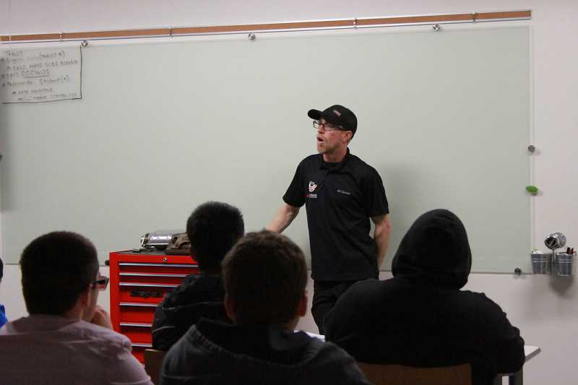

LINDSAY KEEFER - Instructor Jerrod Galyon teaches automotive fundamentals using both hands-on techniques and regular class instruction.

technical education) credits. And with three different courses being offered, that could represent up to 12 college credits.

“If they’re not thinking of pursuing that secondary education, they already have the credits so that could motivate them (to pursue an automotive career),” Ferguson said. “You never know where education will take you. Or they could see it as a cool hobby that has value.”

The more young people they can get interested in the automotive industry, the better, Ferguson said.

“For every 10 trained technicians leaving the industry (to retirement), there’s one to take their place,” he said. “So there’s a great need out there. This is an opportunity that could lead to good-paying jobs. It’s more than the local mechanic. It can be that, but there are so many other paths in the industry.”

While the automotive skills are important to learn, having the classes held in the museum has been beneficial to students in other ways. Not only do they receive memberships to the museum, but they also get behind-the-scenes glimpses of exhibits and have met professionals in the field.

“The whole museum is an educational tool,” Ferguson said. “They get to see behind the scenes and talk with industry experts.”

Wilsonville Toyota donated the cars the students work on in the bay, which used to be part of the Dodge dealership that previously occupied the building.

Students also receive free tuition thanks to their schools footing the bill, at least partially.

“The schools cover the instructors, credit hours and transportation, and World of Speed provides the space and tools,” Ferguson said. “It’s been a true partnership.”

North Marion, for example, received a “Take It to the Court” grant from Portland Trail Blazers and Wells Fargo so that about a dozen students could take part in the class. And Principal De Ann Jenness said the school continues to look for grants or ways to incorporate it into the school budget.

“When World of Speed contacted me about this opportunity, I didn’t blink an eye,” she said. “We are missing this opportunity for our students and we have students interested in the field. We are excited to offer this class to our students.”

And it has been making a difference in these students’ lives.

“We have teachers say they never had kids talk about their future plans, and now they are,” Ferguson said. “Some kids underperform but now they see something they want to be part of and that’s now translating in core classes like math.”

These courses with CCC instructors aren’t the only way World of Speed is promoting education. Throughout the year, the nonprofit offers field trips for schools and workshops for the general public, often geared toward women or young people, on topics like how to change the oil in a car.

“Our mission is to educate and to entertain,” Ferguson said.

World of Speed is always in need of tools to support its educational outreach. A list of needed donation items can be found at HYPERLINK"http://www.worldofspeed.org/education" www.worldofspeed.org/education.

**To: World of Speed Motorsports Museum Friends and Stakeholders**

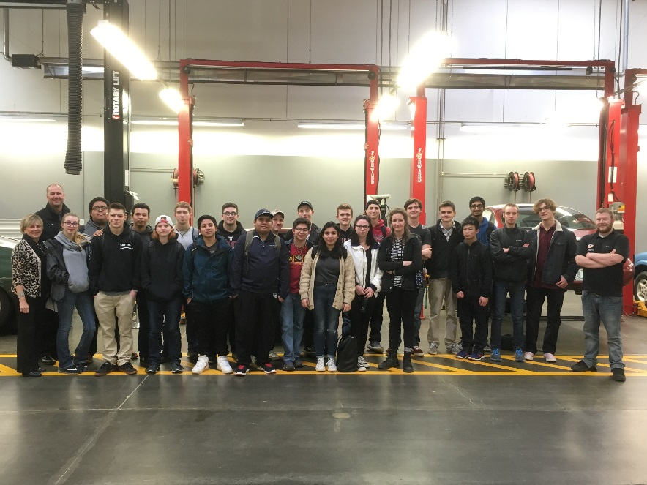Welcome, Tigard-Tualatin students to the automotive education program at the World of Speed Motorsports Museum!

Tigard-Tualatin is the latest school district to join the growing automotive education program at World of Speed! On Tuesday, February 2, a class of 22 very excited students from Tualatin High School started their automotive fundamentals class. Students weren’t the only ones excited about the day. Tualatin High School Associate Principal Jarvis Gomes said of the partnership, “World of Speed has given our students at Tualatin High School an exceptional opportunity to learn auto mechanics at a state of the art facility.  We couldn’t be more excited about this partnership and experience for our students.”

This innovative program is the result of a partnership between school districts, World of Speed and Clackamas Community College. The World of Speed is currently hosting four school districts and over 60 students in this program.

We could not have accomplished this without support from our Board, community partners, funders, and stakeholders!

Thank you,

Dave

**DAVID SCHAEFFER**  
*Executive Director***//***World of Speed®*  
  
**o** 503-563-6435**// c** 971-275-5586  
[david@worldofspeed.org](mailto:david@worldofspeed.org)**//**worldofspeed.org  
27490 SW 95th Ave, Wilsonville, OR 97070

|  |
| --- |
|  |
|  |
|  |
|  |

|  |
| --- |
|  |
|  |
| **Automotive Learning Center classes are back in session!** Students learn all about auto engineering |
| The second year of World of Speed’s Automotive Learning Center is now underway! This innovative program launched in fall of 2015 as the result of a partnership between World of Speed, Clackamas Community College, and local school districts. This year, in addition to the return of all of our 2015-2016 partners — Canby, North Marion, Tigard-Tualatin, West Linn-Wilsonville — we’re joined by a class from Newberg and an additional class from Tualatin High School.   To date, the program has served over 100 students who receive both high school and college credit as they learn about automotive technology, teamwork, and problem-solving, and explore career opportunities. |