**1**

# **ADVANCE CTE EXCELLENCE IN ACTION AWARD**

**PROGRAM SUMMARY**

Advance CTE is pleased to announce a call for applications for the sixth annual Excellence in Action awards, through which we recognize and honor superior Career Technical Education (CTE) programs of study from across the nation.   
  
**CRITERIA FOR JUDGING**

Selected programs will exemplify excellence in:

* Implementing Career Cluster®-based [programs of study](https://careertech.org/programs-study);
* Maintaining effective employer and business partnerships;
* Demonstrating alignment to rigorous and relevant college- and career-ready expectations;
* Demonstrating a clear progression of knowledge and skills and learner transitions across secondary and postsecondary systems;
* Integrating successful career guidance and advisement;
* Integrating high-quality work-based learning experiences;
* Highlighting alignment to workforce and employer needs in the community;
* Providing concrete data on the program of study’s impact on learner achievement, success at both the secondary and postsecondary levels and meeting the needs of underserved populations; and
* Delivering high-quality and effective instruction.

**ELIGIBILITY**

* This award is open to any public secondary or postsecondary schools or colleges in the United States. Your school or institution may submit one application per [Career Cluster](http://careertech.org/career-clusters);
* The program of study must have at least one full graduating class;
* Your program must be eligible to receive funding from the Carl D. Perkins Career and Technical Education Act;
* Applications that do not include data to demonstrate positive impact on learner achievement will not be eligible for consideration.
* If your program has received in an Excellence in Action award from Advance CTE in the past, you may not apply for that same Career Cluster. However, your school or institution may apply in a different Career Cluster.

**AWARD SUBMISSION REQUIREMENTS**

Complete applications will contain the following:

* A completed application including supplemental materials by the application deadline of **November 21, 2018 at 5 p.m. ET.**
* At least one letter of support from an employer or business partner supporting the program of study; and
* At least one additional letter of support from a partner (education, community or business) of your choosing.
* *Optional:* Supplemental materials including photos, videos, news articles, etc., are welcome but not required.

The application must be submitted using [this form](https://careertech.org/2019-excellence-action-application). The application must be submitted in a Microsoft Word format. Supplemental materials, including the letters of recommendation, must be combined and submitted as **one** PDF document.

*Please note:*

* Submissions should **not** include any personally identifiable learner data.
* The application does not have a page limit, however, many questions do have a word limit. Please do not submit responses that go beyond this limit. Also, submissions that do not contain all the required materials (a completed application, two letters of support and supplemental materials in the correct formats) will not be advanced for consideration.

**WINNERS WILL RECEIVE**

* A banner to hang in their school or institution;
* A digital banner to use in email and print materials as they so choose;
* Travel and one hotel room for one night in Washington, DC for a representative to be recognized at an awards ceremony to be held the week of April 8-10, 2019 at the Advance CTE Spring Meeting; and
* Discounted rate to the Advance CTE Spring Meeting

**WINNERS WILL ALSO BE FEATURED IN**

* A national press release, which will be distributed to national media.
* A winner-specific press release to distribute to local media;
* A standalone one-pager;
* A standalone blog on the [Learning that Works blog](http://blog.careertech.org/);
* Representation on the Advance CTE [website](http://www.careertech.org).
* Many past winners have been featured in national conferences, in briefs and reports, on webinars and in the media.

**HOW TO APPLY**

* Fill out the following application.
* Once you have finished, complete [this form](https://careertech.org/2019-excellence-action-application) and upload the following:
* Your full application saved as a Word document (.docx)
* All of your supplemental documents or evidence consolidated as one PDF document.

# **BACKGROUND INFORMATION**

1. Program of study name: Health Science
2. Point of Contact

**Name:** Jessica Sheffer, Ashley Bailey, Lori Fulkerson, Amy Gibson, Dana Alves

**Email Address:** [Jessica.sheffer@henderson.kyschools.us](mailto:Jessica.sheffer@henderson.kyschools.us)

**Phone Number:** 270-831-8850

**Address:** 2424 Zion Rd, Henderson, KY 42420

1. Applicant’s School/College:

Henderson County High School

1. State:

Kentucky

1. Type of institution (click the box to check)

☐ Area technical center

☐ Career academy

**X** Comprehensive high school

☐ Community college

☐ Technical college

Other (please specify)

|  |
| --- |
|  |

1. Career Cluster in which your program of study should be considered (Follow this link for a further explanation of each Career Cluster [careertech.org/career-clusters](http://careertech.org/career-clusters)) **(Select only ONE):**

☐ Agriculture, Food & Natural Resources Career Cluster

☐ Architecture & Construction Career Cluster

☐ Arts, A/V Technology & Communications Career Cluster

☐ Business Management & Administration Career Cluster

☐ Education & Training Career Cluster

☐ Finance Career Cluster

☐ Government & Public Administration Career Cluster

**X** Health Sciences Career Cluster

☐ Hospitality & Tourism Career Cluster

☐ Human Services Career Cluster

☐ Information Technology Career Cluster

☐ Law, Public Safety, Corrections & Security Career Cluster

☐ Manufacturing Career Cluster

☐ Marketing Career Cluster

☐ Science, Technology, Engineering & Mathematics Career Cluster

☐ Transportation, Distribution & Logistics Career Cluster

1. In three sentences or less, describe your program of study, including the secondary and postsecondary components and how long the program of study has been in place.

*The HCHS CTE Health Science program has been an integral part of Henderson County High School for approximately 35 years. The Health Science Department is comprised of five instructors and offers students courses in the following pathways: Allied Health, Pre-Nursing, and Medical Administrative Assistant. We have established formal partnerships with local community colleges within the KCTCS system to offer dual credit course that allow our students to earn articulation credit within their pathway of interest.*

1. Please check the geographical and demographic setting for your program of study and describe the geographic and economic conditions of the region served by the school.

☐ Urban

☐ Suburban

**X** Rural

☐ Other

*The city of Henderson lies along the Ohio River in Western Kentucky. Henderson has a population of approximately 28,870 people. The composition of the population of Henderson is 81.8% white residents, 10.9% black residents, 3.33% residents of two or more races, 2.56% Hispanic residents and 0.84% residents classified as “other”. The most common foreign languages spoken in Henderson are Spanish (0.02%) and German (0.003%). 2.9% of the population speaks a non-English language with the most common foreign languages spoken being Spanish, German and Tagalog. The economy of Henderson employs approximately 12,425 people. The largest industries in the area are Retail/Trade (2,128), Manufacturing (2,082) and Healthcare/Social Assistance (1,975). Henderson has a poverty rate of 24.1%, with white being the largest race living in poverty and females age 25-34 being the largest demographic living in poverty.*

1. Please describe how your program of study was developed and how it ensures learners are academically and technically prepared for both postsecondary education and careers. Please also address the following:
   1. How were employers involved in the development and continue to be involved in the maintenance of your program of study? (500 word limit)

* *The Health Science program began at HCHS 35 years ago and has evolved into comprehensive pathways that prepare students to earn a healthcare degree.*
* *Henderson County, a "Work Ready Community," partners with Henderson County Schools to advance the career and technical education program. Henderson County Schools partners with the committed citizens of the community through the partnership of the CTE Unit with Henderson's industry and businesses, and HCC for dual credit courses.*
* *Community healthcare facilities are saturated with students participating in work based learning. Frequent, and ongoing, communication occurs between HCHS Health Science teachers and employers*
* *Henderson Community College provides tours and presentations geared toward HCHS Health Science students.*
* *The Health Science advisory board is comprised of local healthcare professionals, employers, HCC staff, students, and at least one parent member. The Advisory board meets twice a year with the purpose of analyzing feedback from industry partners to identify and address program areas requiring improvement.*
* *Our Health Science educators collaborate with community healthcare providers, post-secondary instructors, and other health science educators to continually improve our course offerings. This includes beginning SRNA junior year, TEEN CERT program for juniors and seniors, medical office assisting, and the use of industry standard technology in EMR.* 
  1. How does this program of study meet the economic needs of your community?
* *HCH Health Science is a direct feeder program into the HCC Allied Health programs that include Nursing, Clinical Lab Technician, and Medical Assisting.*
* *Methodist Hospital recruits students from our program to work after graduation and then offers tuition assistance to offset the cost of college.  Redbanks Nursing and Rehabilitation hires many of our certified nursing students during their senior year of high school and continue to work there for many years following high school graduation. Deaconess and St. Vincent’s Hospital hire our certified medical administrative assistants after graduation.*
  1. How does this program prepare learners for postsecondary education? (if applicable)

(clinical experiences/co-op, articulation credit, college ready skills?)

* *HCHS works with HCC to develop dual credit courses and clearly outlined pathways that lead to direct admission into post-secondary Health Science programs.*
* *Students in the Health Science program receive dual credit for certain classes from HCC that can be applied to degree requirements and may transfer to four year colleges.  All students in the health science program have the opportunity to obtain up to 12 hours of college credit while in high school.*
* *Instructors attend annual CTE conferences and several are members of professional development committees.*
* *HCHS Health Science is a leader in Kentucky’s Allied Health Program due to innovative approaches to learning and advanced program implementation.*
* *Students have opportunities for clinical and co-op placements at a multiple healthcare facilities. Students can “explore” career fields while gaining valuable knowledge and skills.*
  1. How were both secondary and postsecondary educators involved in the development and/or maintenance of the program of study? (500 word limit)
* *Our Health Science educators collaborate with community healthcare providers, post-secondary instructors, and other health science educators to continually improve our course offerings. This includes beginning SRNA junior year, TEEN CERT program for juniors and seniors, medical office assisting, and the use of industry standard technology in EMR.*
* *Three of the Health Science instructors are advisory boards members at HCC.*
* *Secondary educators develop a Program Improvement Plan. Through Implementation and Impact checks.*

# 

# **LEARNER POPULATION & DATA**

1. Please describe your program of study’s demographic and outcome data for the most recent academic year(s). It is our strong preference to have data from both secondary and postsecondary levels. If this is not available, please provide an explanation as to why the data from the other learner level is not available. Applications that do not include data to support positive impact on learner achievement will not be eligible for consideration. (100 word limit)  
     
   *Demographic data from the last three school years indicates an overall increase in female enrollment in our program. There has been an overall decrease in the enrollment of males, minority, and low-income learners, as well as learners with disabilities.*

*Outcome data for the past three years indicates overall growth in the number of students earning post-secondary credit, industry certifications, participating in work-based learning and enrolling in post-secondary education. There has been an overall decrease in the number of students who entered the workforce or military. We have had a consistent 100% graduation rate among our pathway students.*

**NOTE**: Please specify if and when you are using a percentage with a different denominator (e.g., seniors) than the one listed.

**When completing the data section, please only use percentages and include data that is from your program of study. Additionally, only include data where learners are eligible to participate (e.g., only seniors in high school will be eligible for the section asking for percent of seniors who graduated high school, so only seniors should be included in that data; if your work-based learning only occurs within a specific grade level, only include them in your data for that category.)**

***Note:*** *%-age marked with an asterisk is 0 because there was not data available for the 2015-2016 school year. We were unable to offer dual credit CTE courses through Henderson Community College for the 2015-2016 school year.*

|  |  |  |  |
| --- | --- | --- | --- |
| SCHOOL YEAR | 2015-16 | 2016-17 | 2017-18 |
| **SECONDARY-LEVEL DATA** | | | |
| **What is the total number of learners served by your school/institution?** | 1939 | 1959 | 1971 |
| What is the total number of minority learners served by your school/institution? | 343 | 360 | 366 |
| What is the total number of low-income learners served by your school/institution? | 962 | 1053 | 1042 |
| What is the total number of learners with disabilities served by your school/institution? | 220 | 225 | 203 |
| What is the total number of English language learners served by your school/institution? | 13 | 18 | 20 |
| **What is the total number of learners served by your program of study?** | 481 | 436 | 537 |
| % male learners in program of study | 19% | 13% | 14% |
| % female learners in program of study | 81% | 87% | 86% |
| % minority learners program of study | 21% | 21% | 19% |
| % low-income learners program of study | 30% | 50% | 46% |
| % learners with disabilities program of study | 0.02% | 0.03% | 0.01% |
| % English language learners program of study | 0.006% | 0.005% | 0.006% |
| Other relevant *demographic* data from your **program of study** |  |  |  |
| % of learners in program of study who earned postsecondary credit (dual enrollment, AP, etc.) | 0%*  (12th Grade) | 32%  (12th Grade) | 52%  (12th Grade) |
| % of learners in program of study who earned an industry-recognized credential | 84%  (12th Grade) | 81%  (12th Grade) | 95%  (12th Grade) |
| % of learners in program of study who participated in work-based learning | 54%  (11th/12th Grade) | 40%  (11th/12th Grade) | 61%  (11th/12th Grade) |
| % of seniors in program of study who graduated high school (who were eligible/seniors) | 100%  (12th Grade) | 100%  (12th Grade) | 100%  (12th Grade) |
| % of graduates in program of study who enrolled in postsecondary education (who were eligible/seniors) | 63%  (12th Grade) | 67%  (12th Grade) | 84%  (12th Grade) |
| % of graduates in program of study who entered the workplace and/or military (who were eligible/seniors) | 19%  (12th Grade) | 14%  (12th Grade) | 9%  (12th Grade) |
| **POSTSECONDARY-LEVEL DATA** | | | |
| **What is the total number of learners served by your school/institution?** | N/A | N/A | N/A |
| What is the total number of minority learners served by your school/institution? | N/A | N/A | N/A |
| What is the total number of low-income learners served by your school/institution? | N/A | N/A | N/A |
| What is the total number of learners with disabilities served by your school/institution? | N/A | N/A | N/A |
| What is the total number of English language learners served by your school/institution? | N/A | N/A | N/A |
| **Total number of learners served by your program of study** | N/A | N/A | N/A |
| % male learners in program of study | N/A | N/A | N/A |
| % female learners in program of study | N/A | N/A | N/A |
| % minority learners in program of study | N/A | N/A | N/A |
| % low-income learners in program of study | N/A | N/A | N/A |
| % learners with disabilities in program of study | N/A | N/A | N/A |
| % English language learners in program of study | N/A | N/A | N/A |
| **Other relevant *demographic* data from your program of study** |  |  |  |
| % of learners in program of study who completed postsecondary/earned a degree or certificate (who were eligible) | N/A | N/A | N/A |
| % of learners in program of study who earned an industry-recognized credential (who were eligible) | N/A | N/A | N/A |
| % of graduates in program of study who entered the workplace and/or military (who were eligible) | N/A | N/A | N/A |
| % of graduates in program of study who transitioned to further postsecondary education (who were eligible) | N/A | N/A | N/A |

1. Provide links to the source of the above data. If the links are not publicly accessible, please explain the source of the data. If you are missing any data, please explain why and how you measure success.

*The Technical Education Data System (TEDS), the Free and Reduced Application Management (FRAM) System and Infinite Campus were the sources accessed to compile the above data. TEDS is the official repository of student data for all career pathways taught in Kentucky. TEDS is used to collect data required to be reported to the United States Department of Education for the Carl Perkins grant on Career and Technical Education career pathways and students.  The Perkins data required for reporting includes graduation rate, academic attainment, secondary placement, and technical skill attainment. The FRAM report is the source of data on low-income learners in our program and provides the tools for processing applications and approving federal meal service assistance for students. Infinite Campus (IC) is the Student Information System (SIS) used by the Henderson County School System to manage student learning. IC is the source of student demographic data such as ethnicity, disability and post-secondary transition data.*

1. How does your school or institution ensure equitable access for learners with diverse backgrounds? (150 word limit)

*Our mission at HCHS is to provide equitable access for all learners. Our department has identified potential barriers to participation in our program that may be faced by learners from diverse backgrounds. Such barriers include language barriers, financial need, physical and cognitive disabilities and transportation. Through the assistance of the High School’s Family Resource Center, the use of department funds, and with teacher dedication, we are able to remove these barriers. The Family Resource Center assists students with financial need by covering the cost of program fees, uniforms and shoes. Differentiated lessons, the provision of accommodations and modifications and adapted equipment allow students with disabilities full participation in our program. Finally, bus transportation is provided, at no cost to the student, for those without transportation to and from worksites.*

13. How do you ensure learner success, especially of those who from diverse backgrounds? Please provide examples of what supports you offer learners. (150 word limit)

*Our program integrates digital learning through the combined use of one-to-one devices Google-based tools allowing student’s access to classroom resources and assignments at all times. We utilize virtual learning through web-based resources and our labs contain simulated manikins capable of imitating human functions, simulating symptoms and responding to verbal cues. This technology engages students and provides a realistic learning experience. To address varying learning styles we design lessons that integrate all modes of learning. We have implemented a school-wide intervention system that allows additional time with students for remediation or additional skills practice. Student requiring more intense instruction and practice may be provided optional Saturday morning skills practice. To meet the needs of students with disabilities, we have a special education teacher dedicated to the CTE unit. Our community offers various work-based learning opportunities in diverse healthcare settings which allows students options and a variety of experiences, broadening their exposure.*

14. Is your program of study associated with a Career Technical Student Organization (CTSO)? If so, which one(s) and in what way(s)? (Check the [approved list](http://www.ctsos.org/ctsos/) of CTSOs) (50 word limit)

*Yes. We are associated with HOSA: Future Health Professionals. HOSA’s core values are embedded into each Health Science curriculum, enhancing the delivery of compassionate, quality healthcare. Through HOSA membership learners are provided opportunities for skill training and leadership development while assisting students in meeting the needs of the healthcare community.*

15. Describe how career guidance/advisement is integrated into your program of study to support learners’ completion of the program of study and entry into additional education/training and/or a successful career. Describe how you recruit students into CTE programs. Where applicable, describe the tools (individual career and academic plans, career exploration websites, etc.) that are provided to learners and how they are used. (200 word limit)

*Career advisement is critical to the success of the students enrolled in our program. Our Unit has a full-time Career Coach who coordinates recruiting and retention activities. We showcase healthcare careers and skills to middle school students through career camps our annual CTE Open House and tours of the CTE Unit. 8th grade students receive additional information our program when they attend the CTE Career Fair followed by an extensive tour specific to the student’s career interests.*

*6 guidance counselors assist students in understanding career pathways offered. With support, students complete and annually update a 4-year course-of-study to ensure that students meet graduation requirements and their schedule is in alignment with CTE course sequences.*

*Student’s annually update their Individualized Learning Plan (ILP) through the Career Cruising program. This tool provides access to pathway recommendations based on surveys and interest inventories. HCHS employs two employment specialist to transition services, including Job Exploration and Workplace Readiness, to students with disabilities, providing structured and supported career planning.*

*Health Science student’s have opportunities as Freshman and Sophomore to explore healthcare careers while gaining necessary foundational knowledge and skills. Juniors and Seniors can participate in career exploration in the form of work-based learning.*

16. Which technical, academic and/or employability standards does your program of study incorporate at the secondary and/or postsecondary level and how? (Please list the standards you use and be specific regarding how your program uses industry, national, state and/or locally-developed standards) (250 word limit)

|  |  |
| --- | --- |
| **Standard Types** | **Please list the standards your program of study uses and how it uses them below:** |
| Academic Standards | ***Kentucky Academic Standards (State)***  *Lessons and daily instruction are focused on Kentucky’s Academic Standards in the areas of reading, writing, speaking/listening, language and mathematics.  Health Science students are required to complete a co-curricular senior project that also fulfills the senior English project.  English teachers work with health science teachers to encourage students to use their health science classes for the project topic.  English teachers assist with language and writing development while health science teachers assist learners with content. Many postsecondary health programs require a minimum score on the ACT for admittance. Our Health Science teachers use ACT practice questions aligned with the KY Standards to prepare learners for the ACT.*  [*https://education.ky.gov/curriculum/standards/kyacadstand/Documents/Kentucky%20Academic%20Standards_Final-9%2011%2015.pdf*](https://education.ky.gov/curriculum/standards/kyacadstand/Documents/Kentucky%20Academic%20Standards_Final-9%2011%2015.pdf)  ***Next Generation Science Standards (NGSS) (State Specific)***  *The Next Generation Science Standards (NGSS) are research-based K–12 science content standards. These standards set the expectations for what Kentucky learners are expected to know and be able to do. These standards allow educators flexibility to design classroom learning experiences that stimulate students’ interests in science and prepares them for college, careers, and citizenship. Our Health Science teachers align lessons with these standards to ensure that science content is embedded into lessons.*  [*https://www.nextgenscience.org/*](https://www.nextgenscience.org/) |
| Career Cluster or Technical Standards | ***Health Science Program of Studies (State)***  *The Health Science Program of Studies Standards provides Secondary students with orientation, exploration and preparation into the healthcare industry through the integration of literacy, numeracy, science, employability, 21st Century Skills and technical skills vital to each course offering.*  [*https://education.ky.gov/CTE/ctepa/Documents/HealthSci--2017-2019.pdf*](https://education.ky.gov/CTE/ctepa/Documents/HealthSci--2017-2019.pdf)  ***National Consortium of Health Science Education Standards (National)***  *These standards are created by the NCHSE in an effort to “collaboratively define and advance the framework of Health Science education” and are utilized by many states for use in CTE health science programs. NCHSE standards “provide essential knowledge common across health profession to prepare and increase the number of students who are college and career ready”. NCHSE provides free sample test questions and, although our program does not currently use the NCHSE assessment, the sample questions are useful resources for test preparation. The benefits of NCHSE include: service on the Health Science Cluster Advisory Committee for the States’ Career Clusters Project; National Healthcare Foundation Skill Standards and Accountability criteria (behavioral expectations) including revisions and updates; networks with mutual stakeholders, online assessment and certificate program with detailed data analysis; Variety of products and resources with membership discounts; grant, project, and product line updates and services; input to members of the Publishers Coalition; involvement in field-test opportunities with grants and projects; professional development opportunities; healthcare workforce needs; research findings; informed interpretations of healthcare and education reform trends and issues; and research on critical healthcare workforce preparation issues.*  [*https://education.ky.gov/curriculum/standards/kyacadstand/Documents/Kentucky%20Academic%20Standards_Final-9%2011%2015.pdf*](https://education.ky.gov/curriculum/standards/kyacadstand/Documents/Kentucky%20Academic%20Standards_Final-9%2011%2015.pdf)  ***National Association of Healthcare Certified Medical Administrative Assistant Standards (National)***  *The standards for the CMAA certification include standards that students must learn to become a certified medical administrative assistant.  The standards are occupational based and specific to* *this career. These standards are taught in the Medical Office class which is part of the CMAA pathway. Upon completion of learning and mastering these standards, students take the National Association of Healthcare CMAA test. They are eligible to receive an industry certification if they pass which can lead to employment in a medical office or facility.*  [*http://www.aama-ntl.org/cma-aama-exam/study#.W_PsAKhKhqM*](http://www.aama-ntl.org/cma-aama-exam/study#.W_PsAKhKhqM)  ***Nurse Aide Training and Competency Evaluation Program Standards (MNA_NAA curriculum and MNA study guide):***  This curriculum provides guidelines for teaching the class.  The MNA study guide includes tips for the written assessment and step by step instructions for the performance skills.  The students use the study guide to prepare for the test. Instructors also use the study guide to teach skills but follow the curriculum when planning instructions.  [*https://chfs.ky.gov/agencies/dms/dpo/bpb/Documents/2015MNA_NAACurriculum3.pdf*](https://chfs.ky.gov/agencies/dms/dpo/bpb/Documents/2015MNA_NAACurriculum3.pdf)  ***CTE EOP Skills Standards Document (State)***  *The skill standards document describes skill standards to be assessed in the certification process. Current curriculum offered at HCHS aligns to these standards.*    [*https://education.ky.gov/CTE/ctepa/Documents/HealthSci--2017-2019.pdf*](https://education.ky.gov/CTE/ctepa/Documents/HealthSci--2017-2019.pdf) |
| Employability Standards | ***NOCTI Healthcare Core (Specific Employability Standards and Competencies)***  *NOCTI collaborates with the National College Credit Recommendation Service (NCCRS) to evaluate all of its credentials. Experienced industry experts and professors evaluated the rigor of the NOCTI assessments to translate the content into college credit equivalencies.*  [*http://www.nocti.org/PDFs/JobReady/3033_Workplace_Readiness.pdf*](http://www.nocti.org/PDFs/JobReady/3033_Workplace_Readiness.pdf)  ***Health Science Program of Studies (State)***  *\*\*\*See statement above*  ***National Consortium of Health Science Education (National)***  *\*\*\*See statement above*  ***Western Kentucky Work Seal (State/Local)***  *A regionally created work seal certificate is given to students who meet certain requirements. In 2018-2019, this certificate will become part of Kentucky’s State Work Ready Standards.  This work seal certificate has been available to seniors for two years.*  *Requirements Include: no more than 2 unexcused absences or tardies their senior year; minimum 2.0 GPA; zero Safe-School violations; participation in 2 or more activities beyond the classroom their senior year; and successfully pass soft skills curriculum.*  [*http://www.kychamberexecutives.com/uplimg/docs/Education%20Programs/KCCE%20Local%20Chamber%20Education%20Programming%20Study.pdf*](http://www.kychamberexecutives.com/uplimg/docs/Education%20Programs/KCCE%20Local%20Chamber%20Education%20Programming%20Study.pdf) |
| Other | ***Work Ready Community (National)***  *The Work Ready Community certification program assures employers that a local workforce has the talent and skills necessary to staff existing jobs and learn technologies new jobs require. When launched in 2011, Kentucky became the third state in the nation to participate in the Work Ready Community program. To become certified, communities must gather local support and commitment and apply for the Work Ready Community designation. Counties have to meet criteria in six areas including high school graduation rate, National Career Readiness Certificate holders, demonstrated community commitment, educational attainment, soft-skills development and digital literacy. Our county has been a Work ready Community from 2012-2019.*  [*http://www.thinkkentucky.com/Workforce/Work_Ready_Communities.aspx*](http://www.thinkkentucky.com/Workforce/Work_Ready_Communities.aspx) |

# **SEQUENCE OF COURSES & CREDIT TRANSFER**

17. Please fill out the chart below, and describe your program of study’s course sequence by grade level, including the relevant or required academic and technical courses, as well as other required activities.

See below. **Make sure to highlight the course sequence that bridges secondary and postsecondary education.** Explain how your program of study ensures learners gain the broader Career Cluster-level knowledge/skills and, over time, gain the more specific occupation-level knowledge/skills as they progress through the program of study. You can also include graphics or [plans of study](https://cte.careertech.org/sites/default/files/PlanPathways-CareerCluster-AG-AgribusinessSystem.pdf) of the course sequence in lieu of filling out the chart below.

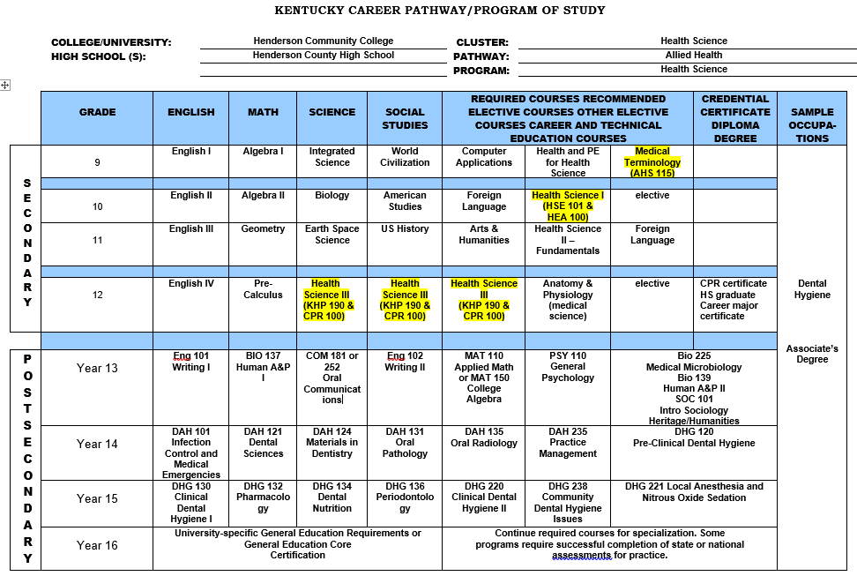

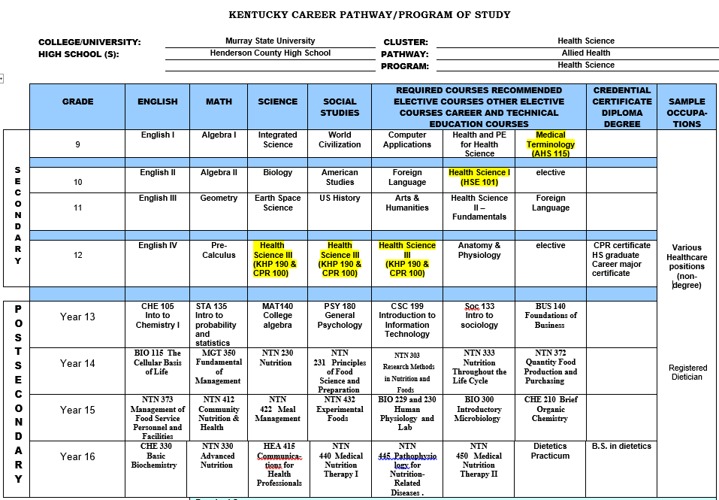

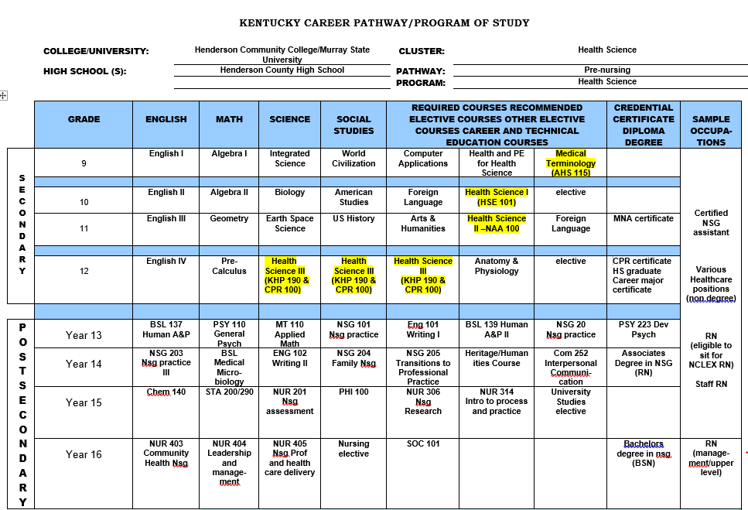

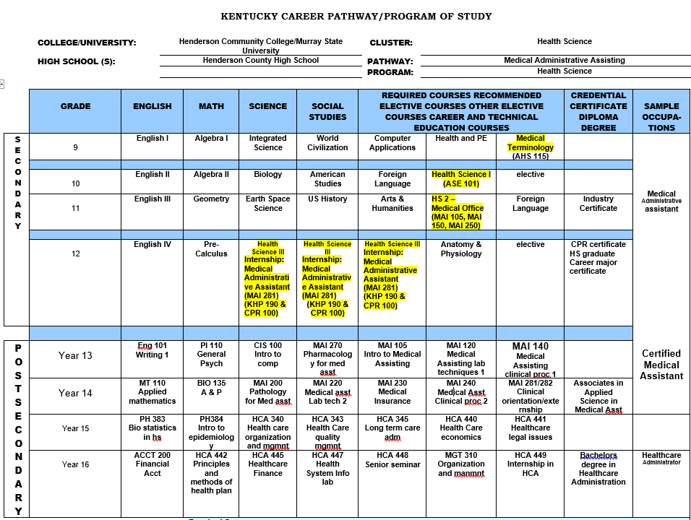

18. How do you ensure that CTE instruction and coursework is integrated with core academics? Please provide one, specific example.

*The HCHS Health Science program ensures that core academics are incorporated into instruction and coursework through the development and implementation of curriculum maps, daily lesson plans and coursework aligned with the Kentucky Health Science Program of Studies. The Health Science Program of Studies connects Health Science coursework with the Kentucky State Standards for Mathematics, ELA, 21st Century Science Standards AND Employability Standards. Our integrated curriculum is designed to engage students, teach problem solving skills and develop meaningful connections between core academics and real-world application. We are continuously evaluated on our integration of core content, particularly reading and math skills, in our everyday instruction through lesson plan reviews, principal walk-throughs and weekly Health Science department meetings. We also hold ourselves accountable by including a literacy and math goal in our individual Professional Growth Plans each year. The Health Science department faculty attends annual district-wide literacy and math professional development geared to cross-curricular integration of these skills. In addition, Health Science teachers attend professional developments specific to their Health Science pathway throughout the school year.*

*One specific example is our Medical Dosage Calculations class. Math is the primary focus of this class so it is at our strong recommendation that students who enroll have successfully completed Algebra 1. Those that have not must be granted administrative permission to enroll in Medical Dosage Calculations because there are so many pre-requisite math skills necessary for a learner to successfully complete the course. This course is designed to focus, utilize and build on mathematical skills commonly used in all health occupations. Students will use applied techniques, problem-solving and critical thinking to perform mathematical operations such as computations, ratio and proportion, weights and measurements and conversions. The skills taught in this class align with the Kentucky Math Content Standards and meets the requirements for the fourth elective mathematics credit required for graduation with an allied health major. Several years ago, through collaboration with Henderson Community College, we discovered that incoming pre-nursing students were demonstrating weaknesses in basic math calculations. It was at this point that our department, guidance counselors and the Nursing Program Advisory Committee members at HCC began to strongly encourage all pre-nursing students to include Medical Dosage Calculations in their high school course of study.*

19. List the opportunities for learners to earn articulate and/or transcript dual enrollment credit ­­­­across K-12 and postsecondary, such as AP/IB, dual and concurrent enrollment, capstone experiences and/or transcript credit articulation agreements. (250 word limit)

*HCHS Health Science students are provided the opportunity to enroll in core academic advanced placement courses to earn articulate credit, as well as CTE courses to earn dual enrollment credit.*

* *HCHS students have the opportunity to enroll in core academic Advanced Placement courses. Articulation credit is awarded to students who pass the AP Exam.*
* *HCHS students have the opportunity to earn college credits through courses offered within each of the three health Science Pathways. We offer the following dual credit courses:* 
  + *AHS 115 (Medical Terminology) with college credit from Henderson Community College (HCC)*
  + *HSE 101 (Introduction to Health Science) with college credit from HCC*
  + *AHS 100 (Human Growth and Development)*
  + *MNA 100 (Medicaid Nurse Aide) with college credit from HCC*
  + *KHP 190 (First Aid and Emergency Care) with college credit from HCC*
  + *MNA 105 ( ) with college credit form HCC*
  + *MAI 140 (Medical Assisting Clinical Procedures) with college credit through HCC (beginning 2019-2020 School Year)*

20. Please provide information on **at least three partnerships** with *education institutions and groups* your program of study has, and describe how these partnerships have been built, maintained and sustained over time. Use this space to specifically address the secondary and postsecondary partners that contribute to and maintain this program of study.

|  |  |  |
| --- | --- | --- |
| **Education Partnership Name** | **What role does this partner have in directly supporting your program of study?** | **How many years has this partnership been active, and how was this partnership developed?** |
| Henderson Community College | *HCC provides dual credit for four Health Science classes.  The faculty in the allied programs (nursing, clinical lab technician, dental hygiene, and medical assisting) support our students by providing tours of their facilities specifically for HCHS health science students.  Guest speakers from these programs come to our school and talk to our students about opportunities in their programs. They will discuss with students the requirements, the environment, and the need for healthcare professionals in our community.  Several faculty members serve on our advisory board and provide recommendations for improvements to our program. HCC nursing faculty is currently working with the health science department to make the transition from high school to nursing school easier.  The students, if they meet certain requirements, would be allowed direct admission into the nursing program in the fall following high school graduation.*  *In an attempt to increase HCC’s Associate Degree Nursing (ADN) program enrolment as well as assist HCHS students make an easier transition to post-secondary education an agreement for early acceptance into the HCC ADN program has been made.  HCC has agreed to hold up to ten spots for our currently SRNA students that will graduate in 2020. In order to be eligible for this program the student has to either pass the HESI A2 exam with a score of 75% or have a composite ACT score of 20.*  *(Nancy can you clean this up)In 2008, Medical Office class was offered with an opportunity for work based learning as senior. (HCHS Medical Office program was piloted for KDE CTE) In 2017, Certified Medical Administrative Assisting became eligible to take the NHA CMAA for state accountability piloted by our program. Dual credit for MAI 105 since 2014. For 19-20, HCC will also offer dual credit for MAI 140 Medical Assisting Clinical Procedures.*  *Do you need this here since it’s in the previous section?* | *The partnership between HCC and the HCHS Health Science program has been active approximately 13 years ago.  Prior to this, the HCHS Health Science program had a partnership with Madisonville Community College and the CTE unit was required to utilize the local community college, thus beginning our relationship with HCC.  The curriculum for our program, which originally began as an area technology center, was aligned to the curriculum provided by our state’s community college system. HCC has always been a supporter of our health science program by serving on our committees, providing dual credit enrollment courses, and by allowing students to tour their allied health facilities and providing them with activities and information to help them decide on a post-secondary career path.*  *\*\*\*This is the first year for this agreement.  Currently we are awaiting ACT scores.*  *\*\*\*This benefit started this year and currently working on offering a clinical component for 19-20.* |
| Madisonville Community College | *We have Early College Academy at Henderson and Madisonville. We are in the second year with Henderson and the participating students will graduate with a high school diploma and an Associate’s Degree at the same time. The students at Madisonville are all seniors that are starting college early, while still meeting high school graduation requirements. Students in the Early College Academy meet weekly with their college advisor and once a month or more if necessary with the HCHS Early College Coordinator. Students were selected based on maturity, future plans, grades, attendance, and all must have met the ACT benchmarks for college-level work. Parents are also heavily involved in the process. Students in both of these programs are taking their general education classes so that they can move into their area of major sooner. Last year, 2 out of the 11 seniors in the program earned spots in the nursing program, which is very competitive at HCC. Last year, the early college academy student’s average GPA was 3.5 and they completed a total of 577 college credits.* | *Previously partnered with MCC before being required to partner with our local community college. We have recently reconnected with MCC and have worked actively with them for the past year to offer Early College opportunities to our students while attending HCHS.* |
| Henderson County Schools | *U.S. News - Silver rated school ranked #27 in KY*  *The mission of the Henderson County Schools is to provide extraordinary educational opportunities for every student. The vision of Henderson County Schools is to excel as a national innovative leader in education.*  *Authentic service to all*  *-8 Elementary Schools Grades*  *K - 5*  *-2 Middle Schools Grades 6 - 8*  *-1 High School Grades 9 - 12*  *-1 Alternative Learning Center*  *-1 Preschool Center* | *Henderson County Schools has supported the Health Sciences programs since they were established.  Approximately 20 years ago we began to work closely with school nurses, occupational therapists, physical therapists and speech therapists in the district in order to give our work-based learning students interested in these areas internship opportunities. These individuals provide our students with a great deal of knowledge and background information on their chosen career. This partnership continues today.* |
| Kentucky Department of Education | *The Kentucky Department of Education (KDE) supports our program by providing resources and support for our instructors.  Three teachers served on KDE committees to develop curriculum and standards for all health science programs in Kentucky.  Our Health Science program was the first in the state to offer the medical administrative assistant pathway and one of our teachers worked with a KDE consultant to create the entire curriculum and course outline for that program* | *The Kentucky Department of education has been a partner with the HCHS Health Science Program since 2001 when the career and technical department  at HCHS became controlled by our local district rather than remaining an area technology center and being controlled by the state of Kentucky. The school district now provided funding for our department and our leadership at the state level switched to the Kentucky Department of Education versus Kentucky Tech School District, which controlled all area technology centers in the state. The work that area technology centers and locally operated career and technical centers do is similar, but funding is from different sources. KY Tech School District was recently changed to the Office of Career and Technical Education and became a part of KDE.  There are currently 53 area technology centers and 42 locally operated career and technical centers and comprehensive high schools. They are now all a part of the Kentucky Department of Education.* |

# **ALIGNMENT WITH INDUSTRY AND BUSINESS NEEDS**

21. Describe how your program of study is aligned with the needs of the workforce and industry in your community. Make sure to include information on how the program of study helps meet workforce demand identified by business and industry. What labor market data does your program of study use to align to workforce needs? (250 word limit)

*According to the Green River Area Development Districts’ Occupational Outlook report health-related careers account for 14 of the top 25 fastest growing careers in our area with Registered Nurses and Nursing Assistants being two of the top 10 occupations with the most annual job openings. Medical Assisting was also mentioned as being in high demand. Our program prepares students for all these careers and meeting these workforce needs by offering students the Medicaid Nurse Aide class and SRNA certification. SRNA students are given the opportunity to enroll in co-operative education their senior year and work as a Nurse Aide. The MNA class is a required class for most nursing programs, so students applying for these programs are a step ahead. The Medical Assisting pathway allows students to receive a CMAA certification that can lead to employment as a medical assistant. CMAA students may participate in internships in multiple healthcare settings their senior year. The knowledge students gain from other Health Science courses offered in our pathway provides basic knowledge and skills needed to be successful in post-secondary education in health related careers. The CTE principal serves on the Chamber of Commerce committee that provides information on healthcare careers and employee needs. The principal uses industry feedback to guide, update, and improve our program to meet the community needs.*

22. Are ALL learners in the program of study required to participate in a work-based learning opportunity? Please describe the work-based learning opportunities available to learners who participate in this program of study. (250 word limit)

*Yes. The Health Science Pathway requires work-based learning experiences.*

*Students must complete a minimum of 16 hours of supervised practical training to be eligible to take the state issued exam. Juniors enrolled in the SRNA pathway participate in 18 hours of mandatory clinical time at Redbanks Nursing and Rehabilitation.*

*Learners enrolled in all pathways must have completed, or be concurrently enrolled in the Capstone course, Health Science 3, their senior year to complete the 175+ required hours of work-based learning experience. Learners have access to a wide range of healthcare facilities, professionals, and career exposure through formal partnerships with over 47 local healthcare facilities. The two types of work-based learning experiences offered include paid cooperative education and unpaid internships. Students receive grades based on employer and teacher evaluations and are required to maintain daily reflections on their experiences at their work-based learning site.*

*Many of our student’s work-based learning experiences have led to long-term employment.*

23. Please list the industry-recognized credentials/certifications/licenses offered/required. If your program of study does not include industry-based credentials/certifications, please explain why. (200 word limit)

|  |  |
| --- | --- |
| **Offered** | **Required** |
| SRNA (State Registered Nurse Assistant)  Offered to juniors in the pre-nursing pathway; Certifies students to work as State Registered Nurse Assistants in the state of Kentucky which is required in all LTC facilities. | BLS for HCP (Basic Life support for Health Care Providers) required for all seniors enrolled in Health Science 3 and preferred by most healthcare facilities in our work based learning program. |
| CMAA (Certified Medical Administrative Assistant) offered to all students enrolled in the medical administrative assistant pathway is designed to help gain the skills to provide administrative support in a medical setting. | First Aid Certification required for all seniors enrolled in Health Science 3 and essential for healthcare providers to provide care in emergency situations. |
| CERT (Community Emergency Response Team) offered to juniors in the allied health pathway offers a consistent, nationwide approach to training and organization that professional responders can rely on during disaster situations, educates about disaster preparedness for the hazards that may impact their area and trains them in basic disaster response skills, such as fire safety, light search and rescue, team organization, and disaster medical operations. | SRNA (state registered nurse assistant) offered to juniors in the pre-nursing pathway allows students to work as State Registered Nurse Assistants in the state of Kentucky which is required in all LTC facilities. |

24. Please provide information **at least three** *business, industry and/or labor* partnerships your program of study has, and describe how these partnerships have been built, maintained and sustained over time.

|  |  |  |
| --- | --- | --- |
| **Business/Industry Name** | **What role does this partner have in directly supporting your program of study?** | **How many years has this partnership been active, and how was this partnership developed?** |
| Methodist Hospital | *Methodist Hospital is a 192-bed facility that provides care to our community.  They also manage the Methodist Physician’s Group, a team of more than 50 medical professionals working throughout 20 clinics in the state.  The Health Science department has partnered with Methodist Hospital to provide work-based learning experience for students enrolled as seniors in our Health Science 3 class.  Our students are allowed to complete 4-6 week internship rotations in over 20 different departments at the hospital. Several employees of Methodist Hospital also serve or have served on our Health Science advisory committee and collaborate with Health Science teachers on a continuous basis to help guide students to success each school year.* | *The Health Science partnership with Methodist Hospital dates back approximately 35 years when the Health Science program was established at Henderson County High School.  At that time, the hospital donated money/equipment and sponsored a lab in the department. Since then, our relationship with Methodist hospital has grown. Not only do they now provide our students with a multitude of internship opportunities, but they also serve on our advisory board and provide feedback on ways to continually improve our program.* |
| St. Anthony’s Hospice | *St. Anthony’s Hospice provides care to and support for patients and family members facing life-limiting illnesses.  The Lucy Smith King Care Center is an inpatient facility offered by St. Anthony’s Hospice. Patients can choose to spend their final days at home or at this facility.  Hospice provides our work-based students interested in learning more about the services they provide with an annual training. Students who complete the training are given the opportunity to complete a 4-6 week internship at the Lucy Smith King Care Center* | *The Health Science partnership with St. Anthony’s Hospice began in 2009 when the organization opened the Lucy King Care Center inpatient facility.  Due to the number of students we have in our program, we always have the need for additional internship opportunities. St. Anthony’s willingly agreed to partner with the program to allow students interested in palliative care the opportunity to experience what their organization has to offer.  It was agreed that due to the sensitive nature of the services provided by hospice, students should go through an orientation prior to completing an internship at their facility. This orientation is provided annually by Hospice and students are required to go through the training if they think they are interested in completing an internship at the Lucy King Cancer Center.  Our partnership with St. Anthony’s continues today.* |
| Redbanks Nursing Home and Rehab | *Redbanks serves our community as the only not-for-profit skilled nursing and short term rehabilitation facility in the city. They also work with Alzheimer’s patients to provide care and resources for the individual and their family to cope with the disease.  Redbanks employs senior work-based learning students who earn their MNA certification during their junior year.  These students go to work for part of the school day as an MNA and also work extra hours after school and on the weekends.  Redbanks also gives our HOSA students opportunities to earn volunteer hours.* | *The Health Science partnership with Redbanks dates back to the 1990’s when pre-nursing became a Health Science pathway.  Students in the pre-nursing pathway must take the Medicaid Nurse Aide (MNA) class and complete 16 clinical hours in a long-term care facility in order to obtain their certification.  Our MNA students continue to receive required clinical hours at Redbanks. In the early 2000’s, Redbanks offers employment opportunities to senior health science students who earned their MNA certification their junior year.  These students go to work for part of the school day as an MNA and also work extra hours after school and on the weekends. Redbanks Director of Nursing also serves on the Health Science Advisory Board.* |
| Henderson County Schools | *Henderson County Schools* | *Henderson County Schools has supported our program since it was established.  Approximately 20 years ago we began to work closely with school nurses, occupational therapists, physical therapists and speech therapists in the district in order to give our work-based learning students interested in these areas internship opportunities. These individuals provide our students with a great deal of knowledge and background information on their chosen career. This partnership continues today.* |
| Henderson County Humane Society | *The Humane Society provides shelter and care to animals in need of homes. The Health Science department has partnered with the Humane Society to provide work-based learning experience for Health Science 3 students interested in working with animals.  The Humane Society also provides opportunities for our HOSA (Health Science student organization) students to gain volunteer hours.* | *The Health Science partnership with the Henderson County Humane Society began approximately 20 years ago to give our students interested in animals and the veterinary field internship opportunities.  The Humane Society continues to be willing and eager to accept our students into their facility. They also continue to provide our HOSA (student organization) members opportunities to earn volunteer hours.* |
| *New Hope Animal Rescue* | *New Hope Animal Rescue provides shelter and care to animals in need of homes. The Health Science department has partnered with the New Hope to provide work-based learning experience for Health Science 3 students interested in working with animals.  New Hope also provides opportunities for our HOSA (Health Science student organization) students to gain volunteer hours.* | *The Health Science partnership with the New Hope Animal Rescue was established approximately 5 years ago to give our students interested in animals and the veterinary field internship opportunities. New Hope continues to be willing and eager to accept our students into their facility.  They also continue to provide our HOSA (student organization) members opportunities to earn volunteer hours.* |
| *Morton Family Dentistry* | *Morton Family Dentistry provides a variety of dental services to patients in our community.  The Health Science department has partnered with Morton Family Dentistry to provide work-based learning students interested in being a dentist, dental hygienist or dental assistant internship opportunities.* | *The Health Science partnership with Morton Family Dentistry was established approximately 10 years ago in order to give our students interested in dental careers internship opportunities.  The students who complete internships with Dr. Morton gain a great deal of knowledge about the dental field. Our partnership with Dr. Morton continues today.* |
| *T&T Drug Store* | *T&T Drug Store is a locally owned pharmacy in Henderson, KY. The Health Science department has partnered with T&T drugs to provide work-based learning experience for Health Science 3 students interested in pharmacy related careers* | *The Health Science partnership with T& T Drug Store, a locally owned pharmacy, was established approximately 20 years ago in order to low work-based learning students interested in a pharmacy related career internship opportunities.  Our partnership with T&T continues today. Pam Marshall, owner of T&T, has served on the Health Science advisory board offering recommendation and suggestions to help improve our program* |
| *Deaconess* | *Deaconess Health System is the premier provider of health care services to 26 counties in three states (IN, IL, and KY).  Deaconess Clinic, a fully integrated multispecialty group featuring primary care physicians as well as top specialty doctors, provides patients with consistent and convenient care. Additional components a network of preferred hospitals and doctors, more than 30 care sites, and multiple partnerships with other regional health care providers. Our Deaconess partnership has allowed our students increased opportunities in work-based learning in HS3. Deaconess has been instrumental in providing electronic medical record technology and training through their EPIC software system. Deaconess has members of their administration that serve on our advisory committee.* | *For 125 years Deaconess Health System to provide high-quality health care. This year, Deaconess has affiliated with Methodist Hospital which has helped in bridging our partnership. Deaconess has served our program for one year. We recognize the need to foster our relationship in an effort to meet the needs of both organizations.* |
| *Gibbs* | *Gibbs is a global manufacturer of precision die-cast, machined, and assembled products for the automotive industry.  Unique within the die-casting industry employs over 1000 team members. Gibbs believes in supporting and fostering growth in the communities where we live and work.  We support community organizations and events through corporate sponsorships and grants and encourage hands-on volunteerism with organizations that enhance the community.  From youth mentoring to workforce development and many more initiatives, we are actively improving the well-being of children and families in our neighborhoods. Gibbs Wellness Center has partnered with our health science work-based learning program to allow CMAA students to intern with the occupational nurse.* | *Gibbs has been a major employer in our community for over 50 years and has focused on health and wellness for their employees for several years. The primary mission of the Gibbs Wellness Center is to provide medical intervention to all Gibbs Team Members, Contingent Workers and Contractors on site. The key areas are to address any symptomatic team members who are experiencing occupational injuries due to the workplace. Provide all needed services related to personnel medical conditions, preventive care, wellness as well as lining out primary care doctors for services beyond our capabilities. The Wellness Center is utilized in the pre-employment phase to develop baseline data, conduct hearing tests and pre-employment drug screening. Make rounds in each production facility to follow up with team members and promote safe behaviors. The nurses are trained in performing ergonomic assessments to assist the Safety Department in developing engineering improvements targeted on sound objective measures. All nurses are LPN or RN’s with additional training unique to their environmental conditions. Team members who utilize our services are healthier, diagnosed sooner, have regimented treatment plans with an accountability partner and therefore are less apt to miss work. This year, our students are able to serve a 10 week rotation at Gibbs to experience another aspect of healthcare.* |

25. Please feel free to use the space below to share any other information or evidence of success of your program of study and the learners who participate. (Optional)

* *The Health Science program serves over one-third of the student population at Henderson County High School.  It is the largest career and technical education program in the school and in the state of Kentucky.*
* *Our student organization, HOSA:  Future Health Professionals, is consistently recognized as one of the largest chapters in the state.  Our students are active participants in HOSA with 19 students placing in the top three in their regional conference in 2017. In 2017 two students placed first in their event and 2018 one student placed first in their event at the HOSA State Leadership Conference, making them eligible to attend the HOSA National Leadership Conference. Our HOSA chapter provides multiple community service opportunities with our local nursing homes, our local hospital health events, American Red Cross Blood Drive, Salvation Army soup kitchen/canned food drive, HOSA national service project fundraisers with NAMI, LLS, and National Pediatric Cancer Foundation, and breast cancer awareness. Our chapter helps to raise awareness for health conditions important to our students through school-wide education for students and staff. Our chapter conducts monthly student-led chapter meetings, establishes a program of work for the year, and allows students improve their leadership and teamwork skills.*
* *The health science program has a 100% overall pass rate for the State Registered Nurse Aide (SRNA) certification.  We are the only program in the state to offer this as a junior level course, allowing students to use their certification during the senior year.  We currently have twelve seniors employed as State Registered Nurse Aides at Redbanks Nursing and Rehabilitation as their co-operative education experience.*

*\*\*\*The chart below shows the State Registered Nurse Aide (SRNA) Competency Evaluation pass rate for the last three school years.  (Note: All percentages are based upon students that were eligible to retake the exam and did not self-exempt by such means as graduating, refusing to take the exam again, and relocation)*

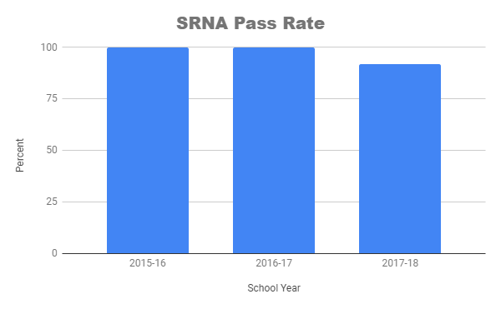

* *We are the first health science program in Kentucky to offer the Medical Administrative Assistant pathway.  Our program developed the curriculum and set the standards for this program. We were the first program to offer an industry certification (CMAA) for this pathway.*
* *HCHS TEEN CERT has provided national certifications for 248 health science juniors over the last four years. HCHS TEEN CERT was the first program for high school students in the state of Kentucky.  Our CERT program organizes a live disaster simulation for our students and many community partners to collaborate and mitigate on how to make our school and community safer in the event of a disaster. Our last simulation on November 16, 2018, included the Henderson County Fire Department, the Henderson County Police Department, Methodist Hospital Ambulance Service, Korseen Fire and Safety, Henderson County Emergency Management, Henderson Nursing and Rehab, just to name a few.  There were three local news channels present for the event. Methodist Hospital, Henderson County’s only hospital, partnered with us on this event to train their employees on disaster preparedness and how to handle multiple victims in a short amount of time. During the simulation, multiple “victims’ with a wide range of “injuries” were sent to the hospital by ambulance.  This allowed the hospital staff to practice receiving and treating many victims at one time and the nursing home staff to receive overflow of patients from the hospital.*
* *The HCHS health science program has the largest work-based learning program in the high school and in the state.  ALL of our senior level students are required to complete work-based learning in the form of a paid co-operative education opportunity or an unpaid internship. In addition to this, any juniors enrolled in SRNA also complete 18 hours of work based learning clinical time.  Work based learning prepares our students for employment and allows them to explo*re *different healthcare careers. Our work based learning partners are very supportive of our health science program.*
* *Many former HCHS health science students have returned to assist the health science program by participating as guest speakers, as judges for mock SRNA skills testing, and participants on our advisory board.*
* *The Health Science Program at HCHS created the class, Allied Health Core Skills, for the state program of studies for health science.  Our program developed the curriculum and standards for this class in the allied health pathway.*

26. If applicable, please provide more detail on any partnerships your program of study has that have not been mentioned already. This includes community groups, non-profits, volunteer organizations, etc. Describe how these partnerships have been built, maintained and sustained over time. (Optional)

|  |  |  |
| --- | --- | --- |
| **Additional Partnerships** | **What role does this partner have in directly supporting your program of study?** | **How many years has this partnership been active, and how was this partnership developed?** |
| ***Salvation Army*** | *The Salvation Army provides an access point for members of our student organization, HOSA, to gain community service hours.   HOSA members volunteer annually at the Salvation Army soup kitchen and also participates in the Salvation Army “adopt a family” program.* | *We have had a community relationship with the Salvation Army for the past 10 years.   The Salvation Army needs community volunteers and our HOSA students need community service hours so a natural relationship was formed* |
| ***American Red Cross of Western Kentucky*** | *American Red Cross provides education and opportunities in disaster preparedness to our CERT students (students receiving certification for Community Emergency Response Team).   The Red Cross provides valuable information on how to help communities that are in need due to a disaster. The HCHS Health Science Program partners with the American Red Cross each Spring and fall to organize a community blood drive in our school.  We are able to provide volunteers, a facility, and blood donors.* | *The partnership for CERT has been active for four years.  Students in our classes needed emergency preparedness training and our community was in need of trained emergency responders.  The Red Cross assists with so many natural disasters and crises that they were a natural partner for this project. The Health Science Program has been conducting the blood drive at HCHS for over 11 years.  Our local American Red Cross knew that we had a health science program and asked for our assistance in increasing their blood supply.* |
| ***Henderson County Emergency Management*** | *Henderson County EMA assists our TEEN CERT program, preparing and educating our students on disaster preparedness. During emergencies, CERT teams can administer first aid, collect damage estimates for local authorities, and establish and maintain communications with emergency responders. EMA also provides additional emergency preparedness continuing education for our students* | *This partnership has been active for four years due to the community need for CERT members.  Kenny Garrett, director of Henderson County EMA, approached our program and asked if we would be interested in helping the community develop a bigger pool of certified emergency responders.  Also, the high school principal believed that because the school has over 2000 students that the high school would benefit from trained first responders in the classroom* |
| ***Henderson Police Department*** | *HPD acts as a community partner and resource officer for our TEEN CERT students.  HPD informs our CERT students of safety risks that would affect the health of our community.   HPD comes into the classroom and educates our students on daily threats in our community.* | *This partnership has been active for four years.  The terrorism education offered in TEEN CERT is taught by the HPD.  This relationship has developed from there.* |
| ***City of Henderson Fire Department*** | *HFD acts as a community partner that educates our TEEN CERT members on fire suppression, fire safety, and fire prevention.  HFD also educates our students on medical services that may provide in the event of an emergency. HFD comes into the classroom and educates our students on all fire related topics.* | *This partnership has been active for four years.  HFD assist the teacher with fire safety and suppression unit in TEEN CERT.  TEEN CERT students have developed personal community relationships with the members of HFD because of this program.* |
| ***Methodist Ambulance Service*** | *Methodist Ambulance Service is a great resource for our TEEN CERT students in medical triage and treatment in the event of a disaster.  Methodist Ambulance Service works closely with our students during triage and treatment offering medical operations feedback. Methodist Ambulance Service provides insight on education, traits of EMT/paramedics, and the stress of critical healthcare.* | *This partnership has been active for three years.  There are two lessons in medical operations for TEEN CERT that personnel from Methodist Ambulance Service assist in teaching and provide information of roles of different health careers in EMS.* |
| ***Korseen Fire and Safety*** | *Korseen offers fire extinguisher training and OSHA fire safety certification for our TEEN CERT students.  In addition to the training they provide, Korseen also provides fire extinguishers for us to use during our live simulation training.* | *This partnership has been active for two years.  HCHS has a contract with Korseen and because there is a fire safety skill that requires TEEN CERT students to extinguish a live fire, we needed a fire extinguisher company to partner with us and Korseen agreed and the relationship continues to grow.* |
| ***Green River District Health Department*** | *GRDHD provides a connection through Medical Reserve Corp. and further training by the epidemiologist for our TEEN CERT members monthly. GRDHD is piloting a program that uses our TEEN CERT members as a point of dispensing vaccinations at our school* | *This partnership has been active for four years.  GRDHD has a partnership with the CERT program. GRDHD helps provide layers of training for CERT members.* |
| ***Air Evac Lifeteam*** | *Air Evac brings their life flight helicopter to HCJS for the health science students to look at and explore.  Members of their crew provide information about the helicopter and how procedures are handled as well as present information about life flight careers.* | *The partnership with Air Evac began in 2015. Life flight complements the CERT program, as it is used in emergency response situations.  The team at Air Evac has been more than willing to allow our students the opportunity to have the experience.* |
| ***Green River Area Development District*** | *GRADD has supported our TEEN CERT program through Citizens Corp.  GRADD Citizen Corp actually funded HCHS CERT program initially. The instructor of HCHS CERT serves on the GRADD Citizen Corp board for feedback and model for other counties in the GRADD area.* | *GRADD has partnered with our program for three years. Citizen Corp board members assist with supervising our final CERT simulation and offering feedback to improve our volunteer skills.  The* [*Citizen Corps Council*](http://www.ready.gov/citizen-corps) *was formed in response to the need to train volunteers and educate citizens on public safety and disaster preparedness issues. Members of the council include emergency management, law enforcement, fire service, American Red Cross, AmeriCorps, Catholic Diocese of Owensboro, Green River District Health Department, ARES (amateur radio emergency services), VOAD (Volunteer Organizations Active in Disasters) members, school districts and other volunteer, faith based and non-profit organizations.  The mission of Citizen Corps is to harness the power of every individual through education, training, and volunteer service to make communities safer, stronger, and better prepared to respond to the threats of terrorism, crime, public health issues, and disasters of all kinds.* |

# **SUBMIT YOUR APPLICATION**

**SUBMIT YOUR APPLICATION**

* Fill out this application.
* Once you have finished, complete [this form](https://careertech.org/2019-excellence-action-application) and upload the following:
* Your full application saved as a Word document (.docx)
* All of your supplemental documents or evidence consolidated as one PDF document.

**THANK YOU!**

Thank you for completing this application! You will know the status of your application by January 22, 2019. The programs of study will be evaluated based on their effective leveraging of partnerships, alignment to rigorous and relevant college- and career-ready expectations, clear progression of knowledge and skills across secondary and postsecondary systems, integration of successful career guidance/advisement, and key indicators of learner success.

Don’t forget to use the Excellence in Action award submission checklist to make sure you’ve completed your application in its entirety.

We look forward to learning more about your program!

For questions, concerns please contact [awards@careertech.org](mailto:awards@careertech.org).