From: Dave Myers & Toeupu Liu

Subject: Heavy Equipment Science

Date: November 15, 2017

Period Covered: Sept. 2017 – Present

***H.E.S. Advisory Board Report***

***H.E.S. Mission Statement: Prepare each student to become college & career ready!***

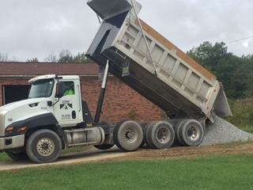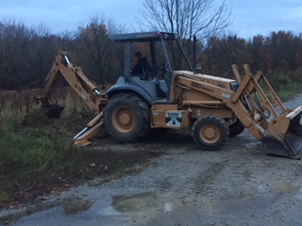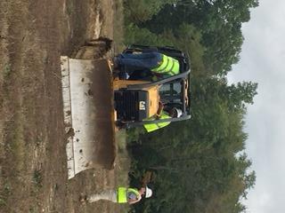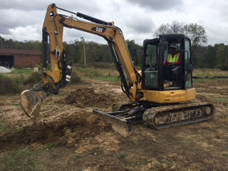

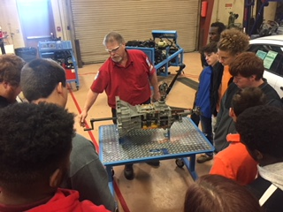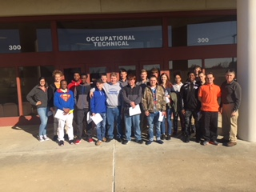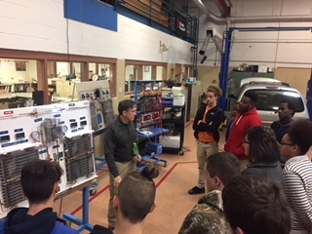

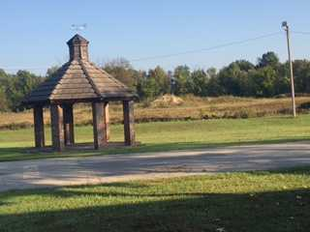 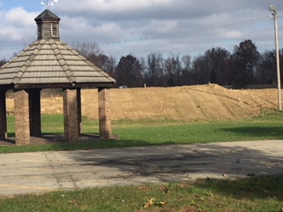

***E.C.T.C. Field Trip – Community Service – Campus Projects***

**Celebration:**

Hundreds of our H.E.S. Alumni are now working in the construction industry because of this Advisory Board!

* M.S.D.
* Whayne Supply
* Flynn Brothers
* L.W.C.
* Fischel
* Clark
* Evapar
* Atlantic Construction
* Military
* Owners of own business

**Recent Grants, Awards & Donations:**

Louisville Water Company – donation of P.P.E. and materials to locate and excavate.

Mr. Ed Flynn – Donating his expertise and time in building the Renfrow Fitness hill.

Flynn Donation from last year has allowed us to purchase a concrete mixer.

Flynn Brothers repaired our Harley Rake.

2017 Graduate Skylar Sample working with his brother to get a diesel engine donated to the program.

Whayne Supply / Caterpillar $1,000 donation to program.

CTE specialist – Ryan Deal in the process of getting our simulator lab updated.

Metro Public Works – Donation of equipment

Louisville Water Company – Letter of support for CTE Excellence Award

**Simulator Lab(s)**

* Heavy Equipment labs
  + - Equipment lab suffering growing pains with the addition of the MSD dump truck. (New Building)
    - Add virtual reality to our simulator lab.
    - I-pads and membership for H.E.S. students to complete N.C.C.E.R. module work.
    - (2) Additional forklift simulators along with new software for our existing simulators.
      * Completing installation of Simlog upgrades.
      * Cat simulators need upgrades and possible advanced computers.

**Fairdale H.S. & Community Projects**

* Construction of Renfrow fitness hill.
* Fairdale Sign (new location)
* Park benches refurbished
* Landscaping Projects on Campus.
  + Campus clean up before Fairdale Fair and Homecoming
    - Upkeep of Bio-swales.
    - Storm damage clean up.
* Build sidewalk from Fairdale Road to campus.

**TRACK Apprenticeship program**

* Mary Taylor & David Lawson – KDE Industrial Training and Development
  + - * Whayne Supply has adopted the Track apprenticeship program.
        + Marcus Cox and Parker Davis have passed their pre-employment aptitude exam.
      * M.S.D. looking into how they can be a part of the Track program.

**Inventory and Equipment:**

* Service on equipment needed
  + Fluids and general maintenance.
  + New Holland dozer blade malfunctioning.
  + Dresser Dozer injectors worn out.

**H.E.S. – Events since our September meeting & Upcoming Events:**

* Visit I.C.U.E.E. Oct. 4 Professional Development
* 8th Grade Magnet Showcase – KFEC Oct. 28
* FHS – HES field trip to E.C.T.C. – Nov. 9
* Coach Gardner dealing with delivery issue of our concrete mixer.
* Excellence in Action award application due Nov. 15
* A.C.T. practice exam Nov. 20
* Solve for Tomorrow Grant – State finalist announced Nov. 20
* College Fair @ F.H.S. Nov. 21
* Mrs. Corbin organizes faculty meeting / tour of building 3. Nov. 21
* Thanksgiving break Nov. 22-26
* F.H.S. - 8th Grade Open House Dec. 6
* A.C.T. Exam Dec. 8
* A.C.T.E. National Conference – Dec. 6-9 (N.C.C.E.R.) & (Simlog)
* 8th Graders applications deadline Dec. 14
* H.E.S. Advisory Board meeting Jan. 17 ***CANCELLED***
* Senate Bill 1 - SKYPE meeting w/ David Lawson Jan. 17
* K.D.E. / N.C.C.E.R Wayne King visit Fairdale – Jan. 26
* Christmas break Dec. 20 – Jan. 3
* K.O.S.S.A. exam Feb. 5-9 and/or Feb 12-16
* Skills USA membership drive – Regional contest in February
* Nat’l Farm Machinery Show Field Trip Feb 14
* Student Lead Reviews Feb 26
* FHS juniors - A.C.T. Exam March 20
* ***Next*** H.E.S. Advisory Board meeting March 21
* M.S.D. – pre-employment exam C.A.P.S.

**H.E.S. Alumni visits:**

* **H.E.S. Alumni - recent visits from**: Charles Juras – U. of L. Speed School, Jason Carter – Team Fischel, Skylar Sample – U.L. Clark Equipment, Glynn Heavrin – L.W.C., Lucas Bennett – Maximum Service Construction, Megan McWilliams – M.S.D., Herb Webb – JCM, Adam Butler – Mac Construction, Nick Dietrich – Evapar, John Dadonna – Whayne Supply, Sam Austin – Atlantic Construction, Brent Metcalf – L.W.C., Matt Clark – M.S.D.:

**PROGRAM NEEDS:**

* Additional Track Apprenticeship(s)
* Simulator PC’s updated and installation of software.
* H.E.S. building built.
* Equipment Serviced

***ON THE BEHALF OF ALL OF OUR STUDENTS WE WANT YOU TO KNOW THAT WE SINCERELY APPRECIATE EVERYTHING THAT YOU DO TO HELP BUILD OUR THEIR FUTURES!!!***

***THANK YOU!!!***