# **BACKGROUND INFORMATION**

1. Program of study name: **Middletown DECA: Marketing & Cooperative Work Experience**

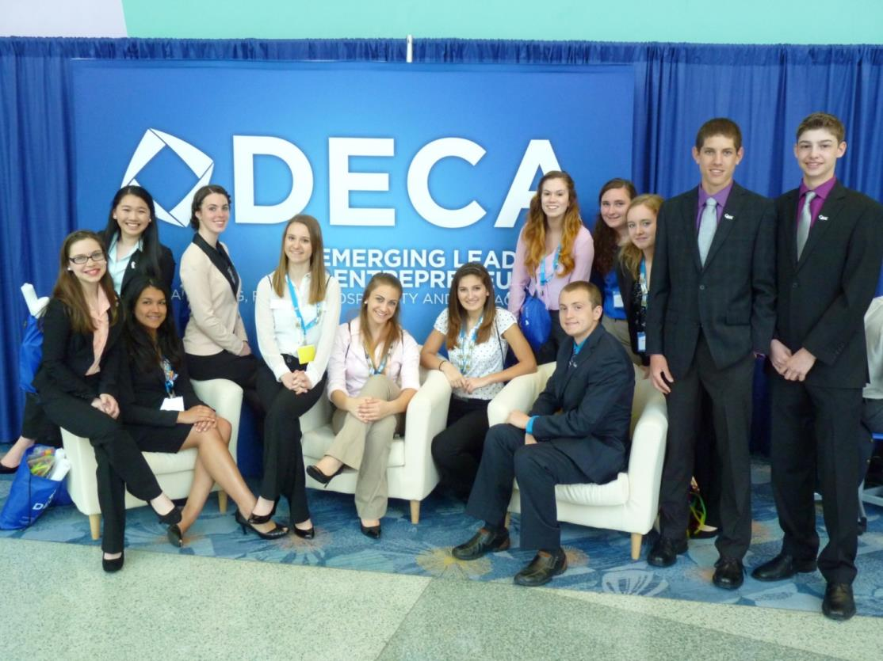

1. Point of Contact  
    Name: **David Reynolds**

Email Address: **reynoldsd@mpsct.org**

Phone Number: **(860) 874-8067 (cell) (860) 704-4500 (work)**  
Address: **200 LaRosa Lane, Middletown, CT 06457**

1. Applicant’s School: **Middletown High School**
2. State **Connecticut**
3. Type of institution (click the box to check)

**Comprehensive high school**

1. Career Cluster in which your program of study should be considered (Follow this link for a further explanation of each Career Cluster [careertech.org/career-clusters](http://careertech.org/career-clusters)) **(Select only ONE):**

**Marketing Career Cluster**

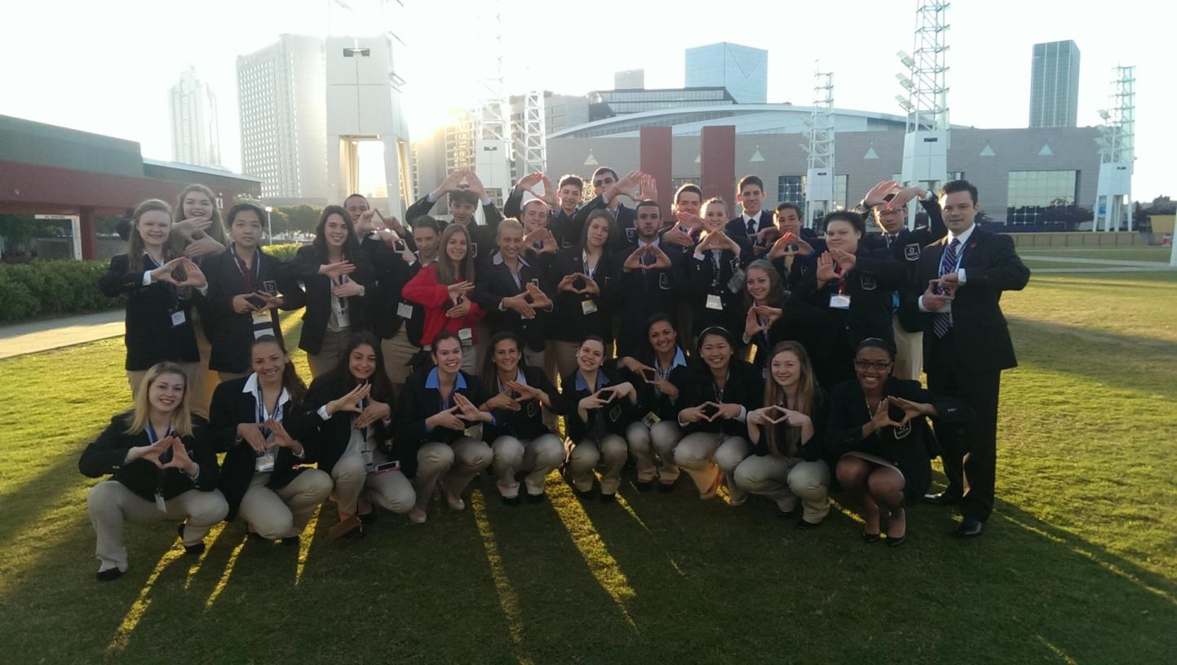

1. In three sentences or less, describe your program of study, including the secondary and postsecondary components and how long the program of study has been in place.

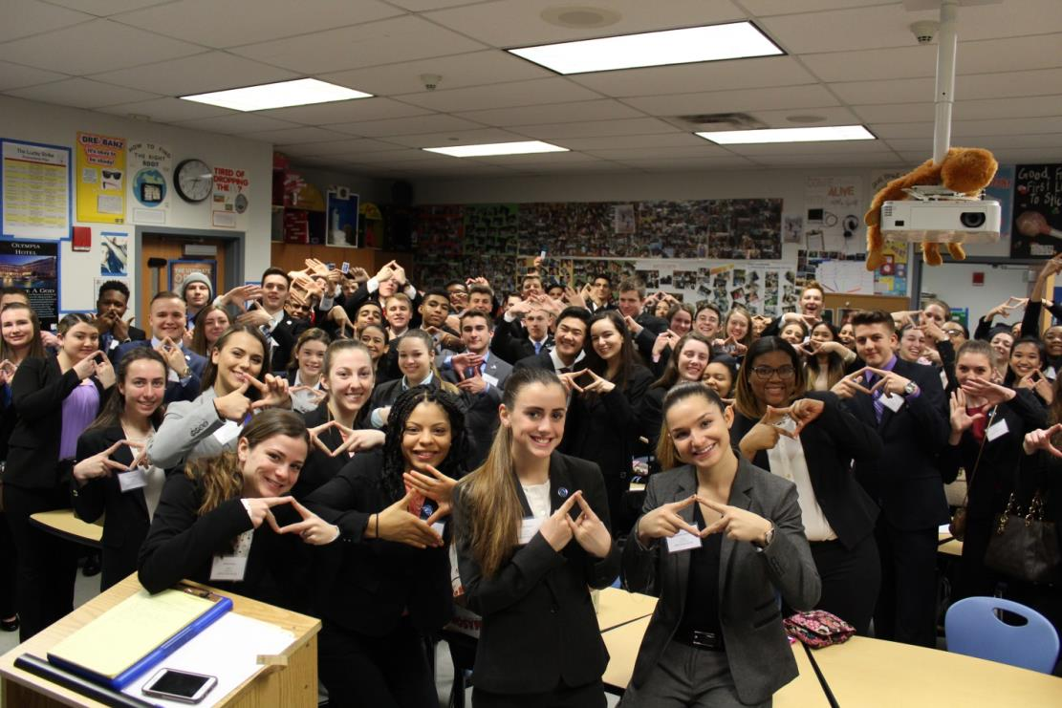***Middletown DECA is a two-year, diverse and equitable, co-curricular Marketing and Cooperative Work Experience program for juniors and seniors in a comprehensive public high school. Our program was one of the very first Marketing/Cooperative Work Experience/DECA programs in CT and has been in existence for almost 40 years. The program, recognized at the international level for the past six years and ranked #1, for four years running, by the State of Connecticut Department of Education for Marketing-competency based testing performance, effectively synergizes rigorous and relevant classroom learning with cooperative work experience, community service, community partnerships, DECA conferences and competitions, and operating a school retail operation.***

1. Please check the geographical and demographic setting for your program of study and describe the geographic and economic conditions of the region served by the school.

**Urban**

***Middletown, located in the center of Connecticut and along the Connecticut River, is a large town of almost 48,000 residents, 96% of which are concentrated in urban areas. Over the past 10 years, the population has increased approximately 10%. While 70% of the residents are white, in Middletown High School 53% of students are white, evidencing a shifting demographic.***

***The median house value is $224,000 which is 18% less than the median for Connecticut as a whole. The median income is $67,000, or 8% less than the median for Connecticut as a whole. English is the primary language in 83% of households. The student population is considered transient as evidenced by the number of students exiting and registering at our schools each year. Approximately half of Middletown High School students are on free or reduced lunch.***

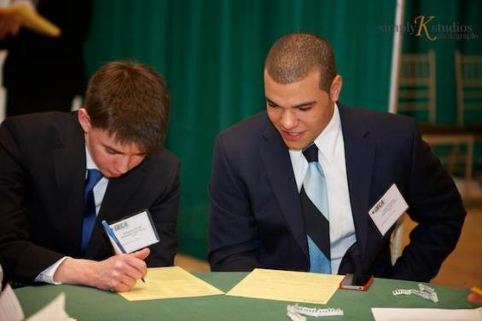

# **STUDENT POPULATION & DATA**

1. Please describe your program of study’s demographic and outcome data for the most recent academic year(s). It is our strong preference to have data from both secondary and postsecondary levels. If this is not available, please provide an explanation as to why the data from the other learner level is not available. Applications that do not include data to support positive impact on student achievement will not be eligible for consideration. (100 word limit)

***The data below evidences the following:***

* ***The program has a diversity that closely mirrors the population of our school as a whole***
* ***Many students participate in our work-based cooperative work experience program, one of the few remaining programs of its kind in Connecticut***
* ***Our program’s students all graduate on time (100%)***
* ***Our program’s students all have a post-secondary path (college, military, employment)***
* ***The program is self-contained in a comprehensive, public high school without an official post-secondary component; therefore no data is available but anecdotal evidence strongly suggests our students are fully prepared for post-secondary success.***

|  |  |  |  |
| --- | --- | --- | --- |
| SCHOOL YEAR | 2014-15 | 2015-16 | 2016-17 |
| **SECONDARY-LEVEL DATA** | | | |
| **Total number of students served by your program of study** |  |  |  |
| % male students | 48% | 49% | 50% |
| % female students | 52% | 51% | 50% |
| % minority students | 40% | 41% | 42% |
| % low-income students | 25% | 25% | 25% |
| % students with disabilities | 0% | 0% | 0% |
| % English language learners | 0% | 0% | 0% |
| Other relevant *demographic* data |  |  |  |
| % of students who met or exceeded goal on the annual State of Connecticut exam of Marketing Concentration | 86% | 100% | 100% |
| % of students who earned postsecondary credit (dual enrollment, AP, etc.) | 50% | 50% | 50% |
| % of students who earned an industry-recognized credential | 0% | 0% | 0% |
| % of students who participated in work-based learning | 28% | 31% | 31% |
| % of seniors who graduated high school (who were eligible/seniors) | 100% | 100% | 100% |
| % of graduates who enrolled in postsecondary education (who were eligible/seniors) | 98% | 98% | 98% |
| % of graduates who entered the workplace and/or military (who were eligible/seniors) | 2% | 2% | 2% |
| % of students who earned an industry-recognized credential (who were eligible) | 0% | 0% | 0% |
| % of graduates who entered the workplace and/or military (who were eligible) | 2% | 2% | 2% |
| % of graduates who transitioned to further postsecondary education (who were eligible) | 98% | 98% | 98% |

1. Provide links to the source of the above data. If the links are not publicly accessible, please explain the source of the data.

***The sources of the data are from our internal PowerSchool system, surveys given to students during the Career and Technical Education exam process and from reports produced by the State of Connecticut Department of Education.***

1. How does your school or institution ensure equitable access and outcomes for students with diverse backgrounds? (150 word limit)

***Our enrollment closely mirrors the demographics of our school as a whole, which is to say the program is diverse with regards to factors such as gender, identified orientation, racial, ethnic, religious, and financial. With regards to equitable outcomes, our test scores (best in state for four years running) are proof of equitable outcomes as the achievement gap, while large in our school as a whole, is virtually non-existent in our Marketing program (see chart below).***

***The participation of students in activities that have financial challenges also resembles our demographics as we award internal scholarships and financial defrayments to those students with financial challenges. During our recruitment of new students, we use a varied group of student-speakers that reflects our program. This student recruitment group and the program’s student leadership team ensures students have a comfort level with students that are comparable.***

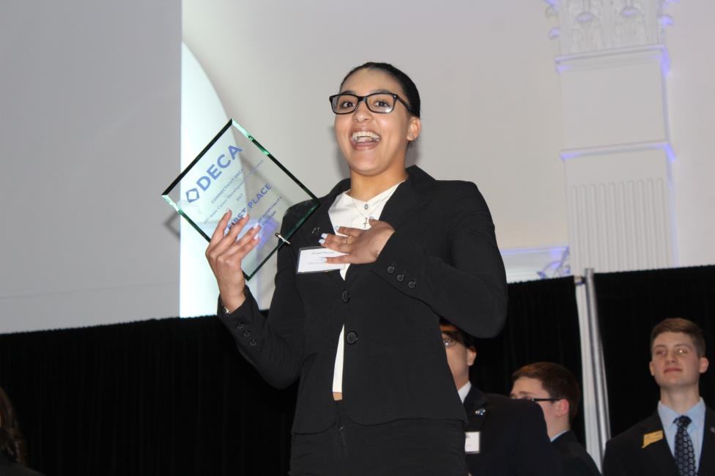

1. If applicable, what strategies or technologies do you use to close access gaps? (e.g. integrated digital learning, virtual work based learning.)

* ***The program mirrors the demographics of our school***
* ***All students are given a Chromebook to use***
* ***Carl D. Perkins grant is used for various technology access and co-curricular event cost supplement***
* ***Equitable distribution of funds for co-curricular events occurs and financial aid is provided for students that find events challenging to afford***
* ***We are partnered with the Virtual High School consortium to allow distance learning***
* ***We use Virtual Business software programs in the classroom***
* ***Various instructional and assessment methodologies are used to impact all learning styles***
* ***Most of all, a lot of hard work, love and effort are put in by the program’s staff to ensure all kids have access to all areas of the program.***

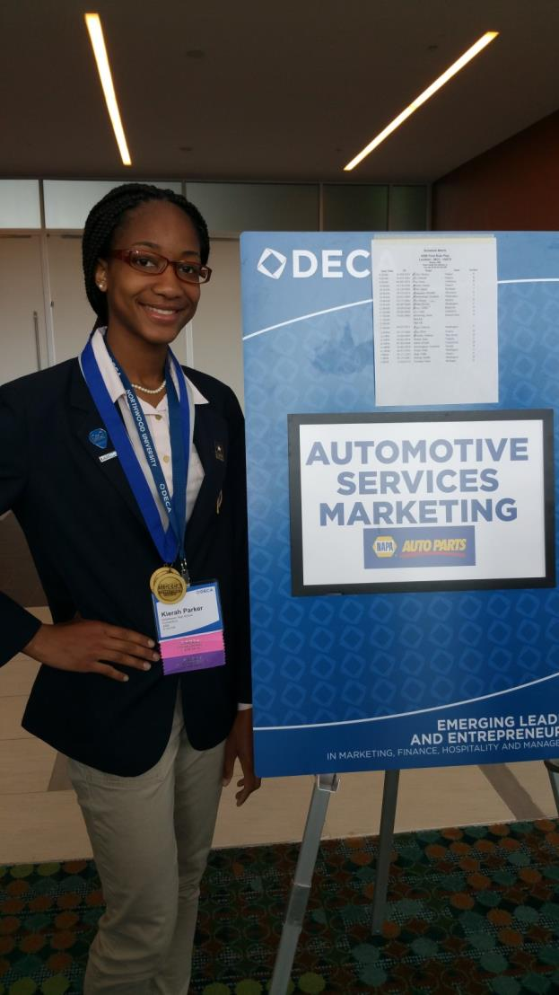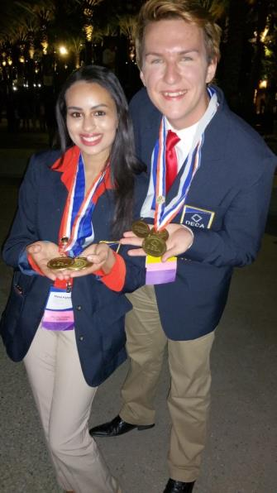

1. What activities does your school or institution do to recruit elementary, middle, high school students and/or adult learners into the program of study? Please provide examples. (150 word limit)  
     
   ***Students join/enroll in/are recruited into our program in the following ways:***

* ***They are aware of the program through family/friends/peers who recommend it.***
* ***They are directly identified and recruited by their peers and sent letters inviting them to join the program.***
* ***Middletown has enjoyed this program for so long that each year a group of students are children and siblings of past DECA members as it “runs in the family.”***
* ***Social media and student news promotional items in which students see our members engaging in activities they want to be a part of as well.***
* ***Referral system with personal letters sent to potential recruits by current DECA members.***
* ***Working closely with our Guidance staff to ensure student interest.***
* ***School retail space staffed by members and they interact with all students and staff.***

1. Is your program of study associated with a Career Technical Student Organization (CTSO)? If so, which one(s) and in what way(s)? (Check the [approved list](http://www.ctsos.org/ctsos/) of CTSOs) (50 word limit)

***DECA is fully integrated and aligned in our program. Our program is co-curricular and DECA principles are integral to student’s learning and achievement. DECA standards are aligned with state, federal and workplace standards. Our students participate in many local, state and international DECA activities and conferences.***

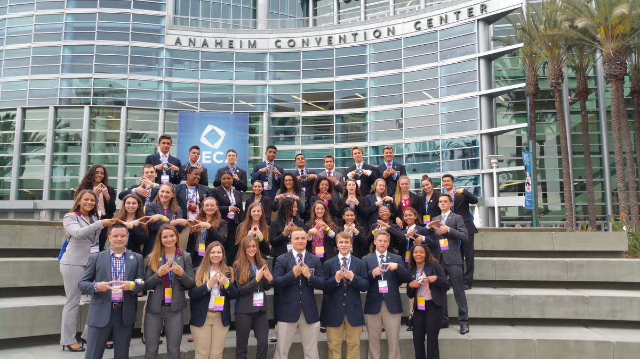

1. Describe how career guidance/advisement is integrated into your program of study to support students’ completion of the program of study and entry into additional education/training and/or a successful career. Where applicable, describe the tools (individual career and academic plans, career exploration websites, etc.) that are provided to learners and how they are used. (200 word limit)

* ***All students begin with a Student Success Plan (SSP) in which their course choices are guided by a specific career-cluster (see Appendix).***
* ***Students must take credits in Career and Technical Education for graduation.***
* ***In the 11th grade, students typically enroll in Personal Finance or our program as part of the graduation requirement of being exposed to financial literacy.***
* ***We have a College and Career Center that is staffed full time by an experience guidance counselor***
* ***Our program has partnerships with a wide array of college and university programs that support our students, provide scholarships, and guest speakers (example Johnson and Wales University).***

# **COLLEGE- AND CAREER-READY STANDARDS/EXPECTATIONS**

1. Please describe how your program of study was developed and how it ensures students are academically and technically prepared for postsecondary education and careers. Please also address the following:

***Middletown DECA was created almost 40 years ago by a partnership with the State of Connecticut Department of Education Marketing department and DECA Inc. to bring a Marketing and Cooperative Work experience to public high schools. The State Department of Education paid for the salary of the founder, Mr. Michael Awdziewicz, and provided mentorship for the first three years. The program was so successful that it became a staple in Middletown and has been an integral part of the community since that time. Many local entrepreneurs got their start in our DECA classroom.***

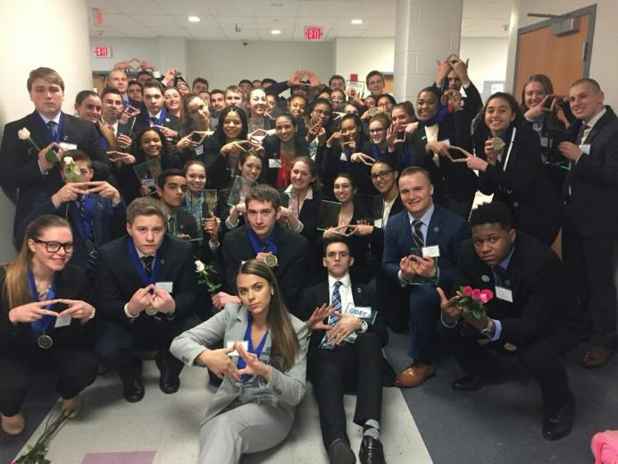

* 1. How were employers involved in the development and/or maintenance of your program of study?

***Employers and industry are involved in a myriad of ways:***

* ***Chamber of Commerce Business and Education Advisory Board***
* ***Cooperative Work Experience partnerships***
* ***Career and Technical Education Advisory Board***
* ***Working with our students on the job***
* ***DECA Inc. national advisory board member support via curriculum support***
  1. How does this program of study meet the economic needs of your community?

***The needs are met in the following ways:***

* ***Access to all students, regardless of any demographic factor, to a rigorous, well-known and respected, college and career preparatory program that prepares students to serve and lead in the community.***
* ***Partnerships in the community, over 30 in 2017-2018, employ our students.***
* ***Generally speaking, all communities need academically prepared, socially-conscious, community oriented, experienced leaders and that is what our students are prepared to be.***
* ***Community service events for JDRF, the Elks Club and Lyman’s***
  1. How does this program prepare students for postsecondary education? (if applicable)
* ***Postsecondary education is competitive, difficult and requires responsible habits. Our program focuses on nurturing these qualities.***
* ***Rigor and relevance. Our program is rigorous and relevant in both the curricular and co-curricular aspect. Furthermore, the textbook we use is the most popular college Marketing textbook, Lamb, Hair, McDaniel “Marketing” 11th edition.***
  1. How were both secondary and postsecondary educators involved in the development and/or maintenance of the program of study? (500 word limit)

***Secondary and post-secondary educators are involved in the planning, instructing, assessing and reflecting on the curriculum and co-curricular aspects of our program on a regular basis via conferences, observations, workshops, professional development, networking, visitations of business, presentations, collaboration, and further education.***

1. Which technical, academic and/or employability skill standards does your program of study incorporate at the secondary and/or postsecondary level and how? (Please list the standards you use and be specific regarding how your program uses industry, national, state and/or locally-developed standards) (250 word limit)

|  |  |
| --- | --- |
| **Standard Types** | **Please list the standards your program of study uses and how it uses them below:** |
| Academic Standards | ***Common Core State Standards (40% of our annual State of Connecticut Career and Technical Education exam are contextual CCSS Math and Reading (link*** [***HERE***](http://www.corestandards.org/)***)*** |
| Career Cluster or Technical Standards | ***2015 State of Connecticut Performance Standards and Competencies (link*** [***HERE***](http://www.sde.ct.gov/sde/lib/sde/PDF/DEPS/Career/perf_stand_comp.pdf)***)***  ***DECA Standards, general (link*** [***HERE***](https://www.deca.org/wp-content/uploads/2014/08/edu_curriculum_connection.pdf)***)***  ***Business Management Standards (link*** [***HERE***](https://www.deca.org/wp-content/uploads/2017/10/HS_Performance_Indicators_Business_Mgmt_Cluster.pdf)***)***  ***Marketing Standards (link*** [***HERE***](https://www.deca.org/wp-content/uploads/2017/10/HS_Performance_Indicators_Marketing_Cluster.pdf)***)***  ***Finance Standards (link*** [***HERE***](https://www.deca.org/wp-content/uploads/2017/10/HS_Performance_Indicators_Finance_Cluster.pdf)***)***  ***Hospitality Standards (link*** [***HERE***](https://www.deca.org/wp-content/uploads/2017/10/HS_Performance_Indicators_Hospitality_Cluster.pdf)***)***  ***Entrepreneurship Standards (link*** [***HERE***](https://www.deca.org/wp-content/uploads/2017/07/HS_Entrepreneurship_Performance_Indicators.pdf)***)*** |
| Employability Standards | ***Common Career Technical Core (link*** [***HERE***](https://careertech.org/cctc)***)***  ***Cooperative Work Experience standards (link*** [***HERE***](http://www.sde.ct.gov/sde/lib/sde/PDF/DEPS/Career/perf_stand_comp.pdf)***)*** |

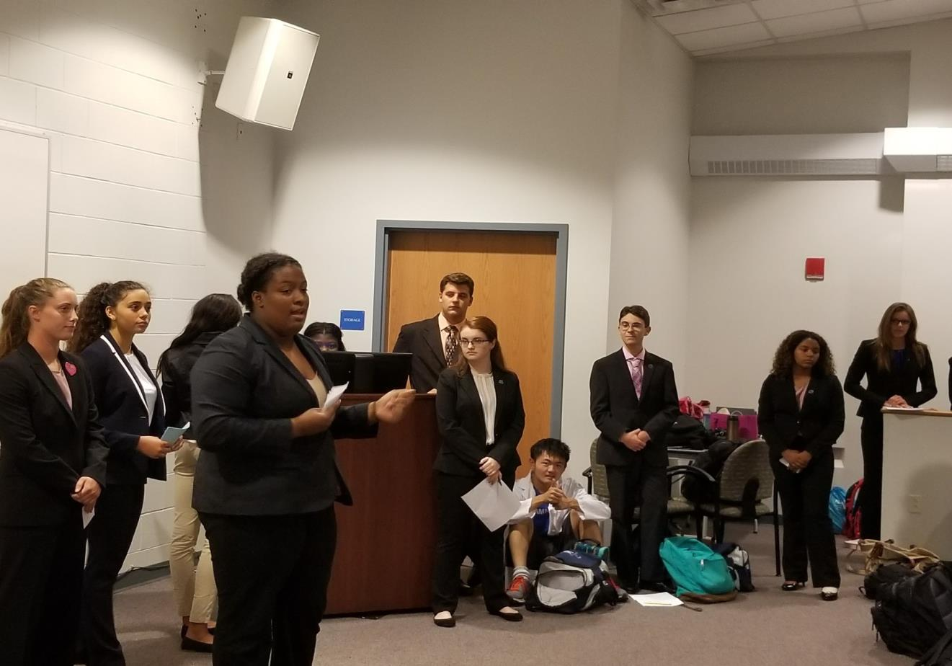

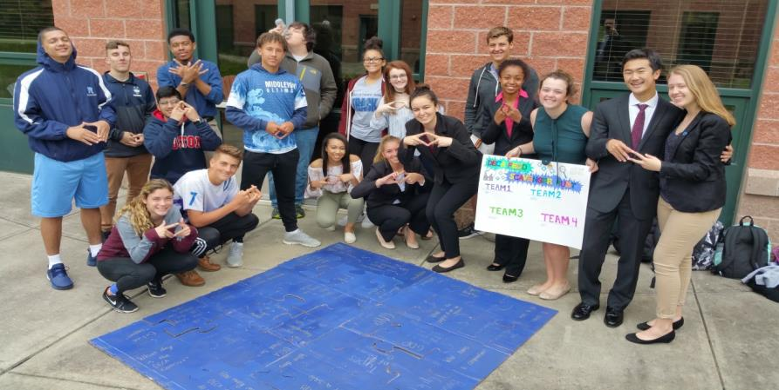

# **SEQUENCE OF COURSES & CREDIT TRANSFER**

9th grade - all students complete a *“Student Success Plan”* or SSP that drives a student towards one of the 16 nationally-recognized career clusters (sample in Appendix)

Our program is a suggested pathway for seven of the 16 pathways.

9th grade and/or 10th grade students may begin in *“Introduction to Business”* and/or *“Sports and Entertainment Marketing.”*

[HERE](https://drive.google.com/file/d/0B4gXeeWd84DZQ256cXVuY2M0azdTSWRCVWE4Y1hoR045bW9R/view) is a link to our school’s program of studies.

11th grade students, as a graduation requirement, either select Personal Finance or our DECA program in a course titled *“Retailing.”* They also are eligible to enter into our Cooperative Work Experience program

Approximately 1/3 of the 11th grade students select to enter our DECA program.

In 12th grade students enter or remain enrolled in DECA and/or Cooperative Work Experience. We have a high retention rate, approximately 85% of students that enter the program continue in the 12th grade.

Approximately 50% of our students compete at the state and international level in curricular DECA competitive events. Over the past six years, approximately 73% of Middletown students competing at the state level earn their way to the stage.

Students are tested annually by the State of Connecticut on state and national Marketing standards. We have been ranked #1 for four consecutive years for student achievement with virtually no demographic achievement gap. We have more students, by far, at/above goal than any of the approximately 55 schools that test (see Appendix)

1. How do you ensure that CTE instruction and coursework is integrated with core academics?

* ***First, CTE instruction is required for graduation in multiple ways. Students must have taken either Personal Finance or complete two years of our Marketing program. Students must earn multiple credits in a CTE course to graduate our high school.***
* ***Second, we have fully aligned our programs with the CCTC or Common Career Technical Core.***
* ***A full 40% of our annual State of Connecticut test of Marketing competency is based on contextual Math and reading standards and so our curriculum has been aligned and supports such. As one example, our instruction frequently reinforces mathematical concepts such as mean, mode, median, break-even, percentages, Excel formulas, and statistics.***
* ***Finally, we have made contextually-based and contextually-applied core academics of mathematics and reading a priority for our programs. Evidence of the success is shown in our annual State of Connecticut CTE exams.***

1. List the opportunities for students to earn articulate and/or transcript dual enrollment credit across K-12 and postsecondary, such as AP/IB, dual and concurrent enrollment, capstone experiences and/or transcripted credit articulation agreements. (250 word limit).

***Our students have access and equitable opportunity to enroll in dozens of Advanced Placement courses either in our physical location or through our educational partnership with the Virtual High School consortium. The 2nd year of our coursework was designed as a Capstone program as students must produce a complete business plan by course-end.***

1. Please provide information on **at least three partnerships** with *education institutions and groups* your program of study has, and describe how these partnerships have been built, maintained and sustained over time. Use this space to specifically address the secondary and postsecondary partners that contribute to and maintain this program of study.

|  |  |  |
| --- | --- | --- |
| **Education Partnership Name** | **What role does this partner have in directly supporting your program of study?** | **How many years has this partnership been active, and how was it developed?** |
| ***DECA Inc.*** | ***DECA is infused in everything we do from the instructional standards to the core values of being academically prepared, community oriented, professional responsible experienced leaders. We attend many local, state and international conference and competitions and students prepare for these rigorously and diligently.*** | ***Almost 40 years! The State of Connecticut used to provide districts seed money to begin Marketing Education programs and that is how our program began.*** |
| ***CT DECA*** | ***DECA is infused in everything we do from the instructional standards to the core values of being academically prepared, community oriented, professional responsible experienced leaders. We attend many local, state and international conference and competitions and students prepare for these rigorously and diligently.*** | ***Almost 40 years! The State of Connecticut used to provide districts seed money to begin Marketing Education programs and that is how our program began.*** |
| ***State Department of Education, Career and Technical Education Department*** | ***This partner provides Carl Perkins grant oversight, professional development, oversees the annual CTE testing, provides recognition to our program, researches and provides the “Performance Standards and Competencies” and provides guest speakers.*** | ***Almost 40 years.*** |
| ***Seasons Federal Credit Union*** | ***This partnership with SFCU provides a bank branch in our building, employment for our students, guest speakers and scholarships.*** | ***10 years.*** |
| ***VHS Consortium*** | ***Through the VHS, students are able to supplement their Marketing education by taking courses, online, that we don’t physically offer. Examples include, but are not limited to, “Entrepreneurship” and “Stock Market.”*** | ***More than 10 years ago we partnered with the Virtual High School Consortium to offer hundreds of courses, in an online format.*** |
| ***Johnson and Wales University*** | ***JWU supports the program through guest speakers, staff to work with our students on presentation skills, attending and participating in our practice competition sessions and providing scholarships to individual students.*** | ***More than 16 years.*** |

# **ALIGNMENT WITH INDUSTRY AND BUSINESS NEEDS**

1. Please describe how your program of study is aligned with the needs of the workforce and industry in your community. Make sure to include information on how the program of study helps meet workforce demand identified by business and industry. If applicable, what labor market data does your program of study use to align to workforce needs? (250 word limit)

***Time and again, when polled, employers cite “Problem Solving” as the #1 desired trait in new hires. Our program is all about problem solving! It is regularly infused in curriculum and assessment that puts an emphasis on solving real-world problems and not just wrote-memorization of vocabulary. Students that participate in the DECA competitions practice and practice and practice problem solving until they can solve dozens of different types of problems with very little preparation.***

***Second, our students are frequently in business attire and either presenting in class, meeting community leaders, networking with industry professionals or attending conferences where they are surrounded by exemplars of professional behavior.***

***Third, our students enrolled in the cooperative work experience component work in real jobs and internships and have a teacher-mentor to aid them in the learning and improvement process.***

1. Are ALL students in the program of study required to participate in a work-based learning opportunity? NO.

***While students are not forced to participate, approximately 30% do participate in our cooperative work experience program.***

1. Please describe the work-based learning opportunities available to students who participate in this program of study. (250 word limit)

***Generally speaking, students work a job, must meet a minimum of 200 hours on the job, and have a workplace mentor (certified Business Education teacher) to track their learning and improvement. Currently we have students in over 30 local businesses that are our cooperative work experience partners. Students get paid a normal wage and earn credits toward graduation.***

1. Please list the industry-recognized credentials/certifications/licenses offered/required. If your program of study does not include industry-based credentials/certifications, please explain why. (200 word limit)

* ***In the second year of our program, virtually all students are required to take the State of Connecticut Career and Technical Education exam of Marketing Concentration (based on state and federal standards and 40% contextually-based Common Core State Standards Reading and Math). Over the past four years, approximately 98% of students tested have earned this and we have had the most students in the state earn this.***
* ***Students that earn a 70 or above on the tests for certain DECA competitive events may apply for and receive the Financial Literacy Certification and/or the Certified Guest Services Professional Certification.***

|  |  |
| --- | --- |
| Offered | Required |
| ***Financial Literacy Certification through w1se*** | ***Marketing Concentrator, State of Connecticut*** |
| ***Certified Guest Services Professional Certification (CGSP)*** |  |

1. Please describe how you ensure the instructors teaching this program of study keep up-to-date on advancements in the workplace, such as participating in externships and/or requirements to have current industry credentials. (100 word limit)

***Staff keeps up-to-date in the following ways:***

* ***Learning opportunities and networking at local, state, and international conferences***
* ***Ongoing professional development provided by the Middletown district (~40 hours annually)***
* ***Annual curriculum reflection, revision and creation***
* ***Professional degree and certification programs***
* ***Membership in the Middlesex Chamber of Commerce (largest Chamber in Connecticut) Business and Industry Advisory Board***

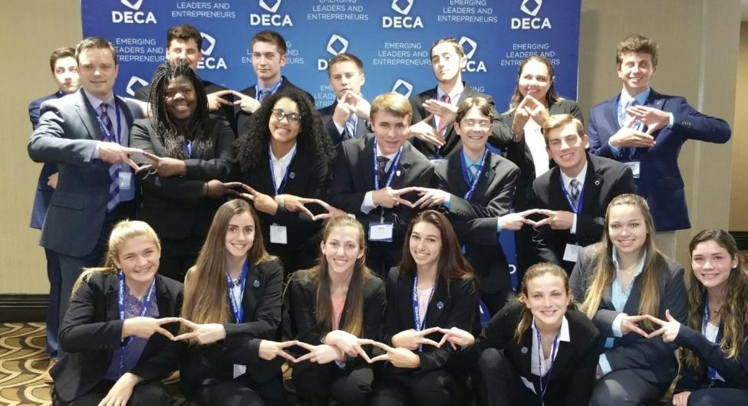

1. Please provide information on **at least three** *business, industry and/or labor* partnerships your program of study has, and describe how these partnerships have been built, maintained and sustained over time.

|  |  |  |
| --- | --- | --- |
| **Business/Industry Name** | **What role does this partner have in directly supporting your program of study?** | **How many years has this partnership been active, and how was this partnership developed?** |
| ***Credit for Life/Liberty Bank*** | ***The “Credit for Life” fair is an all-morning event in which 80-100 community partners volunteer their time, setup booths, prepare budgets, and work with the students through a simulation. In this simulation, the students pretend to be 25 years of age and have financial and career decisions to make before the end of the event.*** | ***10 years, developed when Liberty Bank approached us, due to our community reputation, and wanted to partner.*** |
| ***Middlesex Chamber of Commerce Business and Education Advisory Board*** | ***The board supports our students through advocacy, networking, political and community capital, employment and educational opportunities. Our students also attend speakers and industry-networking breakfast events multiple times per school year. We just became involved with the MEWS or Middletown Entrepreneurial Work Space initiative which provides supports to new entrepreneurs in Middletown.*** | ***We have been partnered with the Middlesex Chamber of Commerce for almost as long as our program has been in existence but just recently became official members of the Advisory Board.*** |
| ***Lyman’s Orchards*** | ***Lyman’s Orchards supports our program through offering a community service opportunity of approximately 300 hours annually. Lyman’s then donates money that helps to offset student expenses for conference, travel and other events to make access more equitable.*** | ***12 years.*** |
| ***Fascia’s Chocolate Factory*** | ***Fascia’s provides tours and presentations to our students regarding the business aspects of a manufacturer in the state of Connecticut.*** | ***2 years.*** |
| ***Men’s Wearhouse*** | ***Men’s Wearhouse provides guest speakers, competitive event and presentation support and practice for our students, coupons and specials for business attire and has donated ties and other items to our students.*** | ***8 years.*** |

1. Please feel free to use the space below to share any other information or evidence of success of your program of study and the students who participate.

***2017 #1 ranked Marketing program, State of Connecticut Department of Education***

***2017 Recognized as a top international DECA chapter at the 2017 International Career Development Conference.***

***2016 #1 ranked Marketing program, State of Connecticut Department of Education***

***2016 Recognized as a top international DECA chapter at the 2016 International Career Development Conference.***

***2015 #1 ranked Marketing program, State of Connecticut Department of Education***

***2015 Recognized as a top international DECA chapter at the 2015 International Career Development Conference.***

***2015 Recognized top school fundraising team, JDRF***

***2014 #1 ranked Marketing program, State of Connecticut Department of Education***

***2014 Recognized as a top international DECA chapter at the 2014 International Career Development Conference.***

***2013 Developmental Asset of the Year, Middletown Youth Services Bureau***

***2013 Recognized as a top international DECA chapter at the 2013 International Career Development Conference.***

***2012 Recognized as a top international DECA chapter at the 2012 International Career Development Conference.***

***2011 Recognized as a top international DECA chapter at the 2011 International Career Development Conference.***

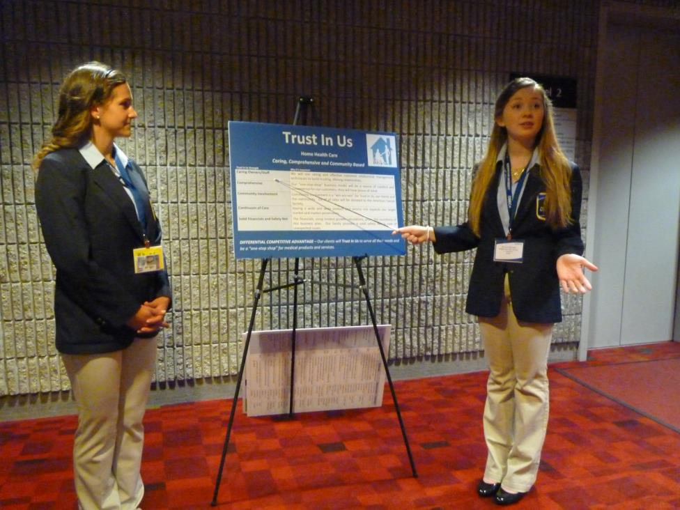

1. If applicable, please provide more detail on any partnerships your program of study has that have not been mentioned already. This includes community groups, non-profits, volunteer organizations, etc. Describe how these partnerships have been built, maintained and sustained over time. (Optional)

|  |  |  |
| --- | --- | --- |
| **Additional Partnerships** | **What role does this partner have in directly supporting your program of study?** | **How many years has this partnership been active, and how was this partnership developed?** |
| ***Elks Club*** | ***“Good business is giving back” and as part of DECA/our mission to be “community oriented” we partner with the Elks Club to put on a free Halloween gala on Halloween night. About 35 of our students dress up and, along with 30-ish community members, host a safe indoor Halloween party.*** | ***Four years running. Middletown DECA has a good reputation in the community and the Elks reached out to me to ask for our help.*** |
| ***JDRF*** | ***“Good business is giving back” and as part of DECA/our mission to be “community oriented” we partner with JDRF each year to collect donations and then walk at Rentschler Field in East Hartford, Connecticut. We typically raise between $1500-$2200 for this worthwhile cause!*** | ***More than 15 years.*** |
| ***MARC Community Resources*** | ***An organization that provides supports for the disabled, our students partnered with MARC to create a comprehensive promotional and public relations plan for this non-profit.*** | ***One year.*** |

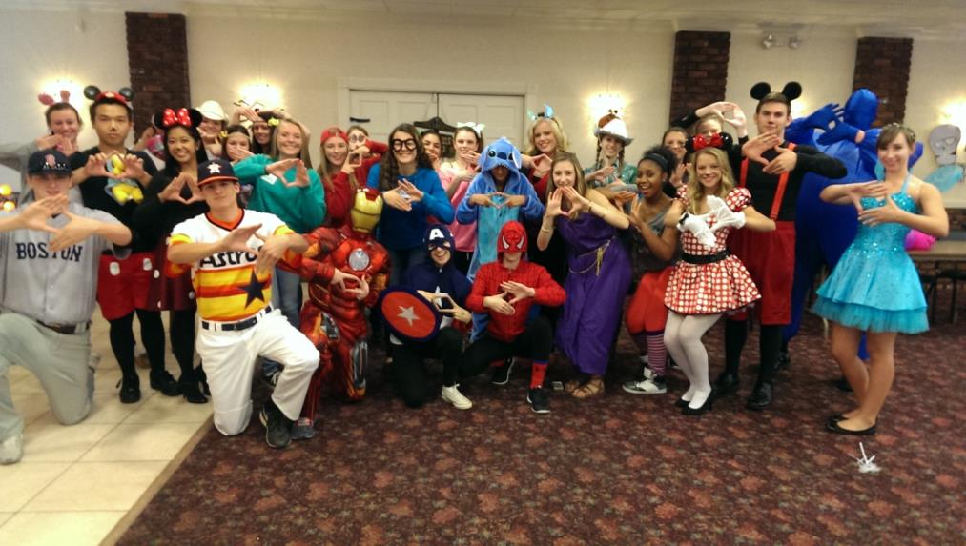***Halloween Community Service, Elks Club***

***JDRF “Walk for a Cure”***

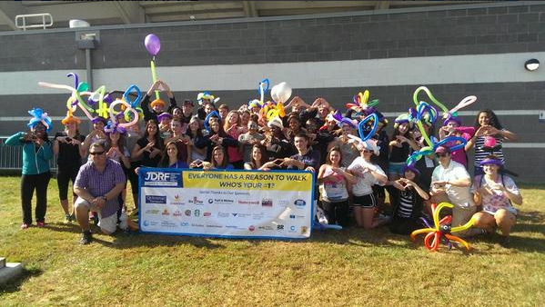

***Video Evidence of Program Excellence – all videos produced by students in the program!***

* [Atlanta International Career Development Conference](https://www.youtube.com/watch?v=eQ6gAgosgnE&t=12s)
* [Anaheim International Career Development Conference](https://www.youtube.com/watch?v=NS8cpHH9zzg&t=29s)
* [Nashville International Career Development Conference](https://www.youtube.com/watch?v=Zqh8G6vO9kY&t=88s)
* [2017 State Competition](https://www.youtube.com/watch?v=MButw4L_4pk)
* [2016 State Competition Event Sweep](https://www.youtube.com/watch?v=O4SqS7dYzes&t=25s)
* [2016 State Competition](https://www.youtube.com/watch?v=U0NPPeNs_kE&t=97s)
* [2016 Washington DC “Power Trip”](https://www.youtube.com/watch?v=BwvzkR74enY)
* [2016 Halloween Community Service](https://www.youtube.com/watch?v=FV7Qyc8k1Sk)
* [2016 Leadership Conference](https://www.youtube.com/watch?v=mjXs3NLz0dw)
* [2016 JDRF “Walk for a Cure” Community Service](https://www.youtube.com/watch?v=7chotiIj7W0)

***Social Media Account, Twitter***

* [Middletown DECA Twitter](https://twitter.com/MiddletownDECA)

***Links to News Articles***

* [May 2017 Article](http://www.middletownpress.com/news/article/Middletown-high-schoolers-place-in-top-20-percent-11757546.php#photo-13686388)
* [March 2017 Article](http://www.middletownpress.com/news/article/Middletown-high-DECA-students-earn-way-to-11759564.php)
* [June 2016 Article](https://twitter.com/shawnbeals/status/739957701875208194)
* [February 2015 Article](http://www.middletownpress.com/news/article/Middletown-High-s-DECA-club-wins-39-awards-11787122.php)
* [May 2015 Article](http://www.middletownpress.com/news/article/Middletown-DECA-students-place-in-worldwide-11787141.php)
* [April 2015 Article](http://www.middletownpress.com/news/article/Middletown-high-schoolers-excel-at-DECA-11806761.php)
* [May 2014 Article](http://www.middletownpress.com/news/article/Middletown-students-place-among-world-s-best-in-11785238.php)
* [April 2013 Article](http://www.middletownpress.com/news/article/Middletown-High-School-students-earn-DECA-awards-11850194.php)
* [March 2013 Article](http://www.middletownpress.com/news/article/Middletown-High-School-DECA-team-takes-home-awards-11849867.php)
* [April 2011 Article](http://www.middletownpress.com/news/article/Middletown-High-School-DECA-team-headed-to-11877931.php)
* [April 2010 Video Article](http://www.middletownpress.com/news/article/WITH-VIDEO-18-DECA-students-at-Middletown-High-11873781.php)
* [April 2009 Article](http://www.middletownpress.com/news/article/MHS-senior-wins-1st-place-in-state-DECA-11890716.php)
* [April 2007 Article](http://www.middletownpress.com/news/article/DECA-students-heading-to-nationals-11886807.php)
* [April 2004 Article](http://www.middletownpress.com/news/article/DECA-students-head-for-Tennessee-11914119.php)
* [April 2003 Article](http://www.middletownpress.com/news/article/Ten-teens-to-compete-in-international-DECA-event-11896813.php)

