# **ADVANCE CTE EXCELLENCE IN ACTION AWARD**

**PROGRAM SUMMARY**

Advance CTE is pleased to announce a call for applications for the fifth annual Excellence in Action awards, through which we recognize and honor superior Career Technical Education (CTE) programs of study from across the nation.   
  
**CRITERIA FOR JUDGING**

Selected programs will exemplify excellence in:

* Implementing Career Cluster®-based [programs of study](https://careertech.org/programs-study);
* Maintaining effective employer and business partnerships;
* Demonstrating alignment to rigorous and relevant college- and career-ready expectations;
* Demonstrating a clear progression of knowledge and skills and student transitions across secondary and postsecondary systems;
* Integrating successful career guidance and advisement;
* Integrating high-quality work-based learning experiences;
* Highlighting alignment to workforce and employer needs in the community; and
* Providing concrete data on the program of study’s impact on student achievement and success at both the secondary and postsecondary levels.

**ELIGIBILITY**

* This award is open to any secondary or postsecondary schools or colleges in the United States. Your school or institution may submit one application per [Career Cluster](http://careertech.org/career-clusters);
* The program of study must have at least one full graduating class;
* Your program must be eligible to receive funding from the Carl D. Perkins Career and Technical Education Act;
* Applications that do not include data to demonstrate positive impact on student achievement will not be eligible for consideration.
* If your program has received in an award in the past, you may not apply for that same Career Cluster. However, your school or institution may apply in a different Career Cluster.

**AWARD SUBMISSION REQUIREMENTS**

Complete applications will contain the following:

* A completed application including supplemental materials by the application deadline of **November 15, 2017 at 5 p.m. ET.**
* At least one letter of support from an employer or business partner supporting the program of study; and
* At least one additional letter of support from a partner (education, community or business) of your choosing.
* *Optional:* Supplemental materials including photos, videos, news articles, etc., are welcome but not required.

The application must be submitted using [this form](https://careertech.org/2018-excellence-action-application). The application must be submitted in a Microsoft Word format. Supplemental materials, including the letters of recommendation, must be combined and submitted as **one** PDF document.

*Please note:*

* Submissions should **not** include any personally identifiable student.
* The application does not have a page limit, however, many questions do have a word limit. Please do not submit responses that go beyond this limit. Also, submissions that do not contain all the required materials (a completed application, two letters of support and supplemental materials in the correct formats) will not be advanced for consideration.

**WINNERS WILL RECEIVE**

* A banner to hang in their school or institution;
* A digital banner to use in email and print materials as they so choose; and
* Travel and one hotel room for one night in Washington, DC for a representative to be recognized at an awards ceremony to be held the week of April 4-6, 2018.

**WINNERS WILL ALSO BE FEATURED IN**

* A national press release, which will be distributed to national media.
* A winner-specific press release to distribute to local media;
* A standalone one-pager;
* A standalone blog on the [Learning that Works blog](http://blog.careertech.org/);
* Representation on the Advance CTE [website](http://www.careertech.org).
* Many past winners have been featured in national conferences, in briefs and reports, on webinars and in the media.

**HOW TO APPLY**

* Fill out the following application.
* Once you have finished, complete [this form](https://careertech.org/2018-excellence-action-application) and upload the following:
* Your full application saved as a Word document (.docx)
* All of your supplemental documents or evidence consolidated as one PDF document.

# **BACKGROUND INFORMATION**

1. Program of study name: Peoria Unified School District’s Fire Science Program of Study
2. Point of Contact  
    Name: Patti Beltram, Ed.D.

Email Address: pbeltram@pusd11.net

Phone Number: 623-412-5333 or 602-882-2817 (cell)  
Address: 6330 W Thunderbird, Glendale, AZ 85306

1. Applicant’s School/College: Sunrise Mountain High School
2. State: Arizona
3. Type of institution (click the box to check)

Area technical center

Career academy

Comprehensive high school

Community college

Technical college

Other (please specify)

|  |
| --- |
|  |

1. Career Cluster in which your program of study should be considered (Follow this link for a further explanation of each Career Cluster [careertech.org/career-clusters](http://careertech.org/career-clusters)) **(Select only ONE):**

Agriculture, Food & Natural Resources Career Cluster

Architecture & Construction Career Cluster

Arts, A/V Technology & Communications Career Cluster

Business Management & Administration Career Cluster

Education & Training Career Cluster

Finance Career Cluster

Government & Public Administration Career Cluster

Health Sciences Career Cluster

Hospitality & Tourism Career Cluster

Human Services Career Cluster

Information Technology Career Cluster

Law, Public Safety, Corrections & Security Career Cluster

Manufacturing Career Cluster

Marketing Career Cluster

Science, Technology, Engineering & Mathematics Career Cluster

Transportation, Distribution & Logistics Career Cluster

1. In three sentences or less, describe your program of study, including the secondary and postsecondary components and how long the program of study has been in place.

Peoria Unified School District’s Fire Science Program was started in 2004 to address the employment needs of the community and train future employees through its stackable credential (See Appendix C in Supplemental Materials) in the Law, Public Safety, Corrections and Security Career Cluster. The Peoria Fire Science program is led by an active duty Peoria Fire Captain, Captain Comella, plus Phoenix Fire Firefighter Chris Meadors, who provide students with stackable credentials - meaning college credit and various industry certifications - to provide students with a head start before applying for the Fire Science Academy. The stackable credential starts with six Industry Credentials; nine (9) dual enrollment credits – (3) dual enrollment credits count toward Glendale Community College (GCC) Certificate of Completion in Fire Science; all nine credits toward an Associates of Science in Emergency Response and Operations in Fire Science; upon completion of Associates transfers to Northern Arizona University (NAU) as 90 credits toward the Bachelors of Science in Fire Science, plus additional pathways include entrance requirements to Fire Science Academy, Emergency Medical Technology (EMT) and Wildland Fire Certification.

1. Please check the geographical and demographic setting for your program of study and describe the geographic and economic conditions of the region served by the school.

Urban

Suburban

Rural

Other   
  
STUDENT POPULATION & DATA

1. Please describe your program of study’s demographic and outcome data for the most recent academic year(s). It is our strong preference to have data from both secondary and postsecondary levels. If this is not available, please provide an explanation as to why the data from the other learner level is not available. Applications that do not include data to support positive impact on student achievement will not be eligible for consideration. (100 word limit)  
     
   The Fire Science Program is located in the Northwest Valley as a suburban community of Phoenix, AZ. The Fire Science program includes students from all seven PUSD high schools, who travel to SMHS for this exemplary program, and has expanded to add an additional instructor for the 2017-2018 school year. From the data table below, students are 90% males, 17% minority (does not include Hispanic-White), 16% low-income students. 100% of seniors pass the state technical assessment, graduate high school, obtain industry certifications and work based learning experiences.

**NOTE**: Please specify if and when you are using a percentage with a different denominator (e.g., seniors) than the one listed.

**When completing the data section, please only use percentages and include data that is from your program of study, not the entire school/institution. Additionally, only include data where students are eligible to participate (e.g., only seniors in high school will be eligible for the section asking for percent of seniors who graduated high school, so only seniors should be included in that data; if your work-based learning only occurs within a specific grade level, only include them in your data for that category.)**

|  |  |  |  |  |  |
| --- | --- | --- | --- | --- | --- |
| SCHOOL YEAR | 2014-15 | | 2015-16 | | 2016-17 |
| **SECONDARY-LEVEL DATA** | | | | | |
| **Total number of students served by your program of study** | *52 | | *47 | | *42 |
| % male students | *96% | | *85% | | *90% |
| % female students | *4% | | *15% | | *10% |
| % minority students | *23% | | *9% | | *17% |
| % low-income students | *0% | | *4% | | *16% |
| % students with disabilities | *2% | | *0% | | *2% |
| % English language learners | *0% | | *0% | | *0% |
| Other relevant *demographic* data | * *84.62% of the students taking both Fire Science classes met or exceed the reading and math standards as measured by the AIMS test. * *90.91% of the students taking both Fire Science classes passed the State Technical Assessment on Fire Science, which was the highest scores in the State of Arizona. * *100% of the graduates were placed in in Fire Science related employment, education, military, or a combination of employment and education. | | * *100% of the students taking both Fire Science classes passed the State Technical Assessment on Fire Science, which was the highest scores in the State of Arizona. * *100% of the graduates were placed in in Fire Science related employment, education, military, or a combination of employment and education. | | * *100% of the students taking both Fire Science classes passed the State Technical Assessment on Fire Science, which was the highest scores in the State of Arizona. * *100% of the graduates were placed in in Fire Science related employment, education, military, or a combination of employment and education. |
| % of students who earned postsecondary credit (dual enrollment, AP, etc.) | *100% | | *100% | | *60% |
| % of students who earned an industry-recognized credential | #100% second year students (25) | | #100% of second year students (16) | | #100% of Second Year Students (12) |
| % of students who participated in work-based learning | ***100% | | ***100% | | ***100% |
| % of seniors who graduated high school (who were eligible/seniors) | *100% | | *100% | | *100% |
| % of graduates who enrolled in postsecondary education (who were eligible/seniors) | *100% | | *100% | | Data being gathered as we speak |
| % of graduates who entered the workplace and/or military (who were eligible/seniors) | **7% | | **7% | | Data being gathered as we speak |
| **POSTSECONDARY-LEVEL DATA** | | | | | |
| **Total number of students served by your program of study** | +56 | | +41 | | +18 |
| % male students | +87.5% | | +82.9% | | +66.7% |
| % female students | +12.5% | | +17.1% | | +33.3% |
| % minority students | +40% | | +41.5% | | +66.6% |
| % low-income students | +Not documented | | +Not documented | | +Not documented |
| % students with disabilities | +Per ADA guidelines, not documented at Institutional level | | +Per ADA guidelines, not documented at Institutional level | | +Per ADA guidelines, not documented at Institutional level |
| % English language learners | +0% | | +0% | | +0% |
| Other relevant *demographic* data | |  |  |  | | --- | --- | --- | | #2014 | SMHS | Phoenix Fire Department | | #2015 | CeHS | Phoenix Fire Department | | | | |  |  |  | | --- | --- | --- | | #2017 | LHS | United States Forest Service | | #2017 | LHS | United States Forest Service | | #2017 | SMHS | US Air Force – Fire Dept | | |
| % of students who completed postsecondary/earned a degree or certificate (who were eligible) | * ++According to Glendale Community College, 58 students have earned college credit in Fire Science during the last three years. | | | Not available – students in first year of program | |
| % of students who earned an industry-recognized credential (who were eligible) | * ++Fifteen (15) Fire Science students completed CCL 5643 – Certificate in Emergency Medical Technology * ++One (1) student completed both the CCL 5643 – Certificate in Emergency Medical Technology and AAS 3112 – Associates in Applied Science in Emergency Response and Operations. | | | Not available – students in first year of program | |
| % of graduates who entered the workplace and/or military (who were eligible) | +Not documented | +Not documented | | Not available – students in first year of program | |
| % of graduates who transitioned to further postsecondary education (who were eligible) | +Not documented | +Not documented | | Not available – students in first year of program | |

1. Provide links to the source of the above data. If the links are not publicly accessible, please explain the source of the data.

The following is a key to the data provided in the above table:

* These data elements are provided to ADE annually for performance measures inclusive of post-secondary, military and workplace. This is an intranet at the Arizona Department of Education called their Data Portal and provided by CTE, Special Education and attendance from districts.

** indicates Peoria Unified School District Fire Science data, the secondary data, was provided through our annual placement survey data instruments disaggregated for Fire Science program. Link is not available, it is a propriety software of PUSD, with student information, that information is provided, but numbers provided to ADE for Performance Measures.

*** Work based learning activities as defined by Arizona Department of Education.

# Data provided from Captain Comella on graduates. Instructor provided the numbers of students who took dual enrollment over the last three years based on his grade roster.

+ Data provided by Glendale Community College Planning & Research Analyst

++Glendale Community College, through Micheile Ujke, provided the post-secondary data above – number of students who obtained Community College Certificate and Associate Degrees.

1. How does your school or institution ensure equitable access and outcomes for students with diverse backgrounds? (150 word limit)

Peoria Unified School District CTE uses the non-discrimination statement on materials (Appendix G, K, L, O). Non-traditional genders and various ethnicities and populations are depicted in pictures for publications (Appendix H, N, O). Peoria CTE encourages students to travel to the high school campus that features unique programs, like Fire Science. Transportation is provided for students, if they do not drive and upon request. During the annual Career Exploration Day and MyLife days, students are encouraged to explore their career. TLC (Technology Life Careers), Peoria Unified School District’s Junior High CTE Program, required for all students seventh and eighth grade students, students take interest inventories and have hands-on experiences in all career clusters.

1. If applicable, what strategies or technologies do you use to close access gaps? (e.g. integrated digital learning, virtual work based learning.)   
     
   The Fire Science program includes students from all seven PUSD high schools, who travel to SMHS for this exemplary program, and has expanded to add an additional instructor for the 2017-2018 school year. Students provide their own transportation to the program, including Saturday classes. The program has targeted non-traditional enrollment of females through workshops, female firefighters visiting classrooms, school bus signs, and female involvement at events like, Career Exploration Day and MyLife Days (see Appendix). Work based learning is explained below on how each student can have an experience.
2. What activities does your school or institution do to recruit elementary, middle, high school students and/or adult learners into the program of study? Please provide examples. (150 word limit)

Peoria Unified School District constantly recruits students to the Fire Science Program of Study. The Peoria CTE Student Guide, distributed to TLC students (all Junior High students), includes all six career fields (Appendix G), Human Resources Career Field (Appendix H), information about the Total CTE Program Model (Appendix F) and the CTE Mastery of Subject Graduation Endorsements (Appendix I). The Fire Science Cut Sheet (Appendix J) and CTE Wheels (Appendix L) are distributed at the Annual Career Exploration Day (Appendix K). TLC Teachers have aligned activities to the guide and the Programs of Study (Appendix C, D, E, O). Peoria has had an event annually for over 20 years now called MyLife Days, where junior high students tour their feeder high schools for hands-on experiences and discover their career options. The CTE Works flyers are sent to parents during CTE Week/Month (Appendix M), plus School Bus Side Ads (Appendix N).

1. Is your program of study associated with a Career Technical Student Organization (CTSO)? If so, which one(s) and in what way(s)? (Check the [approved list](http://www.ctsos.org/ctsos/) of CTSOs) (50 word limit)

Fire Science is affiliated with SkillsUSA. SkillsUSA members create programs of work annually, students participate in Officer Training and conferences. Sunrise Mountain SkillsUSA hosts the Annual Fire Muster where Arizona high school Fire Science Programs compete in drills judged by active-duty Fire Fighters. Students participate in a multitude of community service activities, including Special Olympics events, Senior Adult Outreach Programs, Third Grade Reading Programs, and collecting toys for needy families. Students design and present fire and safety lessons to pre-school classes attending the COOP Programs. Students perform a number of Firefighter I and II skills in preparation for Post-Secondary learning.

1. Describe how career guidance/advisement is integrated into your program of study to support students’ completion of the program of study and entry into additional education/training and/or a successful career. Where applicable, describe the tools (individual career and academic plans, career exploration websites, etc.) that are provided to learners and how they are used. (200 word limit)

Peoria Unified School District’s CTE Director, Patti Beltram, Ed.D. is the Secondary Chair of the Western Maricopa Programs of Study (WMPOS) Consortia, as well as the fiscal agent. In this capacity, Dr. Beltram ensures that the 13 school districts, including Peoria, are included on annual Guidance Counselor training of the Programs of Study. All seven campuses Guidance Departments of the Peoria Unified School District have been represented at the annual WMPOS Training on Programs of Study. Counselors in attendance received a guidance toolkit that included the Arizona Programs of Student Guide, Binder Dividers, general AzPOS postcards, six Career Field postcards, six examples of Stackable Credentials, sample programs of study, student folder, and a fold-out Arizona Programs of Study wheel (Appendix O). The wheel can be used to guide students to their desired career/CTE program. The hostess of this training is one of the guidance counselors from Deer Valley District. Guest Speakers have included Arizona Transfer, and Maricopa County Community College District guidance and dual enrollment coordinators. The Consortia is starting planning for an Arizona Dual Enrollment in partnership with NACEP and MCCCD for April 2018. Please see Appendix O in Supplemental Materials for these information distribution items.

# **COLLEGE- AND CAREER-READY STANDARDS/EXPECTATIONS**

1. Please describe how your program of study was developed and how it ensures students are academically and technically prepared for postsecondary education and careers. Please also address the following:
   1. How were employers involved in the development and/or maintenance of your program of study?
   2. How does this program of study meet the economic needs of your community?
   3. How does this program prepare students for postsecondary education? (if applicable)
   4. How were both secondary and postsecondary educators involved in the development and/or maintenance of the program of study? (500 word limit)

Economic Need of Community: Peoria Unified School District Fire Science program was started to address the employment needs of the community and train future employees. According to the Bureau of Labor Statistics, May 2015 data, Arizona is one of 13 states in highest need of first-line supervisors of firefighting and prevention workers. Arizona needs over 6,000 fire fighters, fire inspectors, supervisors and EMTs. The Peoria Fire Science program is led by an active duty Peoria Fire Captain. Captain Comella provides students with stackable credentials - meaning college credit and various industry certifications - to provide students with a head start before applying for the Fire Science Academy. The program has grown to include a second active duty firefighter from Phoenix, Chris Meadors.

Employer involvement: Fire Science Advisory Council members include the City of Peoria Battalion Chief and representatives from Bureau of Land Management, City of Peoria, Sun City West, City of Buckeye and Daisy Mountain Fire Departments. Glendale Community College instructors round out the Advisory Council membership. These advisory council members, Captain Comella, and Firefighter Meadors provide advice on Arizona CTE State Technical Standards development plus aligned State Technical Assessment questions. The Industry Certifications were determined from this Advisory Council. This program delivers the Peoria CTE Total CTE Program model and is enhanced with industry volunteers who mentor students through the fire fighter physical aptitude test and skills needed to be a Fire Fighter Recruit and prepare them for Post-Secondary Education.

Postsecondary education: GCC Fire Science department was instrumental in approving Captain Comella and Firefighter Meadors for dual enrollment certification and to determine which courses will provide the best alignment to the Certificates of Completion, Associates of Science, Bachelor degree, and the Fire Academy cadets. See program of study section for Fire Academy, plus letters of support.

Program of Study: The Peoria Unified School District Fire Science program prepares its students to transition to the Firefighter Academy by introducing the students to all skills needed to be successful in the academy. Skill based assessments aligned with academy standards are utilized in the sequence of courses. The Firefighter Academy at Glendale Community College is designed for the fire department recruit, includes firefighting skills, equipment, and administrative policies, fire department operations, personnel policies, and International Fire Service Accreditation Congress Practical Skills Testing. The Academy follows the National Fire Protection Association 1001 Professional Firefighter Standards both in the classroom and in extensive hands-on experience, including live fire training. The Academy also includes Firefighter I and II Arizona State Fire Marshal along with IFSAC (International Fire Service Accreditation Congress) testing.

1. Which technical, academic and/or employability skill standards does your program of study incorporate at the secondary and/or postsecondary level and how? (Please list the standards you use and be specific regarding how your program uses industry, national, state and/or locally-developed standards) (250 word limit)

|  |  |
| --- | --- |
| **Standard Types** | **Please list the standards your program of study uses and how it uses them below:** |
| Academic Standards | * Arizona English Language Arts Standards * Arizona Mathematics Standards * Arizona Science Standards |
| Career Cluster or Technical Standards | * Arizona CTE Fire Science Standards * National Incident Management Course Standards |
| Employability Standards | * Arizona Workplace Employability Standards/Professional Standards |
| Other | * Bloodborne Pathogens * First Aid * CPR * Wildland Fire * GCC Fire Academy * GCC Dual Enrollment toward Certificates and AAS |

# **SEQUENCE OF COURSES & CREDIT TRANSFER**

1. Please fill out the chart below, and describe your program of study’s course sequence by grade level, including the relevant or required academic and technical courses, as well as other required activities.   
     
   Make sure to highlight the course sequence that bridges secondary and postsecondary education, and explain how your program of study ensures students gain the broader Career Cluster-level knowledge/skills and, over time, gain the more specific occupation-level knowledge/skills as they progress through the program of study. You can also include graphics or [plans of study](http://careertech.org/sites/default/files/PlanStudy-CareerCluster-AG_0.pdf) of the course sequence in lieu of filling out the chart below.

Below please find the coherent sequence of secondary and post-secondary courses for the Fire Science Program – this is GCC Associates of Science in Emergency Response and Operations in Fire Science (Option 3 below):

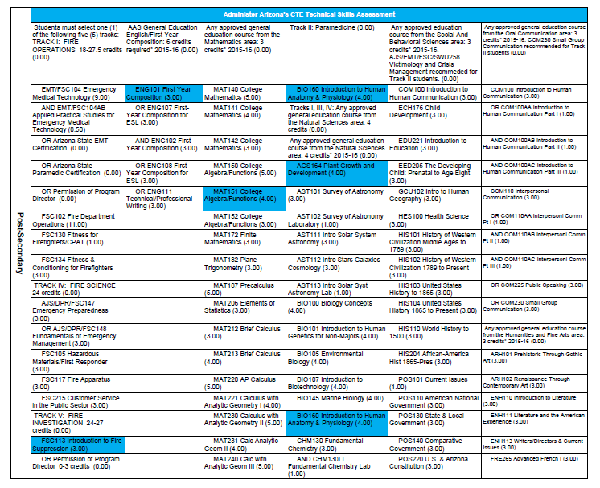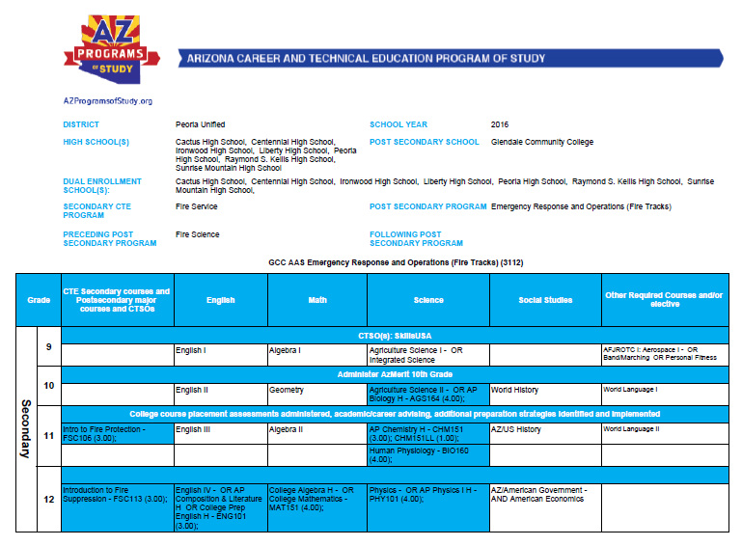

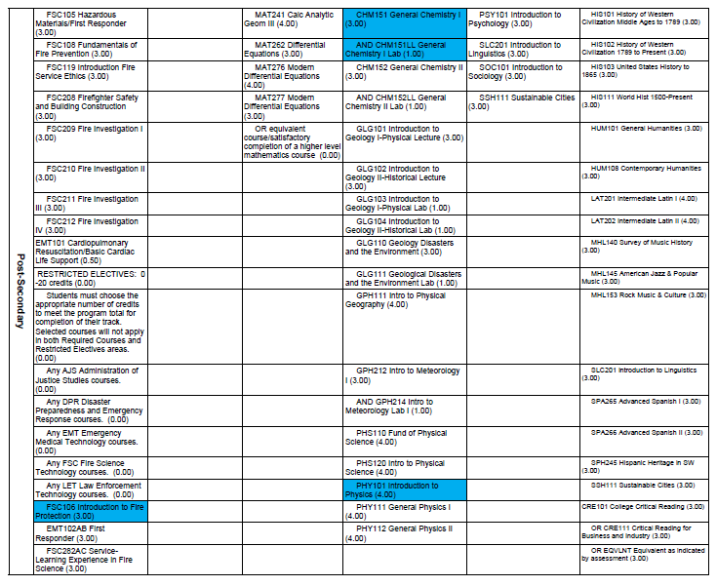

This is the stackable credential graphic for Fire Science and following the graphic is an explanation.

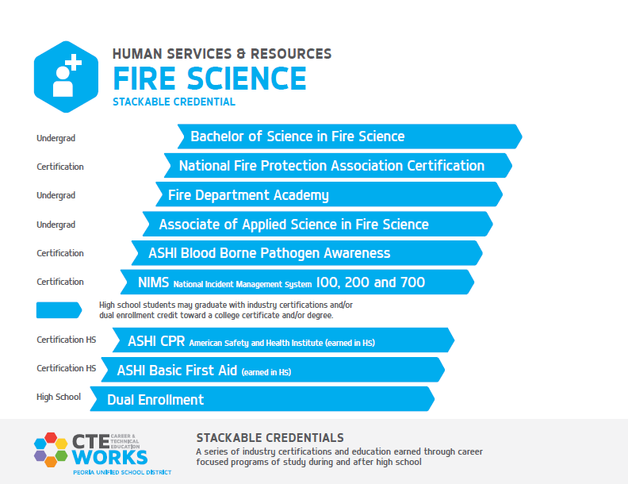

The following are the course of study:

* Grades 7-8: Technology Life Careers (TLC) is a career exploratory junior high school CTE program required for all 7th and 8th grade students to expose them to all six Career Fields (Appendix G) through the Total CTE Program Model (see Appendix F)
* Medical Science (Sophomore year) is highly recommended
* Introduction to Fire Suppression (Junior year)
  + Dual Enrollment = FSC113 Introduction to Fire Suppression (3 credits) at GCC
* Introduction to Fire Selection (Senior year)
  + Dual Enrollment = FSC106 Introduction to Fire Protection (3 credits) at GCC
  + Dual Enrollment = FSC110 Wildland Firefighter (3 credits) at GCC
  + Bloodborne Pathogens Certification
  + First Aid Certification
  + CPR Certification
* CTE Internship – Fire Science (Senior year)
* **Option 1:** Wildland Fire
  + 3 credits obtained through Fire Science Program through GCC
  + National Wildfire Coordinating Group (NWGC) Firefighter I and II standards are taught to students along with National Incident Management Courses (NIMS) which are required to gain employment as a wildland firefighter. This prepares the students for a career with the United States Forest Service, Bureau of Land Management and National Park Service.
* **Option 2**: GCC Certificate of Completion in Fire Science (5486 Major Code) 24 credits (Appendix D)
  + 3 of 24 credits obtained through Fire Science Program as dual enrollment
* **Option 3:** GCC Associates of Science in Emergency Response and Operations in Fire Science (3112 Major Code) 60-83.6 credits
  + 9 credits obtained through Fire Science Program **and/or** the Completion of the 24 credits of the Certificate of Completion in Fire Science
  + 11 credits obtained through core classes
* **Option 4:** Fire Academy
  + The Peoria Unified School District Fire Science program prepares its students to transition to the Firefighter Academy by introducing the students to all skills needed to be successful in the academy. Skill based assessments aligned with academy standards are utilized in the sequence of courses.
  + The Firefighter Academy at Glendale Community College is designed for the fire department recruit. Includes firefighting skills, equipment, and administrative policies, fire department operations, personnel policies, and International Fire Service Accreditation Congress Practical Skills Testing. The Academy follows the National Fire Protection Association 1001 Professional Firefighter Standards both in the classroom and in extensive hands-on experience, including live fire training. The Academy also includes Firefighter I and II Arizona State Fire Marshal along with IFSAC (International Fire Service Accreditation Congress) testing**.**
* **Option 5:** EMT through WestMEC (Joint Technical Education District) (see Appendix E)
  + Students can obtain the Certificate in EMT through WestMEC and GCC
  + Then this certificate is also embedded into the AAS in EMT through WestMEC and GCC
* **Option 6**: Bachelors of Science in Fire Science from NAU
  + Students can transfer the AAS in Fire Science to NAU as 90 credits toward BAS and finish 30 credits at NAU for BAS.

1. How do you ensure that CTE instruction and coursework is integrated with core academics?

Both instructors participate in Peoria CTE Professional Development. Instruction is provided during district-wide professional development and Modified Mondays on how to ensure alignment with Arizona core standards – Language Arts, Mathematics and Science. During advisory council meetings that focus on curriculum, our business partners highlight activities where students are to use written skills for reports, verbal skills to talk to patients and community members, math skills in muster skills, science skills are naturally a part of NIMs course work. Please see question 21 for connections to core classes needed for degrees and question 18 for certificate.

1. List the opportunities for students to earn articulate and/or transcript dual enrollment credit across K-12 and postsecondary, such as AP/IB, dual and concurrent enrollment, capstone experiences and/or transcripted credit articulation agreements. (250 word limit)

The program offers nine (9) dual enrollment credits through Glendale Community College.

* Introduction to Fire Suppression (Junior year)
  + Dual Enrollment = FSC113 Introduction to Fire Suppression (3 credits)
* Introduction to Fire Selection (Senior year)
  + Dual Enrollment = FSC106 Introduction to Fire Protection (3 credits)
  + Dual Enrollment = FSC110 Wildland Firefighter (3 credits)
* CTE Internship – Fire Science is capstone Work Based Learning Experience for the Fire Science Program
* **Option 1:** Wildland Fire
  + 3 credits obtained through Fire Science Program
  + National Wildfire Coordinating Group (NWGC) Firefighter I and II with National Incident Management Courses (NIMS)
* **Option 2**: GCC Certificate of Completion in Fire Science (5486 Major Code) 24 credits (Appendix D)
  + 3 of 24 credits obtained through Fire Science Program as dual enrollment
* **Option 3:** GCC Associates of Science in Emergency Response and Operations in Fire Science (3112 Major Code) 60-83.6 credits
  + 9 credits obtained through Fire Science Program **and/or** the Completion of the 24 credits of the Certificate of Completion in Fire Science, plus 11 credits obtained through core classes
* **Option 4:** Fire Academy
  + The Firefighter Academy at Glendale Community College is designed for the fire department recruit and follows the National Fire Protection Association 1001 Professional Firefighter Standards. The Academy also includes Firefighter I and II Arizona State Fire Marshal along with IFSAC (International Fire Service Accreditation Congress) testing**.**
* **Option 5:** EMT through WestMEC (Joint Technical Education District) (see Appendix E)
* **Option 6**: Bachelors of Science in Fire Science from NAU

1. Please provide information on **at least three partnerships** with *education institutions and groups* your program of study has, and describe how these partnerships have been built, maintained and sustained over time. Use this space to specifically address the secondary and postsecondary partners that contribute to and maintain this program of study.

|  |  |  |
| --- | --- | --- |
| Education Partnership Name | What role does this partner have in directly supporting your program of study? | How many years has this partnership been active, and how was this partnership developed? |
| Maricopa County Community College District – Coordinating College is Glendale Community College | Serves on the CTE Fire Science Advisory Council. Coordinates the Dual Enrollment for the program including certifying the teacher of their eligibility to teach Dual Enrollment and coordinates the Associates Degree program for students. Coordinates partnership with Arizona Universities. Post-Secondary Partner on Rigorous Programs of Study Grant. GCC certifies instructor, shares facility, curriculum advice, certification advice, stackable credential advice, etc. | * This partnership has been active for over 12 years * The partnership started with the CCTI grant, continued through mutual strategic planning and advisory councils and continues for the benefit of students – shares facilities, GCC facility for Saturday classes and drills and dual enrollment. |
| Glendale Community College Firefighter Academy | Serves on the CTE Fire Science Advisory Council. Prepares graduates for Fire Science careers. | This partnership has been active for over 12 years |
| Arizona Programs of Study | Support Stackable Credentials for all programs of studies in Arizona. Has had Peoria present to CTE Local Directors. | Since 2012 AzPOS provides information dissemination materials and collaboration day resources. |
| Arizona Department of Education | Supports CTE Fire Science Program of Study and Stackable Credentials. | Over 50 years, ADE CTE has provided state blocked grants and fiscal overlook of Perkins funds. ADE CTE manages the updating of the standards with industry partners, plus the administration of the State Technical Assessments. |
| West-MEC (Western Maricopa Education Center) | * Peoria CTE is a Satellite District for West-MEC, a Joint Technical Education District (JTED). Through West-MEC funds, Fire Science has specialized equipment, supplies and supports stipends for teachers. * WestMEC provides the EMT courses as con-current enrollment with GCC and Peoria District for students to obtain EMT AAS and BAS. | Since 2003 Arizona voters agreed to a JTED to expand CTE options to students. |

# **ALIGNMENT WITH INDUSTRY AND BUSINESS NEEDS**

1. Please describe how your program of study is aligned with the needs of the workforce and industry in your community. Make sure to include information on how the program of study helps meet workforce demand identified by business and industry. If applicable, what labor market data does your program of study use to align to workforce needs? (250 word limit)

Peoria Unified School District Fire Science program was started to address the employment needs of the community and train future employees. According to the Bureau of Labor Statistics, May 2015 data, Arizona is one of 13 states in highest need of first-line supervisors of firefighting and prevention workers. Arizona needs over 6,000 fire fighters, fire inspectors, supervisors and EMTs. The Peoria Fire Science Advisory Council constantly assesses the need for additional standards, revising standards and what skills students will need to be successful in the workforce. The advisory council members provide constant feedback for student Industry Certifications, Certificates, Associates of Science degrees and Bachelor of Science degrees. The Fire Science Advisory Council provides work based learning experiences for students so they can decide what part of Fire Science is the best fit – Firefighter, EMT, Wildland Fire, etc.

Both instructors are still Fire Fighters – Captain Comella is with City of Peoria Fire Department and Fire Fighter Meadors is with City of Phoenix Fire Department. Since they are still on active duty, they maintain fire department standards, networks of professionals to assist with instruction and work based learning experiences.

1. Are ALL students in the program of study required to participate in a work-based learning opportunity? YES or NO.

Not required, but 100% do participate in CTE Internship – Fire Science – and obtain a minimum of 100 hours of unpaid work experience. 100% of students participate in work based learning experiences – fire muster, simulations, GCC fire jumps, projects, etc.

1. Please describe the work-based learning opportunities available to students who participate in this program of study. (250 word limit)

CTE Internship – Fire Science is a capstone class in this program.

* The pre-requisites for the course are minimum of 1 credit in the Fire Science program; ability to provide own transportation to internship site.
* Course description: This course is a coordinated occupational employment approach to teaching and practicing the concepts in the industry. This course helps the student to practice and improve employability skills in the industry.
* Students participate in a minimum of 100 hours of unpaid internship, job shadow and/or projects including:
  + Internships with Fire Departments
  + Participate in ride-alongs with fire departments
  + Alarm Room Headquarters Job Shadow

Work based learning experiences in Introduction to Fire Suppression and Introduction to Fire Service Selection include:

* Community Service Activities:
  + Volunteer at Special Olympics Events
  + Assist with state mandated CPR Training for all Freshman students
  + Volunteer with the City of Peoria Senior Adult Program
  + Teach fire and life safety skills to COOP programs at three high schools
* Hands on training and scenarios with active Firefighters:
  + Vehicle Extrication
  + Hose Lays
  + Physical Training
  + Rope Rescue
  + Wildland Firefighting
* Departmental functions, interdepartmental relationships, management of buildings and equipment and techniques of fire fighting will also be emphasized. Plus, written application processes, requirements, preparations of resumes and their effect on employment prospects.
* Preparation for the interview is to include communication skills, mental preparation techniques, behaviors and the importance of the interview in the pre-employment process.
* SkillsUSA standards will be an integral part of this class.

1. Please list the industry-recognized credentials/certifications/licenses offered/required. If your program of study does not include industry-based credentials/certifications, please explain why. (200 word limit)

|  |  |
| --- | --- |
| **Offered, but not Required of program** | **Required Certifications part of program** |
| * The Wildland Firefighter course (S130/S190) * Candidate Physical Ability Test (CPAT) | * Bloodborne Pathogens Certification * First Aid Certification * CPR Certification * NIMS 100 * NIMS 200 * NIMS 700.A |

Students can earn the following Industry Certifications:

* Bloodborne Pathogens Certification
* First Aid Certification
* CPR Certification
* National Incident Management System (NIMS 100) is an introduction to the Incident Command System and provides the foundation for higher level ICS training - history, features and principles, and organizational structure of the Incident Command System. The Emergency Management Institute developed with National Wildfire Coordinating Group (NWCG), U.S. Department of Agriculture, United States Fire Administration’s National Fire Programs Branch
* NIMS 200 - enable personnel to operate efficiently during an incident or event within the Incident Command System.
* NIMS 700.A - introduces and overviews the NIMS – a consistent nationwide template to enable all government, private-sector, and nongovernmental organizations to work together during domestic incidents.
* The Wildland Firefighter course (S130/S190) - entry level course to become a Wildland Firefighter and upon successful completion allows the student to apply for jobs with the US Forest Service, Bureau of Land Management, National Park Service and fire departments with Wildland Firefighting teams.  This portion is taught by industry professionals from the Forest Service with 8-hours hands-on scenario based exercises.
* Candidate Physical Ability Test (CPAT) is the entry level physical fitness test required by most fire departments at time of application.

1. Please describe how you ensure the instructors teaching this program of study keep up-to-date on advancements in the workplace, such as participating in externships and/or requirements to have current industry credentials. (100 word limit)

Captain Danny Comella and Firefighter Chris Meadors are active duty Firefighters for the City of Peoria and City of Phoenix, respectively. Firefighter Meadors is also a certified Peer Fitness Trainer with his department, including pre-academy fitness training. They stay current with their Fire Department, participate in Peoria CTE Total CTE Teacher Program Plan, an optional professional development program for delivering the Total CTE Program Model to his students. Both participate in Fire Science Advisory Council meetings and all Peoria CTE Professional Development activities.

1. Please provide information on **at least three** *business, industry and/or labor* partnerships your program of study has, and describe how these partnerships have been built, maintained and sustained over time.

|  |  |  |
| --- | --- | --- |
| Business/Industry Name | What role does this partner have in directly supporting your program of study? | How many years has this partnership been active, and how was this partnership developed? |
| City of Peoria Fire Department | * Provides Advisory Council members * Assists in Skills check-offs in the classroom * In-kind donations of time of fire fighters * Donated a fire truck, 30 turn-outs, and 30 SCBAs * Curriculum recommendations * Internship opportunities | City of Peoria Fire Department has been a partner for over 20 years and provided the first instructors to the Fire Science department and has been maintained partnership with current instructor. |
| Bureau of Land Management | * Provides Advisory Council members * Curriculum recommendations | For the last 10 years, through the instructor, the Bureau of Land Management provides curriculum resources for the instructor. |
| Sun City West Fire Department | * Provides Advisory Council members * Curriculum recommendations | For the last 10 years, through the instructor, the Fire Department provides curriculum resources for the instructor. |
| Buckeye Fire Department | * Provides Advisory Council members * Curriculum recommendations | For the last 10 years, through the instructor, the Fire Department provides curriculum resources for the instructor. |
| Daisy Mountain Fire Department | * Provides Advisory Council members * Curriculum recommendations | For the last 10 years, through the instructor, the Fire Department provides curriculum resources for the instructor. |
| Phoenix Fire Department | * Provides Advisory Council members * Curriculum recommendations | For the last 10 years, through the instructor, the Fire Department provides curriculum resources for the instructor. |
| Surprise Fire Department | * Provides Advisory Council members * Curriculum recommendations | For the last 10 years, through the instructor, the Fire Department provides curriculum resources for the instructor. |
| Glendale Fire Department | * Provides Advisory Council members * Curriculum recommendations | For the last 10 years, through the instructor, the Fire Department provides curriculum resources for the instructor. |
| PMT Ambulance | * Provides Advisory Council members * Curriculum recommendations | For the last 10 years, through the instructor, the ambulance personnel provides curriculum resources for the instructor. |
| APE Academy | * Provides Firefighter Training Sessions * Provides Candidate Physical Ability Test (CPAT) – entry level fitness test | For the last two years provides resources for the instructors. |

1. Please feel free to use the space below to share any other information or evidence of success of your program of study and the students who participate. (Optional)

Of the 45 placements from the 2013-2015 graduation class:

* 25 attending GCC.
* One student attended Gateway Community College,
* One attended Mesa Community College,
* Two students attended Paradise Valley Community College – Sisters Colleges in the Maricopa County Community College District.
* Four students went directly to NAU.
* One student attended each of these post-secondary institutions:
  + Grand Canyon University,
  + Arizona Christian University,
  + University of Arizona,
  + Arizona State University,
  + Western Illinois University, and
  + six students attended Coconino Community College
* One student is at the Phoenix Fire Department Academy
* Three students from the class of 2017 assigned to wildfires in the state of California.

Some of the locations our graduates are working include, but not limited to:

* Buckeye Fire Department
* Flagstaff Hot Shots
* Glendale Fire Department
* Paramedics Unlimited
* Peoria Fire Department
* Phoenix Fire Department
* Prescott Fire Department
* PMT Ambulance
* Surprise Fire Department
* Tonto National Forest
* Department of Public Safety
* United States Forest Service

|  |  |  |
| --- | --- | --- |
| Graduate Year | PUSD High School | Employment |
| 2005 | SMHS | Peoria Fire Department |
| 2005 | SMHS | Peoria Fire Department |
| 2006 | SMHS | Phoenix Fire Department |
| 2007 | SMHS | Phoenix Fire Department |
| 2008 | Peoria | Prescott Fire Department |
| 2008 | SMHS | Peoria Fire Department |
| 2010 | CeHS | Glendale Fire Department |
| 2010 | Peoria | Surprise Fire Department |
| 2010 | SMHS | Phoenix Fire Department |
| 2011 | Cactus | Glendale Fire Department |
| 2011 | Peoria | Phoenix Fire Department |
| 2011 | SMHS | Phoenix Fire Department |
| 2011 | SMHS | Phoenix Fire Department |
| 2011 | SMHS | Peoria Fire Department |
| 2011 | SMHS | Department of Public Safety |
| 2012 | Cactus | US Forest Service |
| 2012 | Cactus | US Forest Service |
| 2012 | Cactus | US Forest Service |
| 2012 | Liberty | Phoenix Fire Department |
| 2012 | Liberty | Phoenix Fire Department |
| 2012 | SMHS | Phoenix Fire Department |
| 2012 | SMHS | Phoenix Fire Department |
| 2012 | SMHS | Phoenix Fire Department |
| 2013 | SMHS | Phoenix Fire Department |

1. If applicable, please provide more detail on any partnerships your program of study has that have not been mentioned already. This includes community groups, non-profits, volunteer organizations, etc. Describe how these partnerships have been built, maintained and sustained over time. (Optional)

|  |  |  |
| --- | --- | --- |
| **Additional Partnerships** | **What role does this partner have in directly supporting your program of study?** | **How many years has this partnership been active, and how was this partnership developed?** |
| City of Peoria Adaptive Recreation Program | Allow students to participate in Special Olympics Events as monitors, judges and event set up/tear down. | 3 years active partnership. Partnership was developed out of need for special olympics volunteers. |
| Peoria Firefighter Charities | Allows students to participate in community service activities such as reading programs, toys for tots and senior adult programs. | 10 years active partnership. Partnership was developed to expose students to opportunities with firefighters and be active in their community. |

# **SUBMIT YOUR APPLICATION**

**SUBMIT YOUR APPLICATION**

* Fill out this application.
* Once you have finished, complete [this form](https://careertech.org/2018-excellence-action-application) and upload the following:
* Your full application saved as a Word document (.docx)
* All of your supplemental documents or evidence consolidated as one PDF document.

**THANK YOU!**

Thank you for completing this application! The selection committee will convene in December 2017 to review the applications and make final decisions. You will know the status of your application by January 25, 2018. The programs of study will be evaluated based on their effective leveraging of partnerships, alignment to rigorous and relevant college- and career-ready expectations, clear progression of knowledge and skills across secondary and postsecondary systems, integration of successful career guidance/advisement, and key indicators of student success.

Don’t forget to use the Excellence in Action award submission checklist to make sure you’ve completed your application in its entirety.

We look forward to learning more about your program!

For questions, concerns please contact [awards@careertech.org](mailto:awards@careertech.org).