# **ADVANCE CTE EXCELLENCE IN ACTION AWARD**

**PROGRAM SUMMARY**

Advance CTE is pleased to announce a call for applications for the fifth annual Excellence in Action awards, through which we recognize and honor superior Career Technical Education (CTE) programs of study from across the nation.   
  
**CRITERIA FOR JUDGING**

Selected programs will exemplify excellence in:

* Implementing Career Cluster®-based [programs of study](https://careertech.org/programs-study);
* Maintaining effective employer and business partnerships;
* Demonstrating alignment to rigorous and relevant college- and career-ready expectations;
* Demonstrating a clear progression of knowledge and skills and student transitions across secondary and postsecondary systems;
* Integrating successful career guidance and advisement;
* Integrating high-quality work-based learning experiences;
* Highlighting alignment to workforce and employer needs in the community; and
* Providing concrete data on the program of study’s impact on student achievement and success at both the secondary and postsecondary levels.

**ELIGIBILITY**

* This award is open to any secondary or postsecondary schools or colleges in the United States. Your school or institution may submit one application per [Career Cluster](http://careertech.org/career-clusters);
* The program of study must have at least one full graduating class;
* Your program must be eligible to receive funding from the Carl D. Perkins Career and Technical Education Act;
* Applications that do not include data to demonstrate positive impact on student achievement will not be eligible for consideration.
* If your program has received in an award in the past, you may not apply for that same Career Cluster. However, your school or institution may apply in a different Career Cluster.

**AWARD SUBMISSION REQUIREMENTS**

Complete applications will contain the following:

* A completed application including supplemental materials by the application deadline of **November 15, 2017 at 5 p.m. ET.**
* At least one letter of support from an employer or business partner supporting the program of study; and
* At least one additional letter of support from a partner (education, community or business) of your choosing.
* *Optional:* Supplemental materials including photos, videos, news articles, etc., are welcome but not required.

The application must be submitted using [this form](https://careertech.org/2018-excellence-action-application). The application must be submitted in a Microsoft Word format. Supplemental materials, including the letters of recommendation, must be combined and submitted as **one** PDF document.

*Please note:*

* Submissions should **not** include any personally identifiable student.
* The application does not have a page limit, however, many questions do have a word limit. Please do not submit responses that go beyond this limit. Also, submissions that do not contain all the required materials (a completed application, two letters of support and supplemental materials in the correct formats) will not be advanced for consideration.

**WINNERS WILL RECEIVE**

* A banner to hang in their school or institution;
* A digital banner to use in email and print materials as they so choose; and
* Travel and one hotel room for one night in Washington, DC for a representative to be recognized at an awards ceremony to be held the week of April 4-6, 2018.

**WINNERS WILL ALSO BE FEATURED IN**

* A national press release, which will be distributed to national media.
* A winner-specific press release to distribute to local media;
* A standalone one-pager;
* A standalone blog on the [Learning that Works blog](http://blog.careertech.org/);
* Representation on the Advance CTE [website](http://www.careertech.org).
* Many past winners have been featured in national conferences, in briefs and reports, on webinars and in the media.

**HOW TO APPLY**

* Fill out the following application.
* Once you have finished, complete [this form](https://careertech.org/2018-excellence-action-application) and upload the following:
* Your full application saved as a Word document (.docx)
* All of your supplemental documents or evidence consolidated as one PDF document.

# **BACKGROUND INFORMATION**

1. Program of study name: CCC-World of Speed Automotive Services Program of Study
2. Point of Contact  
    Name: Cynthia Risan

Email Address: cynthiar@clackamas.edu

Phone Number: 503-594-3440  
Address: 19600 Molalla Ave., Oregon City, Or.

1. Applicant’s School/College: Clackamas Community College
2. State: Oregon
3. Type of institution (click the box to check)

Area technical center

Career academy

Comprehensive high school

Community college

Technical college

Other (please specify)

|  |
| --- |
|  |

1. Career Cluster in which your program of study should be considered (Follow this link for a further explanation of each Career Cluster [careertech.org/career-clusters](http://careertech.org/career-clusters)) **(Select only ONE):**

Agriculture, Food & Natural Resources Career Cluster

Architecture & Construction Career Cluster

Arts, A/V Technology & Communications Career Cluster

Business Management & Administration Career Cluster

Education & Training Career Cluster

Finance Career Cluster

Government & Public Administration Career Cluster

Health Sciences Career Cluster

Hospitality & Tourism Career Cluster

Human Services Career Cluster

Information Technology Career Cluster

Law, Public Safety, Corrections & Security Career Cluster

Manufacturing Career Cluster

Marketing Career Cluster

Science, Technology, Engineering & Mathematics Career Cluster

Transportation, Distribution & Logistics Career Cluster

1. In three sentences or less, describe your program of study, including the secondary and postsecondary components and how long the program of study has been in place.

The Clackamas Community College-World of Speed Automotive Services program began in the Fall of 2015 as a credit recovery program for two nearby high schools. The high schools asked the World of Speed Museum to provide a facility for Clackamas Community College instructors to provide college level automotive services courses to high school students. There are now 10 high schools that send students to take college courses at the World of Speed. Students receive college level course instruction and a college transcript when they complete the courses. Completing the courses leads to advanced standing in the Clackamas Community College Automotive Services AAS degree.

1. Please check the geographical and demographic setting for your program of study and describe the geographic and economic conditions of the region served by the school.

Urban

Suburban

Rural

Other

Geographic and Economic conditions of the region served by the school.

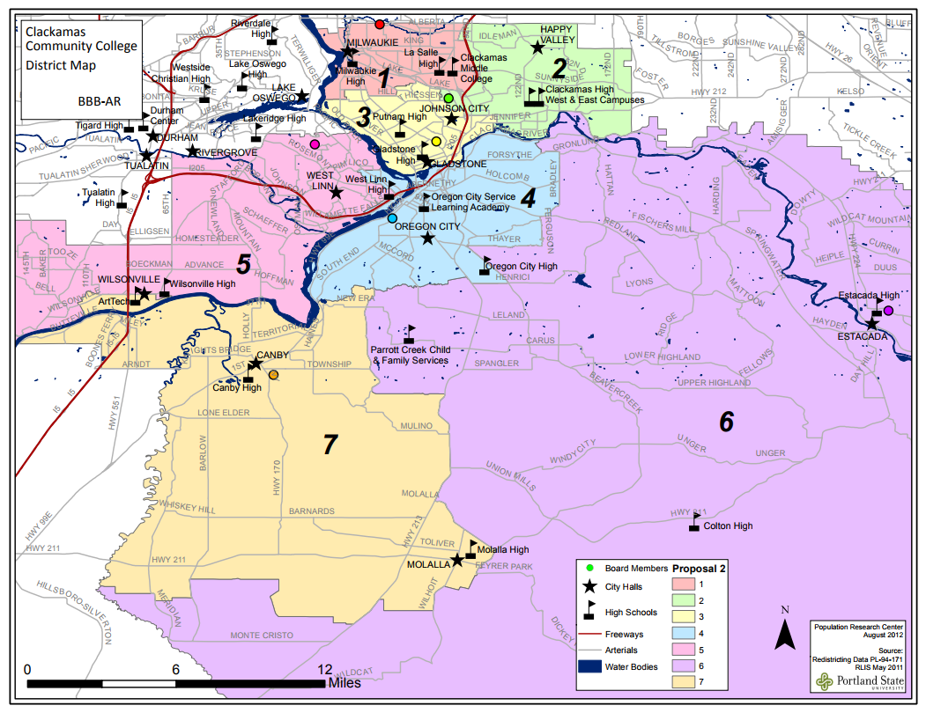

The Clackamas Community College District Map (above) highlights the geographic area served by the College. The College has campuses in Oregon City, Wilsonville, and Harmony (Milwaukie). The World of Speed is located in Wilsonville, which is part of the College’s district. The College’s district encompasses a large area and contains urban, suburban, and rural areas. West Linn, which is located in the College’s district, is an affluent suburb of Portland. Of the approximately 400,00 district residents, 89% are white, with an 8.4% Latino population. The District’s economy is based on manufacturing, healthcare, technology, and construction industries. Although Clackamas County figures indicate that the overall poverty figure for the county is 9.4%, the presence of West Linn, an affluent suburb of Portland, skews the figure significantly.

Even though the World of Speed is located in Clackamas County, students from 10 different high schools attend automotive services classes there. Roughly half of the high schools that send students to this program are not in the College’s service district. The World of Speed Museum is located close enough to the out of district high schools to allow students to be bussed to the World of Speed for classes. All participating high schools have some students that are on free and reduced lunches.

# **STUDENT POPULATION & DATA**

1. Please describe your program of study’s demographic and outcome data for the most recent academic year(s). It is our strong preference to have data from both secondary and postsecondary levels. If this is not available, please provide an explanation as to why the data from the other learner level is not available. Applications that do not include data to support positive impact on student achievement will not be eligible for consideration. (100 word limit)

**NOTE**: Please specify if and when you are using a percentage with a different denominator (e.g., seniors) than the one listed.

**When completing the data section, please only use percentages and include data that is from your program of study, not the entire school/institution. Additionally, only include data where students are eligible to participate (e.g., only seniors in high school will be eligible for the section asking for percent of seniors who graduated high school, so only seniors should be included in that data; if your work-based learning only occurs within a specific grade level, only include them in your data for that category.)**

|  |  |  |  |
| --- | --- | --- | --- |
| SCHOOL YEAR | 2014-15 | 2015-16 | 2016-17 |
| **SECONDARY-LEVEL DATA** | | | |
| **Total number of students served by your program of study** | No data for this year | 112 | 162 |
| % male students | % | 91% | 92% |
| % female students | % | 9% | 8% |
| % minority students | % | 6.25% | 36% |
| % low-income students | % | unknown% | unknown % |
| % students with disabilities | % | unknown % | unknown % |
| % English language learners | % | unknown % | unknown % |
| Other relevant *demographic* data |  |  |  |
| % of students who earned postsecondary credit (dual enrollment, AP, etc.) | % | 100% | 100% |
| % of students who earned an industry-recognized credential | % | 0% | 0% |
| % of students who participated in work-based learning | % | 0% | 0% |
| % of seniors who graduated high school (who were eligible/seniors) | % | unknown% | unknown % |
| % of graduates who enrolled in postsecondary education (who were eligible/seniors) | % | 5.35% | 7.5% |
| % of graduates who entered the workplace and/or military (who were eligible/seniors) | % | unknown% | unknown % |
| **POSTSECONDARY-LEVEL DATA** | | | |
| **Total number of students served by your program of study** |  | 112 |  |
| % male students | % | 91% | 92% |
| % female students | % | 9% | 8% |
| % minority students | % | 6.25% | 36% |
| % low-income students | % | unknown % | unknown % |
| % students with disabilities | % | unknown % | unknown % |
| % English language learners | % | unknown % | unknown % |
| Other relevant *demographic* data |  |  |  |
| % of students who completed postsecondary/earned a degree or certificate (who were eligible) | % | unknown % | unknown % |
| % of students who earned an industry-recognized credential (who were eligible) | % | 0% | 0% |
| % of graduates who entered the workplace and/or military (who were eligible) | % | 0% | 0% |
| % of graduates who transitioned to further postsecondary education (who were eligible) |  | unknown | unknown |

1. Provide links to the source of the above data. If the links are not publicly accessible, please explain the source of the data.

The link cannot be provided because all postsecondary students are protected by FERPA. The information resides in the college’s student information system.

1. How does your school or institution ensure equitable access and outcomes for students with diverse backgrounds? (150 word limit)

Each high school that requests slots in the classes is responsible for recruiting its own students into this program. The World of Speed contacts media outlets (TV and radio) and broadcasts the opportunities available to students throughout the Portland Metropolitan area. (4 counties) World of Speed also provides recruitment fliers in English and Spanish. World of Speed contacts potential school district partners and arranges tours for key decision-makers to view the facility and observe classes in action to encourage additional participation.

1. If applicable, what strategies or technologies do you use to close access gaps? (e.g. integrated digital learning, virtual work based learning.)   
   None. All work is done at the World of Speed under the tutelage of college instructors.
2. What activities does your school or institution do to recruit elementary, middle, high school students and/or adult learners into the program of study? Please provide examples. (150 word limit)  
     
   See answer to #11.
3. Is your program of study associated with a Career Technical Student Organization (CTSO)? If so, which one(s) and in what way(s)? (Check the [approved list](http://www.ctsos.org/ctsos/) of CTSOs) (50 word limit)

No. The college does not operate a CTSO at the World of Speed Museum.

1. Describe how career guidance/advisement is integrated into your program of study to support students’ completion of the program of study and entry into additional education/training and/or a successful career. Where applicable, describe the tools (individual career and academic plans, career exploration websites, etc.) that are provided to learners and how they are used. (200 word limit)

World of Speed brings in a series of guest speakers from the automotive industry, many of whom provide a hands-on experience for students in automotive technology. World of Speed also partners with a local dealership to provide a field trip for students to observe technicians in the workplace, and to learn about other opportunities in the Industry such as sales and management.

Each high school integrates career guidance/advisement into each student’s educational process. Career guidance is also provided when a student expresses interest in attending World of Speed classes. Once a student is accepted into the World of Speed program, industry representatives are invited to speak to the students during class times. In addition, the class instructors and lab assistants talk to the students about career opportunities as well. For example, representatives from NAPA auto parts stores, and local dealerships come in and talk to the students during classes. Faculty take time to talk with students one-on-one about career pathways and continuing their automotive education in the CCC Automotive Services program.

# **COLLEGE- AND CAREER-READY STANDARDS/EXPECTATIONS**

1. Please describe how your program of study was developed and how it ensures students are academically and technically prepared for postsecondary education and careers. Please also address the following:
   1. How were employers involved in the development and/or maintenance of your program of study?
   2. How does this program of study meet the economic needs of your community?
   3. How does this program prepare students for postsecondary education? (if applicable)
   4. How were both secondary and postsecondary educators involved in the development and/or maintenance of the program of study? (500 word limit)

Building the World of Speed program partnerships began over two years ago when college faculty and high school representatives began talking to the World of Speed Museum owners. While the museum was under construction, high school representatives and college automotive faculty held conversations with the owners about the possibilities of their museum offering more to the community than just a museum. The first high school partner, Wilsonville Art and Tech high school, asked the museum if they could offer automotive classes for students at the museum. Clackamas Community College talked to the museum about offering college classes at the museum. So, as all the partners discussed possibilities, the best solution was to offer college classes at the museum and offer them to high school students. The museum was heartily supported by area employers to offer these courses. Some of the partnerships included donations to the museum to buy appropriate and up-to-date equipment and some of the partnerships included donating equipment, cars, and tools to the museum for the students to use. Currently, the museum provides classroom space as well as well stocked automotive bays for laboratory sessions. Snap-on Tools provided many of the tools used by the students to work on the cars donate by several of the local dealerships. The employers continue to support the program through continued donations of money, tools, equipment, and time. The high schools sign a contract with the museum agreeing to pay a particular amount to help pay for the instructor and lab assistants. The college provides the classes to the high schools at no charge. The classes appear on each student’s college transcript. The college offers AM100- Automotive Fundamentals, AM-121 General Auto Repair I, and AM-118 Small Engine Repair for this program. At this time, the college is looking to replace AM-118 Small Engine Repair with AM-122 General Auto Repair II beginning fall 2017. That way, students will have completed two of the required courses for the Associate of Applied Science degree in Automotive Services. What began with one high school partner has evolved into 10 high school partners in just two year.

1. Which technical, academic and/or employability skill standards does your program of study incorporate at the secondary and/or postsecondary level and how? (Please list the standards you use and be specific regarding how your program uses industry, national, state and/or locally-developed standards) (250 word limit)

|  |  |
| --- | --- |
| **Standard Types** | **Please list the standards your program of study uses and how it uses them below:** |
| Academic Standards | **n/a** |
| Career Cluster or Technical Standards | National Automotive Technicians Educational Foundation (NATEF) These standards govern the curriculum, policies and procedures, facilities, and resources for the program. The NATEF standards reflect the quality of the college program relative to the standards established by the industry. |
| Employability Standards | **n/a** |
| Other | **n/a** |

# **SEQUENCE OF COURSES & CREDIT TRANSFER**

1. Please fill out the chart below, and describe your program of study’s course sequence by grade level, including the relevant or required academic and technical courses, as well as other required activities.   
     
   Make sure to highlight the course sequence that bridges secondary and postsecondary education, and explain how your program of study ensures students gain the broader Career Cluster-level knowledge/skills and, over time, gain the more specific occupation-level knowledge/skills as they progress through the program of study. You can also include graphics or [plans of study](http://careertech.org/sites/default/files/PlanStudy-CareerCluster-AG_0.pdf) of the course sequence in lieu of filling out the chart below.

|  |  |  |  |  |  |  |
| --- | --- | --- | --- | --- | --- | --- |
| Grade/Year | English/Language Arts | Math | Science | Social Studies/ Sciences | Other Required Courses/Other Electives/Learner Activities | CTE Courses and/or Degree Major Courses |
| **9** |  |  |  |  |  |  |
| **10** |  |  |  |  |  |  |
| **11** |  |  |  |  |  | AM-100, AM-118 |
| **12** |  |  |  |  |  |  |
| **13** |  |  |  |  |  |  |
| **14** |  |  |  |  |  |  |
| **15** |  |  |  |  |  |  |
| **16** |  |  |  |  |  |  |

1. How do you ensure that CTE instruction and coursework is integrated with core academics?

CCC does that at the postsecondary level. World of Speed does not do this.

1. List the opportunities for students to earn articulate and/or transcript dual enrollment credit across K-12 and postsecondary, such as AP/IB, dual and concurrent enrollment, capstone experiences and/or transcripted credit articulation agreements. (250 word limit)

All three courses offered for the World of Speed Program are transcripted by Clackamas Community College. They are college courses taught by a college instructor.

1. Please provide information on **at least three partnerships** with *education institutions and groups* your program of study has, and describe how these partnerships have been built, maintained and sustained over time. Use this space to specifically address the secondary and postsecondary partners that contribute to and maintain this program of study.

|  |  |  |
| --- | --- | --- |
| **Education Partnership Name** | **What role does this partner have in directly supporting your program of study?** | **How many years has this partnership been active, and how was this partnership developed?** |
| Clackamas Community College | Teaches three college level automotive services courses for high school students only | This partnership has been active for 2 years and it was developed through connections and conversations with the owners of the World of Speed Museum and high school partners. |
| Wilsonville Art and Tech High School | This high school was a founding member who provided the first group of students to take classes in this program. They continue to be a huge supporter of the program and send students every year. All high school partners transport the students to the World of Speed for the classes | They are a founding partner and the partnership has been active for two years. The partnership was developed through conversations with high school personnel, the World of Speed education director, and college faculty |
| Canby High School  Tualatin High School  Sherwood High School  North Marion High School  Lake Ridge High school | High schools that provide students to take classes in this program. This is the second year they have sent students to this program. All high school partners transport the students to the World of Speed for the classes | One full year. The partnership is going strong. The partnership was developed through conversations with high school personnel, the World of Speed education director, and college faculty |
| Newberg High School  Lake Oswego High School | High schools that provide students to take classes in this program. This is the first year they are sending students to the classes. All high school partners transport the students to the World of Speed for the classes. | These two high schools are brand new to the program. The partnership was developed through conversations with high school personnel, the World of Speed education director, and college faculty. |

# **ALIGNMENT WITH INDUSTRY AND BUSINESS NEEDS**

1. Please describe how your program of study is aligned with the needs of the workforce and industry in your community. Make sure to include information on how the program of study helps meet workforce demand identified by business and industry. If applicable, what labor market data does your program of study use to align to workforce needs? (250 word limit)

In the Clackamas Community College region, our gap analysis revealed that the need for automotive mechanics ranked 11th according to a program analysis reported produced for the college by EMSI in 2015. This ranking indicates a large need for these skilled workers in the near future. Our program trains individuals to become automotive mechanics. Some students leave the program before they complete their degree or certificate because they are able to gain employment without it.

The World of Speed program ties into meeting industry need by exposing high school students to this career and giving the students an opportunity to take three college classes for free. These classes are part of the automotive program at Clackamas Community College and give these high school students a head start on completing courses for a certificate or an associate of applied science in automotive services.

1. Are ALL students in the program of study required to participate in a work-based learning opportunity? YES or NO.

No, they are not required to participate in work-based learning, but many of the employers who visit the classes throughout the year offer students internships or summer jobs to work at their business or dealership.

1. Please describe the work-based learning opportunities available to students who participate in this program of study. (250 word limit)

N/A

1. Please list the industry-recognized credentials/certifications/licenses offered/required. If your program of study does not include industry-based credentials/certifications, please explain why. (200 word limit)

|  |  |
| --- | --- |
| **Offered** | **Required** |
|  |  |
|  |  |
|  |  |

Since this is a new program, we are not currently offering students industry-based credentials. However, conversations are underway to bring the ASE student certification exams in for students. World of Speed has offered to pay the $30 testing fee for all students who are interested in taking these exams.

1. Please describe how you ensure the instructors teaching this program of study keep up-to-date on advancements in the workplace, such as participating in externships and/or requirements to have current industry credentials. (100 word limit)

Educators stay current through professional development. The educators who teach in this program are Clackamas Community College employees and they have access to professional development funds just for this purpose. These monies can be used to send educators to national or regional conferences where they can learn more about educational advancements.

1. Please provide information on **at least three** *business, industry and/or labor* partnerships your program of study has, and describe how these partnerships have been built, maintained and sustained over time.

|  |  |  |
| --- | --- | --- |
| **Business/Industry Name** | **What role does this partner have in directly supporting your program of study?** | **How many years has this partnership been active, and how was this partnership developed?** |
| Newberg Rotary | Providing funding to Newberg High School to send students to this program | One year. Word of mouth and stories run on the local news station. |
| Newberg Ford, Newberg Dodge, and True Form Collision Repair | Pledged to offer job shadows, paid internships, and possibly scholarships to students in the program | One year. Word of mouth and stories run on the local news station. |

1. Please feel free to use the space below to share any other information or evidence of success of your program of study and the students who participate. (Optional)

This program is successful because we are getting more and more requests from high schools for their students to participate. We have only limited space, so we need to have more conversations with World of Speed to see how we can accommodate the increased demand.

1. If applicable, please provide more detail on any partnerships your program of study has that have not been mentioned already. This includes community groups, non-profits, volunteer organizations, etc. Describe how these partnerships have been built, maintained and sustained over time. (Optional)

|  |  |  |
| --- | --- | --- |
| **Additional Partnerships** | **What role does this partner have in directly supporting your program of study?** | **How many years has this partnership been active, and how was this partnership developed?** |
|  |  |  |
|  |  |  |
|  |  |  |

# **SUBMIT YOUR APPLICATION**

**SUBMIT YOUR APPLICATION**

* Fill out this application.
* Once you have finished, complete [this form](https://careertech.org/2018-excellence-action-application) and upload the following:
* Your full application saved as a Word document (.docx)
* All of your supplemental documents or evidence consolidated as one PDF document.

**THANK YOU!**

Thank you for completing this application! The selection committee will convene in December 2017 to review the applications and make final decisions. You will know the status of your application by January 25, 2018. The programs of study will be evaluated based on their effective leveraging of partnerships, alignment to rigorous and relevant college- and career-ready expectations, clear progression of knowledge and skills across secondary and postsecondary systems, integration of successful career guidance/advisement, and key indicators of student success.

Don’t forget to use the Excellence in Action award submission checklist to make sure you’ve completed your application in its entirety.

We look forward to learning more about your program!

For questions, concerns please contact [awards@careertech.org](mailto:awards@careertech.org).