# **ADVANCE CTE EXCELLENCE IN ACTION AWARD**

**PROGRAM SUMMARY**

Advance CTE is pleased to announce a call for applications for the fifth annual Excellence in Action awards, through which we recognize and honor superior Career Technical Education (CTE) programs of study from across the nation.   
  
**CRITERIA FOR JUDGING**

Selected programs will exemplify excellence in:

* Implementing Career Cluster®-based [programs of study](https://careertech.org/programs-study);
* Maintaining effective employer and business partnerships;
* Demonstrating alignment to rigorous and relevant college- and career-ready expectations;
* Demonstrating a clear progression of knowledge and skills and student transitions across secondary and postsecondary systems;
* Integrating successful career guidance and advisement;
* Integrating high-quality work-based learning experiences;
* Highlighting alignment to workforce and employer needs in the community; and
* Providing concrete data on the program of study’s impact on student achievement and success at both the secondary and postsecondary levels.

**ELIGIBILITY**

* This award is open to any secondary or postsecondary schools or colleges in the United States. Your school or institution may submit one application per [Career Cluster](http://careertech.org/career-clusters);
* The program of study must have at least one full graduating class;
* Your program must be eligible to receive funding from the Carl D. Perkins Career and Technical Education Act;
* Applications that do not include data to demonstrate positive impact on student achievement will not be eligible for consideration.
* If your program has received in an award in the past, you may not apply for that same Career Cluster. However, your school or institution may apply in a different Career Cluster.

**AWARD SUBMISSION REQUIREMENTS**

Complete applications will contain the following:

* A completed application including supplemental materials by the application deadline of **November 15, 2017 at 5 p.m. ET.**
* At least one letter of support from an employer or business partner supporting the program of study; and
* At least one additional letter of support from a partner (education, community or business) of your choosing.
* *Optional:* Supplemental materials including photos, videos, news articles, etc., are welcome but not required.

The application must be submitted using [this form](https://careertech.org/2018-excellence-action-application). The application must be submitted in a Microsoft Word format. Supplemental materials, including the letters of recommendation, must be combined and submitted as **one** PDF document.

*Please note:*

* Submissions should **not** include any personally identifiable student.
* The application does not have a page limit, however, many questions do have a word limit. Please do not submit responses that go beyond this limit. Also, submissions that do not contain all the required materials (a completed application, two letters of support and supplemental materials in the correct formats) will not be advanced for consideration.

**WINNERS WILL RECEIVE**

* A banner to hang in their school or institution;
* A digital banner to use in email and print materials as they so choose; and
* Travel and one hotel room for one night in Washington, DC for a representative to be recognized at an awards ceremony to be held the week of April 4-6, 2018.

**WINNERS WILL ALSO BE FEATURED IN**

* A national press release, which will be distributed to national media.
* A winner-specific press release to distribute to local media;
* A standalone one-pager;
* A standalone blog on the [Learning that Works blog](http://blog.careertech.org/);
* Representation on the Advance CTE [website](http://www.careertech.org).
* Many past winners have been featured in national conferences, in briefs and reports, on webinars and in the media.

**HOW TO APPLY**

* Fill out the following application.
* Once you have finished, complete [this form](https://careertech.org/2018-excellence-action-application) and upload the following:
* Your full application saved as a Word document (.docx)
* All of your supplemental documents or evidence consolidated as one PDF document.

# **BACKGROUND INFORMATION**

1. Program of study name: Automotive Technology, A.S.E.
2. Point of Contact  
    Name: Richard Panicucci

Email Address: ricpan@bergen.org

Phone Number: (201) 343-6000 ext. 2046  
Address: 540 Farview Avenue

Paramus, NJ 07652

1. Applicant’s School/College: Bergen County Technical Schools, Paramus
2. State: New Jersey
3. Type of institution (click the box to check)

Area technical center

Career academy

Comprehensive high school

Community college

Technical college

Other (please specify)

|  |
| --- |
|  |

1. Career Cluster in which your program of study should be considered (Follow this link for a further explanation of each Career Cluster [careertech.org/career-clusters](http://careertech.org/career-clusters)) **(Select only ONE):**

Agriculture, Food & Natural Resources Career Cluster

Architecture & Construction Career Cluster

Arts, A/V Technology & Communications Career Cluster

Business Management & Administration Career Cluster

Education & Training Career Cluster

Finance Career Cluster

Government & Public Administration Career Cluster

Health Sciences Career Cluster

Hospitality & Tourism Career Cluster

Human Services Career Cluster

Information Technology Career Cluster

Law, Public Safety, Corrections & Security Career Cluster

Manufacturing Career Cluster

Marketing Career Cluster

Science, Technology, Engineering & Mathematics Career Cluster

Transportation, Distribution & Logistics Career Cluster

1. In three sentences or less, describe your program of study, including the secondary and postsecondary components and how long the program of study has been in place.

The Bergen County Technical Schools Paramus High School (BT-Paramus) Automotive Technology program of study (POS) is an Automotive Service Excellence (ASE)-National Automotive Technicians Education Foundation (NATEF) program that teaches students, 73% (average) of whom experience some form of learning disability, to be proactive diagnosticians rather than reactive mechanics and to develop the skills needed to pursue life-long learning.

The POS (47.0604: Transportation, Distribution & Logistics Career Cluster) provides the skills and hands-on experiences needed to master college-level coursework and sit for all eight of the following ASE industry recognized certification examinations: Engine Repair, Engine Performance, Electrical/Electronic Systems, Brakes, Heating & Air Conditioning, Suspension & Steering, Manual Drive Train & Axles, and Automatic Transmissions.

Automotive Technology, ASE curriculum emphasizes project-based learning that differentiated to meet the special learning needs of its student body while delivering a curriculum that enables students to achieve college-credit through articulations with post-secondary partners (see supplemental materials – letter); develop employability skills, (such as teamwork, written and oral communication and presentation skills) and participate in the work-based experiences needed to succeed on worksites like that of industry partners, such as BMW North America, Toyota, Subaru, General Motors and Tire Tec (see supplemental materials – Letter and Program Descriptions booklet).

1. Please check the geographical and demographic setting for your program of study and describe the geographic and economic conditions of the region served by the school.

Urban

Suburban

Rural

Other

# **STUDENT POPULATION & DATA**

1. Please describe your program of study’s demographic and outcome data for the most recent academic year(s). It is our strong preference to have data from both secondary and postsecondary levels. If this is not available, please provide an explanation as to why the data from the other learner level is not available. Applications that do not include data to support positive impact on student achievement will not be eligible for consideration. (100 word limit)

Over 32.8% of the students enrolled in the Automotive Technology, ASE POS, as identified below, represent a minority group, 20.8% receive free or reduced lunch, 10.4% are English Language Learners, and 73% are challenged by a disability. As the data below demonstrates, 100% graduated high school, and an average of 63% enrolled in postsecondary education, 37% obtained employment, and 60% obtained an industry credential. The consistent gain in the attainment of industry credentials and in the participation of students with disabilities in work-based experiences/internships resulted in increasing numbers of graduates transitioning directly from school to work before postsecondary enrollment.

**NOTE**: Please specify if and when you are using a percentage with a different denominator (e.g., seniors) than the one listed.

**When completing the data section, please only use percentages and include data that is from your program of study, not the entire school/institution. Additionally, only include data where students are eligible to participate (e.g., only seniors in high school will be eligible for the section asking for percent of seniors who graduated high school, so only seniors should be included in that data; if your work-based learning only occurs within a specific grade level, only include them in your data for that category.)**

|  |  |  |  |
| --- | --- | --- | --- |
| SCHOOL YEAR | 2014-15 | 2015-16 | 2016-17 |
| **SECONDARY-LEVEL DATA** | | | |
| **Total number of students served by your program of study** |  |  |  |
| % male students | 98% | 100% | 98% |
| % female students | 2% | 0% | 2% |
| % minority students | 38% | 27% | 33% |
| % low-income students | 19% | 20% | 24% |
| % students with disabilities | 71% | 71% | 76% |
| % English language learners | 10% | 10% | 12% |
| Other relevant *demographic* data |  |  |  |
| % of students who earned postsecondary credit (dual enrollment, AP, etc.) | 0% | 0% | 0% |
| % of students who earned an industry-recognized credential | 50% | 60% | 69% |
| % of students who participated in work-based learning | 75% | 80% | 90% |
| % of seniors who graduated high school (who were eligible/seniors) | 100% | 100% | 100% |
| % of graduates who enrolled in postsecondary education (who were eligible/seniors) | 75% | 67% | 46% |
| % of graduates who entered the workplace and/or military (who were eligible/seniors) | 25% | 33% | 54% |

1. Provide links to the source of the above data. If the links are not publicly accessible, please explain the source of the data.

The above data was provided through a variety of internal and external data information systems, including Powerschool and Naviance databases.

1. How does your school or institution ensure equitable access and outcomes for students with diverse backgrounds? (150 word limit)

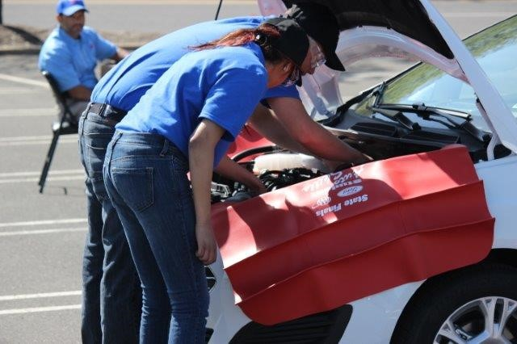BT-Paramus recognizes that females, minorities, students with disabilities and at-risk youth experience barriers to achievement (e.g. low self-esteem, math anxiety, ingrained gender stereotypes, lack of role models, fear of discrimination and harassment). To overcome these, BT-Paramus utilizes multiple strategies, including individualized career guidance; supplemental support services; gender equity and multicultural diversity interventions (e.g. nontraditional role models; hands on activities); career education that integrates employment readiness and life skills; work-based mentorships and other structured learning experiences for all students. Professional development for teachers and mentors, provided by organizations such as Wider Opportunities for Women, promote both the awareness of impediments (such as stereotyping and discrimination) and the use of instructional and supervisory techniques to overcome these challenges. The above strategies combine to build self-confidence, provide individualized academic support and ensure timely access to services that address emerging needs and/or accommodations, including those identified in an Individualized Education Plan (IEP).

1. If applicable, what strategies or technologies do you use to close access gaps? (e.g. integrated digital learning, virtual work based learning.)

Does Not Apply

1. What activities does your school or institution do to recruit elementary, middle, high school students and/or adult learners into the program of study? Please provide examples. (150 word limit)  
     
   BT-Paramus conducts three open houses/tours each fall. An average of 200 prospective students attend each open house. These events are advertised in local, community newspapers and announced on the Bergen County Technical School district website (<https://bcts.bergen.org/index.php/phsaboutus/phs-programs#/gallery-135-image/11>). Announcements about BCTS CTE program offerings and admissions events are also sent via email to all Bergen County middle school guidance counselors and are distributed at an annual counselor’s breakfast. Each year an average of 145 eighth graders applied to BT-Paramus for full-time enrollment and an average of 250 apply to attend on a part or shared-time basis. Applications for the class of 2022 must be submitted by 12/14/17.
2. Is your program of study associated with a Career Technical Student Organization (CTSO)? If so, which one(s) and in what way(s)? (Check the [approved list](http://www.ctsos.org/ctsos/) of CTSOs) (50 word limit)

The ASE POS is associated with Skills USA. In addition, students have successfully competed in the Ford/AAA Student Auto Skills competition (2012, 2013, 2014 State Finalists; 2007and 2010 State Champions).

1. Describe how career guidance/advisement is integrated into your program of study to support students’ completion of the program of study and entry into additional education/training and/or a successful career. Where applicable, describe the tools (individual career and academic plans, career exploration websites, etc.) that are provided to learners and how they are used. (200 word limit)

The counseling department customizes academic, social, and emotional supports to address the special learning needs of each student, regardless of gender, ethnicity, income, or disability status. Counselors collaborate with teachers, administrators, parents, employers, and community members, to support student development of higher level problem solving, decision-making, career planning and employability skills.

College/career placement is enhanced by the assignment of students to a counselor with knowledge of their CTE career field, their IEP or 504 plan (if applicable). The counseling process is supported by grade-specific tasks which are accessed through the Naviance/Family Connections website and guide students in their development and management of individualized college and career plans. Over their four years in the POS students complete the following:

**Grade 9:** Surveys (Transitional, Study Skills, Game Play Survey); Career Interest Profiler; Career Cluster Finder

**Grade 10:** Resume; explore career clusters and enrichment programs; take tests (SAT subject, PSAT); SAT/ACT PrepMe

**Grade 11:** SuperMatch college search; resume; take tests (ACT, SAT subject, Accuplacer); scholarship search; Junior College Conference worksheet; Do What You Are; Student Profiles (teacher/counselor); find enrichment programs

**Grade 12:** Complete college/scholarship searches; Naviance SAT/ACT PrepMe; graduation survey; FAFSA; Senior Intake Conference Worksheet; Common Application; take tests (Accuplacer; SAT subject).

# **COLLEGE- AND CAREER-READY STANDARDS/EXPECTATIONS**

1. Please describe how your program of study was developed and how it ensures students are academically and technically prepared for postsecondary education and careers. Please also address the following:
   1. How were employers involved in the development and/or maintenance of your program of study?
   2. How does this program of study meet the economic needs of your community?
   3. How does this program prepare students for postsecondary education? (if applicable)
   4. How were both secondary and postsecondary educators involved in the development and/or maintenance of the program of study? (500 word limit)

The Automotive Service Association’s recently released “How’s your Business?” survey showed that the largest percentage of respondents – 45 percent – cited the industry’s labor shortage as their No. 1 concern. The U.S. Bureau of Labor Statistics estimates that 237,000 jobs in the automotive repair field are expected to open up from 2014 to 2024. While the U.S. Department of Labor Statistics projects a 7 percent increase in employment for automotive service technicians and mechanics nationwide from 2014 to 2024, a lack of qualified technicians could prevent these jobs from being filled. Jobs for auto, bus and truck mechanics are expected to increase in the coming years, with nearly 5,000 expected job openings between the two fields in 2019. But finding enough qualified workers to fill these jobs isn’t easy. According to the coalition’s report, while the number of low skill workers is expected to grow by nearly 4 percent by 2025, mid-skill workers will drop by about 3 percent in the same time frame. The BT-Paramus Automotive Technology ASE program provides skilled, ASE certified technicians to help fill this void.

The BT-Paramus ASE POS was initiated on the Hackensack campus of Bergen County Technical Schools over 35 years ago. It was established to provide training for secondary and adult students who wanted to pursue a career in automotive service. The adult post-secondary automotive program was discontinued shortly after the secondary program moved to the BT-Paramus campus in the mid-1990’s. The current ASE POS is a product of this transition. This move was made with the intent of providing full and shared time high school students, the majority of whom are challenged by some form of special learning need, with preparation in the areas of transportation technology that lead to ASE certifications and employment. Since its move, the ASE program evolved into a program of study with articulations to post-secondary study and apprenticeships and developed the partnerships with industry needed to increase and provide effective work-based experiences and mentorships for students who are frequently challenged to adapt to the requirements of the worksite. Work-based learning combined with the “Pathways” approach enables the ASE POS to better prepare students with the skills needed to succeed in two and four year technical programs and colleges and/or the military/workforce.

Today, the BT-Paramus ASE POS works very closely with Snap On Corporation, as well as Hunter Engineering to provide students with the latest updates, trends and technology in the automotive industry. These include many industry recognized certifications such as those offered by NC3 through Snap On. The program also relies on a strong advisory board to achieve this goal. Included in this group are the service advisors and principals of local dealerships, as well as industry trainers, equipment specialists and technicians.

BT Paramus ASE students and faculty also work closely with Brookdale Community College (Lincroft NJ, see attached letter) and Rockland Community College (Orange NY) to place students in manufacturer and general associate degree programs in automotive technology.

1. Which technical, academic and/or employability skill standards does your program of study incorporate at the secondary and/or postsecondary level and how? (Please list the standards you use and be specific regarding how your program uses industry, national, state and/or locally-developed standards) (250 word limit)

|  |  |
| --- | --- |
| **Standard Types** | **Please list the standards your program of study uses and how it uses them below:** |
| Academic Standards | **8.1 Educational Technology** All students will use digital tools to access, manage, evaluate, and synthesize information in order to solve problems individually and collaborate and create and communicate knowledge.  **8.2 Technology Education, Engineering, Design and Computational Thinking - Programming** All students will develop an understanding of the nature and impact of technology, engineering, technological design, computational thinking and the designed world as they relate to the individual, global society, and the environment. |
| Career Cluster or Technical Standards | 9.3.12.TD.1 Describe the nature and scope of the Transportation, Distribution & Logistics Career Cluster and the role of transportation, distribution and logistics in society and the economy.  9.3.12.TD.2 Describe the application and use of new and emerging advanced techniques to provide solutions for transportation, distribution and logistics problems.  9.3.12.TD.4 Identify governmental policies and procedures for transportation, distribution and logistics facilities.  9.3.12.TD.6 Describe career opportunities and means to achieve those opportunities in each of the Transportation, Distribution & Logistics Career Pathways. |
| Employability Standards | **Career Ready Practices Covered**  CRP2.  Apply appropriate academic and technical skills.  CRP4.  Communicate clearly and effectively and with reason.  CRP8. Utilize critical thinking skills to make sense of problems and persevere in solving them.  CRP11. Use technology to enhance productivity.  NATEF Standards  Standard 1 – Purpose  Standard 2 – Administration  Standard 3 – Learning Resources  Standard 4 – Finances  Standard 5 – Student Services  Standard 6 – Advisory Committee  Standard 7 – Instruction  Standard 8 – Equipment  Standard 9 – Facilities  Standard 10 – Instructional Staff  Standard 11 – Work Based Learning  Standard 12 – E-Learning |
| Other |  |

# **SEQUENCE OF COURSES & CREDIT TRANSFER**

1. Please fill out the chart below, and describe your program of study’s course sequence by grade level, including the relevant or required academic and technical courses, as well as other required activities.   
     
   Make sure to highlight the course sequence that bridges secondary and postsecondary education, and explain how your program of study ensures students gain the broader Career Cluster-level knowledge/skills and, over time, gain the more specific occupation-level knowledge/skills as they progress through the program of study. You can also include graphics or [plans of study](http://careertech.org/sites/default/files/PlanStudy-CareerCluster-AG_0.pdf) of the course sequence in lieu of filling out the chart below.

The BT-Paramus Automotive Technology, ASE CTE POS blends coursework in academic subject areas, science and the automotive technology.

**ACADEMIC REQUIREMENTS & OPTIONS**

BT-Paramus students are required to take 4 years of English, 4 years of Mathematics, 4 years of Social Studies (including US History I & II, World History), 3 years of Science (Physics, Chemistry, Biology), 2 years of World Language (Spanish). Art & Expression and Financial Literacy (FOSA) are also required courses.

|  |  |  |  |  |
| --- | --- | --- | --- | --- |
| **SUBJECT** | **9TH GRADE** | **10TH GRADE** | **11TH GRADE** | **12TH GRADE** |
| **Social Studies** | Financial Literacy/FOSA | U.S. History I | U.S. History II | World History |
| **Health/PE** | Health/PE 9 | Health/PE 10 | Health/PE 11 | Health/PE 12 |
| **World Language** | Spanish I | Spanish II |  |  |
| **Visual and Perf. Arts** |  |  |  | Art & Expression |
| **Technological Literacy** | Infused: Academic Lit | Infused:  Physical Sci. | Infused: 20th  Century Topics | Infused: Mathematics |
| **CTE courses and/or Degree Major Courses** | Fundamentals of ASE | Introduction to ASE | Applications of ASE | Advanced Systems Seminar |
| **Language Arts** | Academic Literacy I | Academic Literacy II | American Literature | World Literature |
|  | Academic Literacy | Foundations of Literature | American Literature | Writing Composition |
| **Mathematics** | Algebra | Intermediate Algebra | Geometry | Algebra 2  OR  CTE Math |
| **Science** | Intro to Chemistry | Physics | Biology |  |
|  | Physics | Chemistry | Biology |  |

**BT-Paramus Automotive Technology, ASE CTE Course Descriptions**

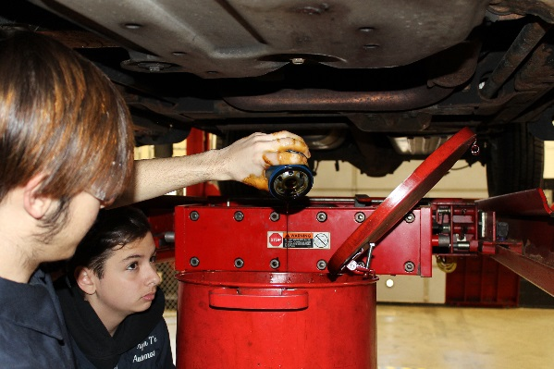**Fundamentals of ASE 9th Grade**: This introductory course in Automotive Technology provides a fundamental experience in general automotive service while simultaneously exploring career opportunities in the field. Materials covered include an introduction to shop safety, proper utilization of tools, equipment and latest field technology, access of service information including manuals; CD ROM based information and on-line resources. Communication skill development is also integrated. This course employs a two- fold approach consisting of a project –based, technology driven lab experience coupled with classroom instructional studies. The lab experience is cooperative in nature (team projects) and based upon the AYES/NATEF cooperative learning model. Textbook**:** Automotive Maintenance and Light Repair,(Rob Thompson, Delmar 2014) Also used in this course are the web-based CDX and Electude NATEF approved study programs

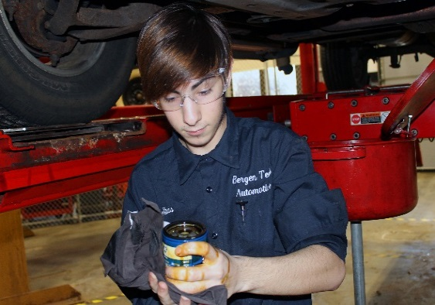**Introduction to ASE 10th Grade:** This second year course is designed to expand upon the basic skills covered in Fundamentals of ASE. The NATEF MLR specialty area is explored in greater depth. Students are required to complete an online OSHA based program. Individual and team projects are completed using assigned NATEF- based tasks. Customer relations as well as problem solving skills and diagnostics are stressed. Students use web-based CDX and Electude online automotive instructional/study programs, and the *Automotive Maintenance and Light Repair* textbook(Rob Thompson, Delmar 2014).

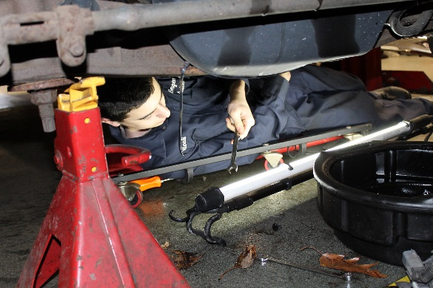**Applications of Auto Systems 11th Grade:** This course explores the NATEF MLR specialty area in greater depth. Emphasis is placed upon AYES (Automotive Youth Educational Systems) internship preparation, which includes mentor/intern training. Students may serve an internship at the conclusion of this course. Individual and team projects are completed using assigned NATEF- based tasks, which are listed in the NATEF MLR task list, 2013 version. Units of study include customer relations as well as problem solving skills and diagnostics. Students continue to use the web-based CDX and Electude online automotive program as well as the text book, *Automotive Maintenance and Light Repair* (Rob Thompson, Delmar 2014)

**Advanced Systems Seminar 12th Grade:** Many of the students enrolled in this course have completed a summer internship at an automotive service facility. Students who meet specified academic requirements are eligible to continue their internship for a maximum of four days per week and maintain a work journal that is reviewed weekly. NATEF MLR areas are further expanded upon and emphasis is upon preparing students to take and pass ASE/NATEF certification examinations. Course units include OBD diagnostics and are constantly updated to respond to changing real-world industry standards, such as a recently added unit covering Hybrid vehicle basics and safety precautions. Students also complete a nationally recognized, web-based, OSHA approved Safety and Pollution Control Certification program. Post-secondary educational opportunities are explored in further depth. This exploration is supported by field trips to various training institutions and colleges.

**PROJECT-BASED LEARNING**

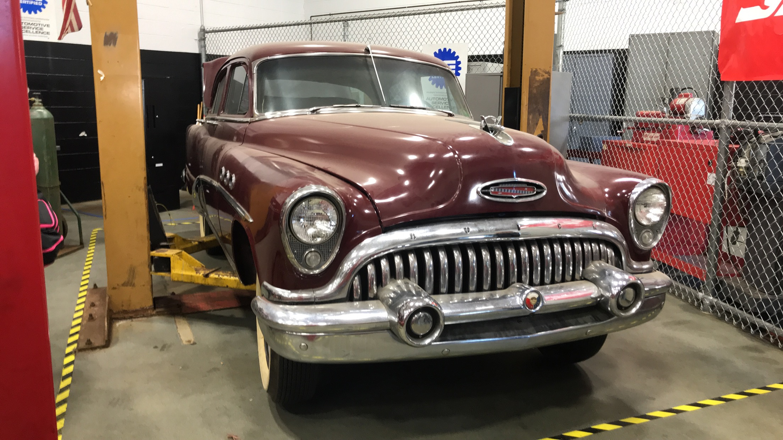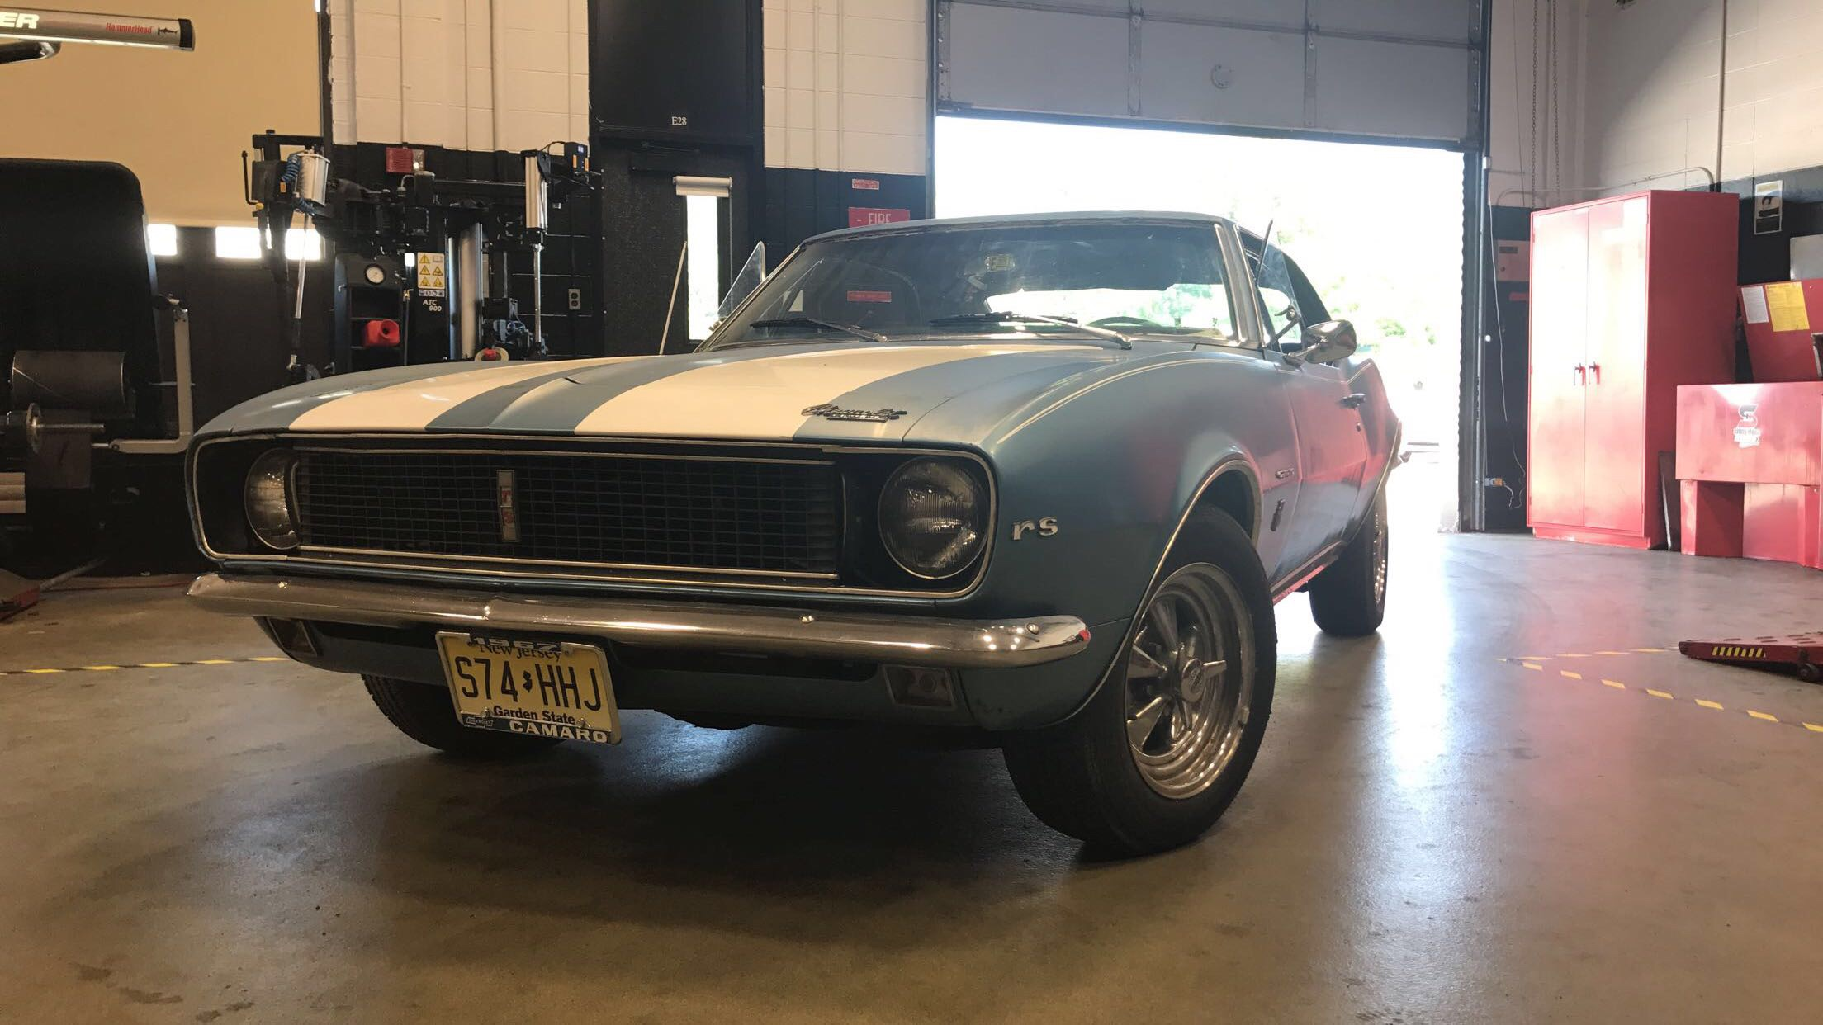All project-based learning activities, with the exception of the 9th grade project, involve innovation, hands-on application. One example of an extra-curricular project was” Clean, Green 383”. This was a group project in which the students designed and completed and installed the drive-train (engine, transmission and rear differential) of a 1986 Chevrolet Monte Carlo SS. This vehicle was built to run quarter mile times in the mid fourteen second range, while maintaining street legal safety and emission specifications. Students are currently doing major and minor mechanical restoration on a 1953 Buick, as well as electrical and mechanical work on a 1967 Camaro.

1. How do you ensure that CTE instruction and coursework is integrated with core academics?

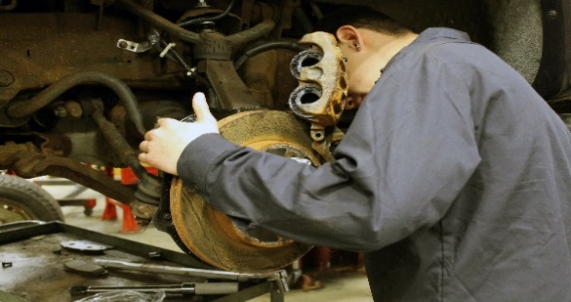Project-based learning, conducted alongside students from other Bergen Tech schools and with representatives from industry provide Paramus ASE students with the opportunity to apply academic knowledge gained in the classroom to real-world, work-related problems. For example, Paramus ASE students worked with students from the Bergen County Academies, Academy of Science and Technology at on a car restoration project.  They applied knowledge gained in science and math to the collaborative design and construction of a drivetrain for a 1987 Monte Carlo Super Sport.  This also involved retrofitting the technology of the car to meet current EPA standards.  Decreasing emission of older vehicles is a complicated process that requires the skills of a master technician with knowledge of the sciences of gas emissions.  Other learning projects combined academic skills/content with training provided by industry representatives from Snap On. These trainings emphasized learning about the latest technology in the auto service industry, including tire service equipment, scanners and TPMS diagnostics, along with written and verbal customer contact skills.

1. List the opportunities for students to earn articulate and/or transcript dual enrollment credit across K-12 and postsecondary, such as AP/IB, dual and concurrent enrollment, capstone experiences and/or transcripted credit articulation agreements. (250 word limit)

Students are eligible to obtain college credits via articulations with postsecondary institutions such as the University of Northwestern Ohio, College of Applied Technologies. Students completing the Automotive Technology ASE POS can obtain up to 12 credits from the University of Northwestern Ohio, as follows: Suspension & Steering, 6 credits; Hydraulic Brake Systems (6 credits). New articulations under development include Rockland Community College and Fairleigh Dickinson University.

1. Please provide information on **at least three partnerships** with *education institutions and groups* your program of study has, and describe how these partnerships have been built, maintained and sustained over time. Use this space to specifically address the secondary and postsecondary partners that contribute to and maintain this program of study.

|  |  |  |
| --- | --- | --- |
| **Education Partnership Name** | **What role does this partner have in directly supporting your program of study?** | **How many years has this partnership been active, and how was this partnership developed?** |
| Fairleigh Dickenson University | Professional development and technical support with particular focus in the area of alternatively fueled vehicles. | This partnership has been in place for over eight years and was initiated via outreach from the School District to the university for technical support. |
| University of Northwestern Ohio | Articulation agreement for 12 credits in the areas of suspension, steering and hydraulic brake systems. | This partnership has been in place for one year and was initiated via outreach from the Bergen County Technical Schools to the University. |
| Rockland Community College | Articulation agreement for 3 credits for students who complete the 4-year program at Bergen Tech. Rockland Community College faculty members have also served on our advisory board for curriculum development. | This partnership has been fostered over ten years. The instructors at Rockland have worked professionally with our instructors as members of our advisory board helping with curriculum revisions and technical support. |

# **ALIGNMENT WITH INDUSTRY AND BUSINESS NEEDS**

1. Please describe how your program of study is aligned with the needs of the workforce and industry in your community. Make sure to include information on how the program of study helps meet workforce demand identified by business and industry. If applicable, what labor market data does your program of study use to align to workforce needs? (250 word limit)

The BT-Paramus ASE POS was developed collaboratively with industry and postsecondary partners to ensure that program content meets the needs of local employers, addresses the skills and knowledge required to pass NATEF/ASE certification examinations and provides workers with the skills needed to address local, state and national labor demand.

Alignment with emerging industry trends and technological advances, including electronic diagnostics, is supported by strong partnerships with employers such as Tire Tech (see letter) and with companies such as Snap-On and Valvoline. Industry representatives are members of our Advisory Board and take an active role in curriculum review. As Board members they learn how to effectively mentor students with special needs. This mentorship takes place within the occupational skills lab, a student operated simulated repair business and on the worksite. As a result of this relationship, an ever increasing number of ASE students (90% in 2016-17) participated in an extended work based learning experience that was guided by a mentor and increasing numbers of students sought employment after high school.

1. Are ALL students in the program of study required to participate in a work-based learning opportunity? YES or NO.

Students are not required to participate. They are, however, strongly encouraged to participate in work-based learning experiences.

1. Please describe the work-based learning opportunities available to students who participate in this program of study. (250 word limit)

Over the past few years, students have participated in internships that enabled them to apply skills learned in school to work based tasks. Internships were provided by both large and small local businesses, such as Phil’s Auto Repair, Fort Lee Tire Service, Prestige Lamborghini, Action Environmental, and ETD Tire Service. Experiences range from truck and trailer service/repair to general automotive service and used car preparation.

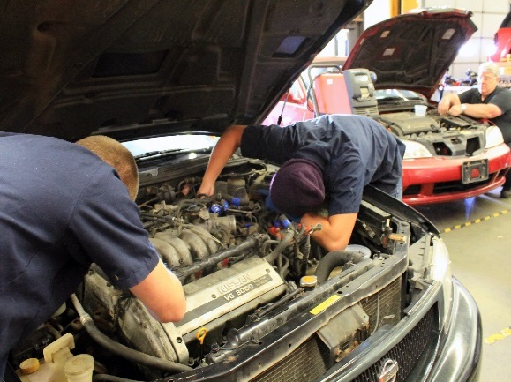Students participating in internships like those identified above gain valuable experience working in all aspects of the aftersales auto service industry. They work under the guidance of a master technician maintaining and repairing vehicles. These internships allow students to perform a variety of job tasks essential to working as an automotive technician, including: Inspect vehicle engine, mechanical/electrical/electronic systems and components to diagnose issues accurately and repair, maintain and upgrade the vehicle; provide accurate estimates for repair or maintenance jobs; and maintain equipment and tools.

1. Please list the industry-recognized credentials/certifications/licenses offered/required. If your program of study does not include industry-based credentials/certifications, please explain why. (200 word limit)

Students in the ASE POS (467.0604: Transportation, Distribution & Logistics Career Cluster) are eligible to sit for all eight of the following ASE industry recognized certification examinations: Engine Repair, Engine Performance, Electrical/Electronic Systems, Brakes, Heating & Air Conditioning, Suspension & Steering, Manual Drive Train & Axles, and Automatic Transmissions. They also have the opportunity to obtain up to four OSHA certifications (including SP2), NATEF MLR, Valvoline, Snap-On NC3, and Tech Tire repair/safety inspection certifications. Two NC3 Snap-On certifications (Torque Wrench/Fastener and Scanner Diagnostics) are pending.

|  |  |
| --- | --- |
| **Offered** | **Required** |
| ASE: Engine Repair, Engine Performance, Electrical/Electronic Systems, Brakes, Heating& Air Conditioning, Suspension and Steering, Manual Drive Train and Axles, Automatic Transmissions | NATEF Auto Maintenance & Repair (ASE student certification) |
| OSHA, including SP2 |  |
| NATEF, MLR |  |
| Valvoline |  |
| Snap-On NC3, Torque Wrench/Fastener and Scanner Diagnostics (pending) |  |
| Tech Tire repair/safety inspection |  |

1. Please describe how you ensure the instructors teaching this program of study keep up-to-date on advancements in the workplace, such as participating in externships and/or requirements to have current industry credentials. (100 word limit)

Automotive faculty keep abreast of changing industry standards and workplace advances through trainings/information provided by Advisory Board, business and postsecondary partners. Emerging industry trends and skill needs are identified during Advisory Board meetings, classroom presentations by business partners and visits to company facilities.

Additional trainings offered by the BCTS district, include student/program evaluation, instructional strategies, collaborative CTE/academic instruction, differentiated instruction, and data usage.

1. Please provide information on **at least three** *business, industry and/or labor* partnerships your program of study has, and describe how these partnerships have been built, maintained and sustained over time.

|  |  |  |
| --- | --- | --- |
| **Business/Industry Name** | **What role does this partner have in directly supporting your program of study?** | **How many years has this partnership been active, and how was this partnership developed?** |
| Snap-On Incorporated | Snap-On Incorporated offers the Bergen County Technical School Auto Students the opportunity to receive training on state of the art equipment aligned to industry standards. Students also have access to Snap-On’s online instructional platform. Snap-On is an active member of the auto advisory board providing suggestions for technical upgrades and curriculum modifications. | This partnership has been in operation for over 10 years and was developed as a result of outreach conducted by BT faculty to Snap-On during the purchasing process. |
| Prestige Lamborghini, Paramus NJ | Prestige Lamborghini has provided Bergen Tech auto students with several internship opportunities and is an active member of our advisory board. Prestige Lamborghini sports a brand-new Service Department featuring state-of-the-art diagnostic and repair equipment, staffed by highly trained and factory-certified Lamborghini technicians. This environment and these technicians provide our student interns with an incredible environment to enhance their skills. | This partnership has been in operation for over 10 years and was initiated by BT faculty during outreach to locate internship placement source and to recruit new advisory board members. |
| Action Environmental | Action Carting Environmental Services, Inc. is the most progressive and innovative provider of non-hazardous waste management services for the five boroughs of New York City and Northern New Jersey (through our acquisition of Interstate Waste – IWS) catering to a diverse range of residential, industrial and commercial customers. Action provides internships for Bergen Tech auto students and is an active member of our advisory board. | This partnership has been in operation for 5 years and was initiated by BT faculty during outreach to locate internship placement source and to recruit new advisory board members. |
| I-Car | I-CAR, the Inter-Industry Conference on Auto Repair, is an international organization dedicated to providing the information, knowledge and skills required to perform complete, safe and quality repairs. I-CAR’s staff and support network provide our staff and students with high quality industry recognized training solutions. | This partnership has been in operation for over 10 years and was initiated by BT faculty during outreach to locate internship placement source and to recruit new advisory board members. |

1. Please feel free to use the space below to share any other information or evidence of success of your program of study and the students who participate. (Optional)
2. If applicable, please provide more detail on any partnerships your program of study has that have not been mentioned already. This includes community groups, non-profits, volunteer organizations, etc. Describe how these partnerships have been built, maintained and sustained over time. (Optional)

|  |  |  |
| --- | --- | --- |
| **Additional Partnerships** | **What role does this partner have in directly supporting your program of study?** | **How many years has this partnership been active, and how was this partnership developed?** |
|  |  |  |
|  |  |  |
|  |  |  |

# **SUBMIT YOUR APPLICATION**

**SUBMIT YOUR APPLICATION**

* Fill out this application.
* Once you have finished, complete [this form](https://careertech.org/2018-excellence-action-application) and upload the following:
* Your full application saved as a Word document (.docx)
* All of your supplemental documents or evidence consolidated as one PDF document.

**THANK YOU!**

Thank you for completing this application! The selection committee will convene in December 2017 to review the applications and make final decisions. You will know the status of your application by January 25, 2018. The programs of study will be evaluated based on their effective leveraging of partnerships, alignment to rigorous and relevant college- and career-ready expectations, clear progression of knowledge and skills across secondary and postsecondary systems, integration of successful career guidance/advisement, and key indicators of student success.

Don’t forget to use the Excellence in Action award submission checklist to make sure you’ve completed your application in its entirety.

We look forward to learning more about your program!

For questions, concerns please contact [awards@careertech.org](mailto:awards@careertech.org).