# **ADVANCE CTE EXCELLENCE IN ACTION AWARD**

**PROGRAM SUMMARY**

Advance CTE is pleased to announce a call for applications for the sixth annual Excellence in Action awards, through which we recognize and honor superior Career Technical Education (CTE) programs of study from across the nation.   
  
**CRITERIA FOR JUDGING**

Selected programs will exemplify excellence in:

* Implementing Career Cluster®-based [programs of study](https://careertech.org/programs-study);
* Maintaining effective employer and business partnerships;
* Demonstrating alignment to rigorous and relevant college- and career-ready expectations;
* Demonstrating a clear progression of knowledge and skills and learner transitions across secondary and postsecondary systems;
* Integrating successful career guidance and advisement;
* Integrating high-quality work-based learning experiences;
* Highlighting alignment to workforce and employer needs in the community;
* Providing concrete data on the program of study’s impact on learner achievement, success at both the secondary and postsecondary levels and meeting the needs of underserved populations; and
* Delivering high-quality and effective instruction.

**ELIGIBILITY**

* This award is open to any public secondary or postsecondary schools or colleges in the United States. Your school or institution may submit one application per [Career Cluster](http://careertech.org/career-clusters);
* The program of study must have at least one full graduating class;
* Your program must be eligible to receive funding from the Carl D. Perkins Career and Technical Education Act;
* Applications that do not include data to demonstrate positive impact on learner achievement will not be eligible for consideration.
* If your program has received in an Excellence in Action award from Advance CTE in the past, you may not apply for that same Career Cluster. However, your school or institution may apply in a different Career Cluster.

**AWARD SUBMISSION REQUIREMENTS**

Complete applications will contain the following:

* A completed application including supplemental materials by the application deadline of **November 21, 2018 at 5 p.m. ET.**
* At least one letter of support from an employer or business partner supporting the program of study; and
* At least one additional letter of support from a partner (education, community or business) of your choosing.
* *Optional:* Supplemental materials including photos, videos, news articles, etc., are welcome but not required.

The application must be submitted using [this form](https://careertech.org/2019-excellence-action-application). The application must be submitted in a Microsoft Word format. Supplemental materials, including the letters of recommendation, must be combined and submitted as **one** PDF document.

*Please note:*

* Submissions should **not** include any personally identifiable learner data.
* The application does not have a page limit, however, many questions do have a word limit. Please do not submit responses that go beyond this limit. Also, submissions that do not contain all the required materials (a completed application, two letters of support and supplemental materials in the correct formats) will not be advanced for consideration.

**WINNERS WILL RECEIVE**

* A banner to hang in their school or institution;
* A digital banner to use in email and print materials as they so choose;
* Travel and one hotel room for one night in Washington, DC for a representative to be recognized at an awards ceremony to be held the week of April 8-10, 2019 at the Advance CTE Spring Meeting; and
* Discounted rate to the Advance CTE Spring Meeting

**WINNERS WILL ALSO BE FEATURED IN**

* A national press release, which will be distributed to national media.
* A winner-specific press release to distribute to local media;
* A standalone one-pager;
* A standalone blog on the [Learning that Works blog](http://blog.careertech.org/);
* Representation on the Advance CTE [website](http://www.careertech.org).
* Many past winners have been featured in national conferences, in briefs and reports, on webinars and in the media.

**HOW TO APPLY**

* Fill out the following application.
* Once you have finished, complete [this form](https://careertech.org/2019-excellence-action-application) and upload the following:
* Your full application saved as a Word document (.docx)
* All of your supplemental documents or evidence consolidated as one PDF document.

# **BACKGROUND INFORMATION**

1. **Program of study name:** *K12 Healthcare Pathway*
2. **Point of Contact**  
    *Name:* Brooke Holbrook

*Email Address:* [brooke.holbrook@nwtc.edu](mailto:brooke.holbrook@nwtc.edu)

*Phone Number:* 920-498-5422  
*Address:* 2740 West Mason Street, Green Bay, WI 54307-9042

1. **Applicant’s School/College:** Northeast Wisconsin Technical College (NWTC)
2. **State:** Wisconsin
3. **Type of institution (click the box to check)**

☐ Area technical center

☐ Career academy

☐ Comprehensive high school

☐ Community college

**X Technical college**

Other (please specify)

|  |
| --- |
|  |

1. **Career Cluster in which your program of study should be considered (Follow this link for a further explanation of each Career Cluster** [**careertech.org/career-clusters**](http://careertech.org/career-clusters)**):**

☐ Agriculture, Food & Natural Resources Career Cluster

☐ Architecture & Construction Career Cluster

☐ Arts, A/V Technology & Communications Career Cluster

☐ Business Management & Administration Career Cluster

☐ Education & Training Career Cluster

☐ Finance Career Cluster

☐ Government & Public Administration Career Cluster

**X Health Sciences Career Cluster**

☐ Hospitality & Tourism Career Cluster

☐ Human Services Career Cluster

☐ Information Technology Career Cluster

☐ Law, Public Safety, Corrections & Security Career Cluster

☐ Manufacturing Career Cluster

☐ Marketing Career Cluster

☐ Science, Technology, Engineering & Mathematics Career Cluster

☐ Transportation, Distribution & Logistics Career Cluster

1. **In three sentences or less, describe your program of study, including the secondary and postsecondary components and how long the program of study has been in place.**

Since Fall 2011, NWTC has partnered with local high schools to offer the K12 Healthcare Pathway to high school juniors and seniors as part of its Early College Programming. The pathway starts with Nursing Assistant Certificate Program, a pre-requisite to NWTC’s Nursing Program, which ladders into the Practical Nursing program or towards the completion of the Healthcare Customer Service Representative Certificate, an embedded credential within the Medical Assistant Technical Diploma Program. This pathway option has become so popular, the number of locations and school districts served has nearly tripled in the last three years.

1. **Please check the geographical and demographic setting for your program of study and describe the geographic and economic conditions of the region served by the school.**

X Urban

X Suburban

X Rural

☐ Other

NWTC is one of 16 districts that operate within Wisconsin in a statewide plan for vocational, technical, and adult education. The College serves all or parts of nine counties in Northeast Wisconsin around the bay of Green Bay: all of Door, Florence, Kewaunee, Marinette, and Oconto counties, all but a small sliver of Brown county, the eastern half of Shawano county, and a very small part of Outagamie and Manitowoc counties. The region, which borders Michigan’s Upper Peninsula, can be described as a mix between metro and non-metro. It is home to 430,000 residents with its most populous county, Brown, home to more than 250,000 residents and its least populous county, Florence, home to less than 4,500 residents. [1],[2],[3]

Wisconsin is experiencing a skilled healthcare workforce shortage. According to the University of Wisconsin-Madison’s *Strategic Employment Growth in* *Wisconsin* study, three of the top ten economic sectors judged “to be the greatest contributors to past and future employment growth for Wisconsin” are related to healthcare: Ambulatory and Healthcare Services, Hospitals, and Nursing and Residential Care Facilities.[4] Across the state, Registered Nurse ranks #9 and Nursing Assistant ranks #14 in the list of occupations with the largest number of projected openings during the 2014-2024 time period.[5] In total, the state projects over 8,000 annual openings between the three occupations through 2026. More than half of the annual openings (51%) will result from individuals exiting the labor force; an additional 41.6% will result from workers leaving the occupation for different professions. Long-term and residential care facilities are particularly feeling pressure points from the workforce shortage: caregiver vacancies have reached “crisis levels,” averaging 14.5% across the state with one quarter of providers noting vacancies of 20% and higher.[6]

The Bay Area Workforce Development service area, which includes NWTC’s district, is projected to have 195 annual Registered Nurse openings, 43 annual openings for each Licensed Practical Nurses and Medical Assistants, and 158 annual Nursing Assistant openings.[7] The shortage is especially concerning given the aging population: Wisconsin’s elderly population (65 and over) will nearly double between 2010 and 2040. NWTC’s district will shift from having five counties with less than 20% of the population age 65 and over in 2010 to three counties having nearly one-third or more of the population and three additional counties having greater than one-fourth of the population age 65 and over in 2040.[8] At the same time, the 15-64 age group is projected to remain steady.[9] For the healthcare sector, this double-edged sword is of great concern: “The growth in the number of older residents is in sharp contrast to…the number of people available to work… It is also expected that older residents will consume more health care.”[10] *BE BOLD 2,* a study by Competitive Wisconsin, Inc. of the state’s talent pool and needs of employers,has indicated that the state’s ability to supply nursing and health-related professionals will have the greatest impact on the state’s quality of life. This will lead to ripple effects throughout communities and the statewide economy as businesses struggle to attract talent due to diminished quality of life standards and subsequently opt not to expand within and/or relocate to the state.[11]

1. **Please describe how your program of study was developed and how it ensures learners are academically and technically prepared for both postsecondary education and careers. Please also address the following:** 
   1. ***How were employers involved in the development and continue to be involved in the maintenance of your program of study?***
   2. ***How does this program of study meet the economic needs of your community?***
   3. ***How does this program prepare learners for postsecondary education? (if applicable)***
   4. ***How were both secondary and postsecondary educators involved in the development and/or maintenance of the program of study? (500 word limit)***
2. Employer involvement in program development and review is critical to ensuring the College is equipping students with the skills needed to be successful in their chosen careers. All programs at NWTC have Advisory Committees which meet biannually to review curriculum and program content and provide input. These discussions keep NWTC informed of market changes and/or workforce needs. Through this feedback and analysis of local labor markets, NWTC identified growing shortages of Healthcare employees in its district which led to the expansion of the *K12 Healthcare Pathway.*
3. The *K12 Healthcare Pathway* provides expanded career entry and exit points. The communities served by NWTC are projected to have over 400 annual nursing-related openings. Upon successful completion of NWTC’s Nursing Assistant (NA) program, students are eligible to take the Wisconsin nursing assistant competency evaluation to be employed in one of the 158 annual openings locally at nursing homes, hospitals, community-based residential facilities, assisted living centers, etc. More than 98% of NA graduates pass their written competency test on their first attempt and have starting salaries averaging $25,842. Further, the K12 program delivery generates interest and further enrollments in the Nursing pathway. Practical Nursing graduates are eligible for careers in a variety of settings (e.g., hospital, long term care/rehab facility, physician's office, etc.). Starting salaries for Practical Nursing graduates six months after graduation average $35,734. Graduates of the Nursing Associate Degree program earn starting wages of $54,159. NWTC graduated 170 students in its Nursing Associate Degree program in 2016-2017; 98% were employed in the field within six months of graduation.
4. The *K12 Healthcare Pathway* allows high school juniors and seniors interested in pursuing a career in healthcare to take the first step and complete the Nursing Assistant Technical Diploma Program. This three-credit technical diploma is taught by an NWTC Instructor, exposing students to a college-rigor course and experience while in high school. Upon completion, students can take a state certification examination and work as a Certified Nursing Assistant or continue on the healthcare pathway.

Students continuing on the healthcare pathway have two postsecondary career options. The first is a Healthcare Customer Service Representative Career Pathway Certificate, an embedded credential that leads into the Medical Assistance Technical Diploma and allows students to seek employment as a healthcare patient services representative. The second option students can pursue while in high school, is the Early College Practical Nursing Program. Students completing the Nursing Assistant program can enroll and earn 23 credits within the Practical Nursing Program. Upon graduation from high school, students can continue on at NWTC for two semesters to complete the remainder of the Practical Nursing Technical Diploma.

1. K-12 partnerships with NWTC are driven by review of labor market needs in the district’s community. This analysis provides the local school district an opportunity to train up employees for needs within their area, thus retaining their local talent. In review of these employment trends and projections, many K-12 school districts find a need to offer a healthcare pathway to their students.

# **LEARNER POPULATION & DATA**

1. **Please describe your program of study’s demographic and outcome data for the most recent academic year(s). It is our strong preference to have data from both secondary and postsecondary levels. If this is not available, please provide an explanation as to why the data from the other learner level is not available. Applications that do not include data to support positive impact on learner achievement will not be eligible for consideration. (100 word limit)**In summary of the data below, we are seeing an increase in enrollment in the program of study (Nursing Assistant) over the past three years. We also see that there is an increase in male, minority and low-income students. With regards to transition of these Technical Diploma completers, we see a slight trend of increase, but overall steady transitions. Additional data points would need to be considered for further analysis.

**NOTE**: Please specify if and when you are using a percentage with a different denominator (e.g., seniors) than the one listed.

**When completing the data section, please only use percentages and include data that is from your program of study. Additionally, only include data where learners are eligible to participate (e.g., only seniors in high school will be eligible for the section asking for percent of seniors who graduated high school, so only seniors should be included in that data; if your work-based learning only occurs within a specific grade level, only include them in your data for that category.)**

|  |  |  |  |
| --- | --- | --- | --- |
|  | 2015-16 | 2016-17 | 2017-18 |
| **POSTSECONDARY-LEVEL DATA** | | | |
| **What is the total number of learners served by your school/institution?** | 16489 | 16156 | 17469 |
| What is the total number of minority learners served by your school/institution? | 2459 | 2801 | 3207 |
| What is the total number of low-income learners served by your school/institution? | 1573 | 1437 | 4235 |
| What is the total number of learners with disabilities served by your school/institution? | 1067 | 1105 | 1124 |
| What is the total number of English language learners served by your school/institution? | 164 | 115 | 88 |
| **Total number of learners served by your program of study** | 590 | 585 | 736 |
| % male learners in program of study | 11.0% | 11.3% | 12.1% |
| % female learners in program of study | 89.0% | 88.7% | 87.9% |
| % minority learners in program of study | 12.5% | 14.7% | 20.1% |
| % low-income learners in program of study | 7.1% | 6.2% | 14.0% |
| % learners with disabilities in program of study | 3.4% | 4.1% | 3.0% |
| % English language learners in program of study | 2.4% | 0.9% | 1.5% |
| **Other relevant demographic data from your program of study** |  |  |  |
| % of learners in program of study who completed postsecondary/earned a degree or certificate (who were eligible) | 91.7% | 90.9% | 92.7% |
| % of learners in program of study who earned an industry-recognized credential (who were eligible) | 81.4% | 86.5% | 90.1% |
| % of graduates in program of study who entered the workplace and/or military (who were eligible) | 29.2% | 41.7% | Data not yet available |
| % of graduates in program of study who transitioned to further postsecondary education (who were eligible) | 60.8% | 56.5% | 58.8% |

1. **Provide links to the source of the above data. If the links are not publicly accessible, please explain the source of the data. If you are missing any data, please explain why and how you measure success.**

In addition to the data above, we would also like to share the following:

Figure 1 shows the Nursing Assistant Program Data for high school enrollments for a period of seven terms.

Figure 1

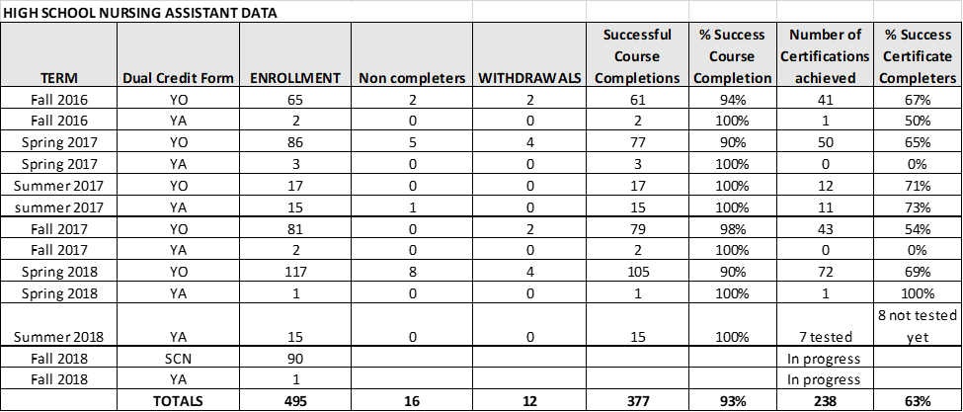

Figure 2 shows the scaling of the Nursing Assistant program at the high school locations, including the number of districts served over a 9 year period of time.

Figure 2

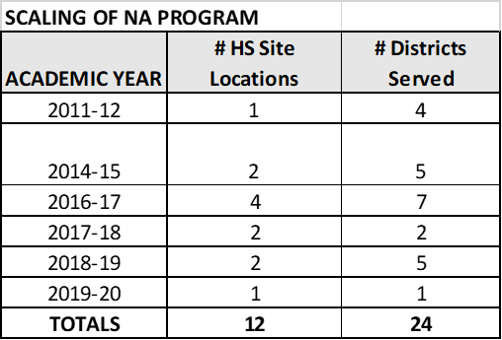

Figure 3 shows the progression of the Early College Practical Nursing Program offered to high school partners, as well as they transition to post-secondary and completion

Figure 3

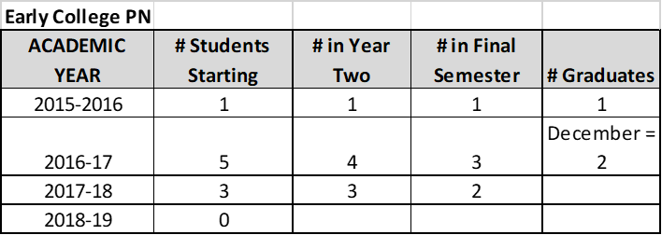

Figure 4 shows the site location, number of beds, high school and year began for the Nursing Assistant courses offered with high school partners.

Figure 4

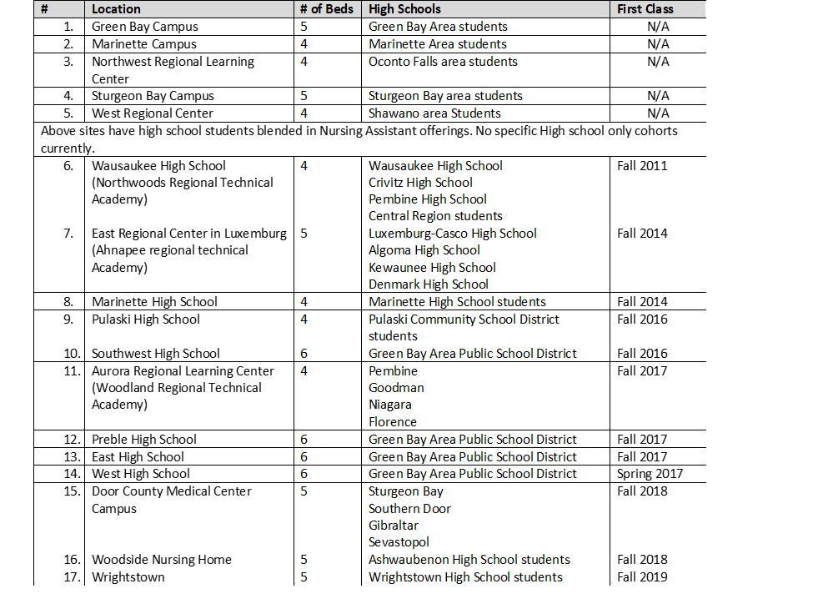

Figure 5 shows the enrollment for our Healthcare Customer Service Representative Certificate for four terms.

Figure 5

|  |  |
| --- | --- |
| **Healthcare Customer Service Representative Certificate (K12 completers)** | |
| **Term** | **Certificate Completions** |
| Fall 2016 | 4 |
| Spring 2017 | 11 |
| Fall 2017 | 6 |
| Spring 2018 | 12 |

1. **How does your school or institution ensure equitable access for learners with diverse backgrounds? (150 word limit)**

Equity in student outcomes is embodied in the College’s core values. Its Affirmative Action/Equal Opportunity Five-Year Plan directs NWTC to create an environment that reflects, appreciates, and celebrates the diverse community and creates a climate for individual success. To meet this goal, the College 1) Implements programs and professional development activities to promote awareness, understanding, and integration of equity and inclusion, 2) Integrates the history, culture, accomplishments, and contributions of people of color; other aspects of diversity are woven into curricula, and 3) Strives to ensure equity is understood and inclusion is practiced at every campus. NWTC conducted an audit to align current practices, programs, and policies that drive equity and uncover gaps. Further, as a member of Achieving the Dream, a national nonprofit dedicated to helping community college students succeed, NWTC is using data to identify strategies to improve student success, with a specific focus on students of color.

1. **How do you ensure learner success, especially of those who from diverse backgrounds? Please provide examples of what supports you offer learners. (150 word limit)**

NWTC has many resources available for all students. The variety of resources available is very helpful when students come from a variety of backgrounds including students from diverse backgrounds. Students in the NA classes come from a wide variety of backgrounds that includes level of academic preparation as well as cultural differences. This variety of students supports a variety of resources that includes academic coaching, study groups, open labs for skills practicing, and supervised practice. The faculty also create review activities that reach the many different learners we may have in the same class. They incorporate things like flash cards, study packets, and games like Kahoot!. The faculty will also partner with our English Language Learner (ELL) faculty to get and share ideas. We do offer a team-taught product specifically for NA students who are English language learners. During this class the ELL instructor provides clarification, reinforcement, study skills, and test taking skills.

1. **Is your program of study associated with a Career Technical Student Organization (CTSO)? If so, which one(s) and in what way(s)? (Check the** [**approved list**](http://www.ctsos.org/ctsos/) **of CTSOs) (50 word limit)**

The K12 Healthcare Pathway best aligns with the HOSA-Future Health Professionals CTSO; however, given the rural/smaller sizes of some of the districts served, not all of NWTC’s K12 partners offer it. The CTSO option most popular at NWTC’s secondary sites is the Family, Career and Community Leaders of America (FCCLA).

1. **Describe how career guidance/advisement is integrated into your program of study to support learners’ completion of the program of study and entry into additional education/training and/or a successful career. Describe how you recruit students into CTE programs. Where applicable, describe the tools (individual career and academic plans, career exploration websites, etc.) that are provided to learners and how they are used. (200 word limit)**

Based on a model at the Pharr-San Juan-Alamo Independent School District in Texas, NWTC assigned Career Coaches to serve in blended recruiter/academic advisor/high school counselor roles. The Career Coaches “advise both students and parents in navigating scheduling issues, financial aid, and degree/credential/career plans. These touchpoints help advance the volume of pathway students persisting in college courses at the high school level and/or enrolling at NWTC.

With the implementation of the Academic Career Planning (ACP) requirements for all Wisconsin Public School students in grades 6-12, the introduction of the healthcare pathway option provides more opportunities for exploration. NWTC Career Coaches and secondary counselors often use career exploration classes and/or ACP career inventories to introduce the healthcare pathway to students. Through survey coursework offered at the secondary level and the deeper pathway experience provided through dual credit, students can make a more informed decision about postsecondary education and career options.

The partnering K12 schools oversee high school pupil recruitment in conjunction with registering students for their junior and senior years of courses. Specific venues of outreach include, but are not limited to, parent/teacher conferences, Individualized Education Plan (IEP) meetings, and disseminating information to students prior to course registration through the school counselors.

1. **Which technical, academic and/or employability standards does your program of study incorporate at the secondary and/or postsecondary level and how? (Please list the standards you use and be specific regarding how your program uses industry, national, state and/or locally-developed standards) (250 word limit)**

|  |  |
| --- | --- |
| **Standard Types** | **Please list the standards your program of study uses and how it uses them** |
| **Academic Standards** | *Nursing Assistant*   * Communicate/interact effectively with clients, family, and co-workers. * Maintain and protect client rights. * Report information and record observations. * Demonstrate the ethical and legal responsibilities of the NA/HHA. * Assist with client rehabilitation and restorative care. * Assist clients with long-term, disabling. * Work cooperatively in a team environment. * Eligible to take the WI NA Competency evaluation**.**   *Healthcare Customer Service Representative*   * Provide excellent customer service in a health care setting. * Be the first contact for customers seeking health care services**.**   *Practical Nursing Technical Diploma*   * Implement one's role as a nurse in ways that reflect integrity, responsibility, ethical practices, and an evolving identity as a nurse committed to caring, advocacy, and quality care while adhering to evidence-based practice * Demonstrate appropriate written, verbal, and nonverbal communication in a variety of clinical contexts * Integrate knowledge of social, mathematical, and physical sciences, pharmacology, and disease processes while participating in clinical decision making * Provide patient centered care under supervision by participating in the nursing process across diverse populations and healthcare settings * Minimize risk of harm to patients, members of the healthcare team, and self through safe individual performance and participation in system effectiveness * Collaborate as a member of the multidisciplinary team to provide effective care throughout the lifespan. * Use information and technology to communicate, manage data, mitigate error, and assist with decision-making |
| **Career Cluster or Technical Standards** | As a member of the Wisconsin Technical College System, NWTC shares state aligned curriculum with the 15 other technical colleges. Administrative and faculty members of each college collaborate to incorporate industry/technical standards into healthcare program curriculum. |
| **Employability Standards** | In addition to specific job-related training, NWTC has identified transferrable employability skills reaching beyond the context of a specific course. All NWTC courses address the following employability skills:   * Communicate Effectively * Work Cooperatively and Professionally * Think Critically and Creatively * Solve Problems Effectively * Value Individual Differences and Abilities * Demonstrate Personal Accountability * Demonstrate Community and Global Accountability |
| **Other** |  |

All these technical, academic, and employability standards are used to assess student performance. For example, students are evaluated on modeling responsible behaviors each class and clinical meeting. The students are provided a list of criteria at the beginning of the class. These criteria provide examples of participation, promptness and professionalism. These three areas are aligned with the employability standards. The goal is to foster the development of the employability skills, so our graduates are prepared to be successful in the workplace.

# **SEQUENCE OF COURSES & CREDIT TRANSFER**

1. **Please fill out the chart below, and describe your program of study’s course sequence by grade level, including the relevant or required academic and technical courses, as well as other required activities.**   
     
   **Make sure to highlight the course sequence that bridges secondary and postsecondary education.** Explain how your program of study ensures learners gain the broader Career Cluster-level knowledge/skills and, over time, gain the more specific occupation-level knowledge/skills as they progress through the program of study. You can also include graphics or [plans of study](https://cte.careertech.org/sites/default/files/PlanPathways-CareerCluster-AG-AgribusinessSystem.pdf) of the course sequence in lieu of filling out the chart below.

|  |  |  |  |  |  |  |
| --- | --- | --- | --- | --- | --- | --- |
| **Grade/Year** | **English/**  **Language Arts** | **Math** | **Science** | **Social Studies/ Sciences** | **Other Required Courses/Other Electives/Learner Activities** | **CTE Courses and/or Degree Major Courses** |
| **9** |  |  |  |  |  |  |
| **10** |  |  |  |  |  |  |
| **11** |  |  |  |  |  |  |
| **12** |  |  |  |  |  |  |
| **13** |  |  |  |  |  |  |
| **14** |  |  |  |  |  |  |
| **15** |  |  |  |  |  |  |
| **16** |  |  |  |  |  |  |

In lieu of completing the chart above, NWTC has developed visuals that outline the healthcare pathways and requirements for student enrollment. Additionally, the K-12 Pathway is also described well through the voice of NWTC’s partners in the following videos:

* Learn How to Create a Healthcare Pathway with NWTC: <https://www.youtube.com/watch?time_continue=15&v=kH36_OwkBsQ>
* Jumpstart Your Medical Career with NWTC:  
  <https://www.youtube.com/watch?v=WVlnwSO8ZaE>

**Figure 1** shows the options for students to enter the *Health Sciences: Therapeutic Services Pathway* by starting with several different general studies dual credit courses that may be available at their high school. The next or concurrent step would be the enrollment and completion of the Nursing Assistant Technical Diploma, followed by Early College Practical Nursing. These pathway options are all forms of dual credit offered at or within secondary locations/sites. Students can then continue on the pathway after high school graduation by completing the Practical Nursing Technical Diploma and pursuing the Nursing Associate Degree Program. Although the Nursing Associate Degree Program is NWTC’s final credential offering of the cluster/pathway, the College has 19 agreements with other postsecondary partners for students to transfer to for the completion of a Bachelor’s of Science Degree in Nursing.

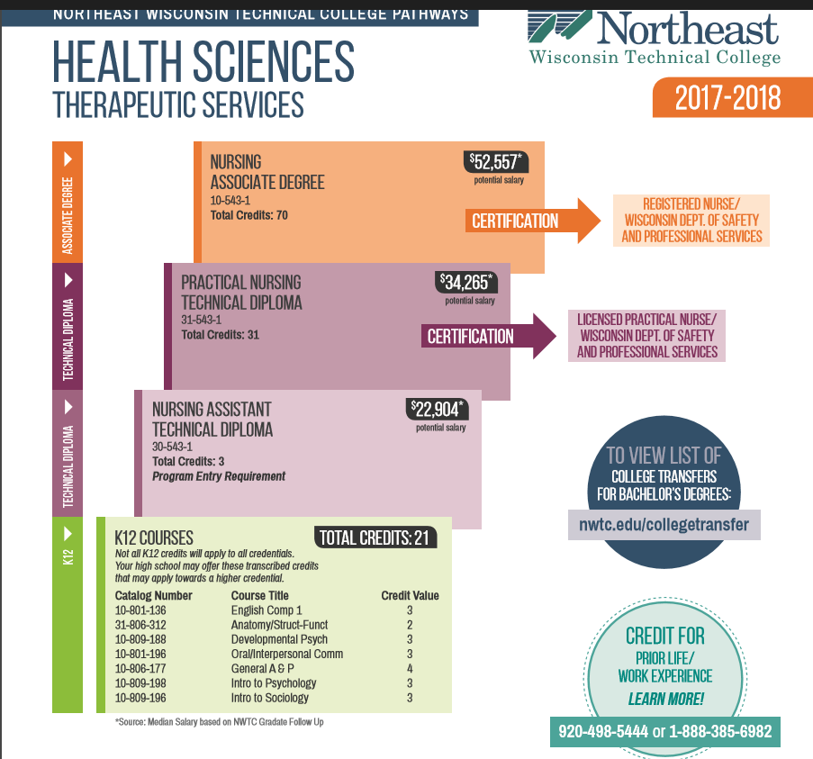

**Figure 1:**

**Figure 2** shows two plans for the Early College Practical Nursing Program. Because some secondary partners offer Chemistry as a sophomore and some as a junior, there are two options. Chemistry is a prerequisite of the General Anatomy and Physiology course, which has pre/co-requisites for the Nursing Pharmacology course.

**Figure 2:**

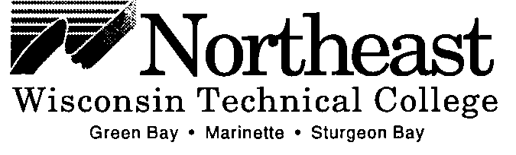

**Early College Nursing Proposal**

Number of Students = Negotiate each semester based upon enrollment interest (class schedule may be adjusted dependent upon volume of students)

Start date: Summer or Fall

Graduation Date: December after high school graduation (if begin as Juniors)

Enrollment Requirements:

1. Suggested: ACT/ASPIRE: Math: 18; Reading: 16; English: 21
2. GPA: 3.0
3. Completion of Chemistry as a sophomore
4. JR or SR status

High School students that begin as Juniors graduate high school in Spring and complete 2 additional semesters to complete Technical Diploma in Practical Nursing.

**Plan A *(Could be taking Chem as a Junior)***

|  |  |  |  |  |
| --- | --- | --- | --- | --- |
|  | **Fall** | **Credits/$** | **Spring** | **Credits/$** |
| Junior year | Nursing Assistant | 3/SCN | Nursing Fundamentals | 2/SCN |
| Oral Interpersonal Communication | 3/Transcribed or SCN | English Composition | 3/Transcribed or SCN |
| College 101 | 1/SCN |  |  |
| Senior year | General A&P | 4/Transcribed or SCN | General A & P | 4/Transcribed or SCN |
| Nursing Pharmacology | 2/SCN | Nursing Skills | 3/SCN |
| CPR (Before Clinical) |  |  | |
| Summer after graduation | Developmental Psych (Plan to start before end of HS school year) | | | 3/SCN |
| Intro to Clinical Practice at Clinical Site (Plan to start before end of school year) | | | 2/SCN |
| HS Graduate | Health Promotions | 3/Student | All at NWTC | |
| Clinical Care Across the Lifespan | 2/Student |
| Health Alterations | 3/Student |
| Intro to Clinical Care Management | 2/Student |
|  | 10 credits |

**Plan B *(Preferred)***

|  |  |  |  |  |
| --- | --- | --- | --- | --- |
|  | **Fall** | **Credits/$** | **Spring** | **Credits/$** |
| Junior year | Nursing Assistant | 3/SCN | Nursing Fundamentals | 2/SCN |
| General A&P | 4/Transcribed or SCN | General A & P | 4/Transcribed or SCN |
| College 101 | 1/SCN |  |  |
| Senior year | English Composition | 3/Transcribed or SCN | CPR |  |
| Nursing Pharmacology | 2/SCN | Nursing Skills | 3/SCN |
| Summer after graduation | Developmental Psych (Plan to start before end of HS school year) | | | 3/SCN |
| Intro to Clinical Practice at Clinical Site (Plan to start before end of school year) | | | 2/SCN |
| HS Graduate | Health Promotions | 3/Student | All at NWTC | |
| Clinical Care Across the Lifespan | 2/Student |
| Health Alterations | 3/Student |
| Intro to Clinical Care Management | 2/Student |
| Oral Interpersonal Communication | 3/Student |
|  | 13 credits |

Finally, **Figure 3** demonstrates how a junior or senior level student can participate in the Healthcare Customer Service Representative Certificate as a dual credit student in high school. All of the courses of this certificate directly feed into the Medical Assistant program, which a student may decide to pursue after graduating from high school.

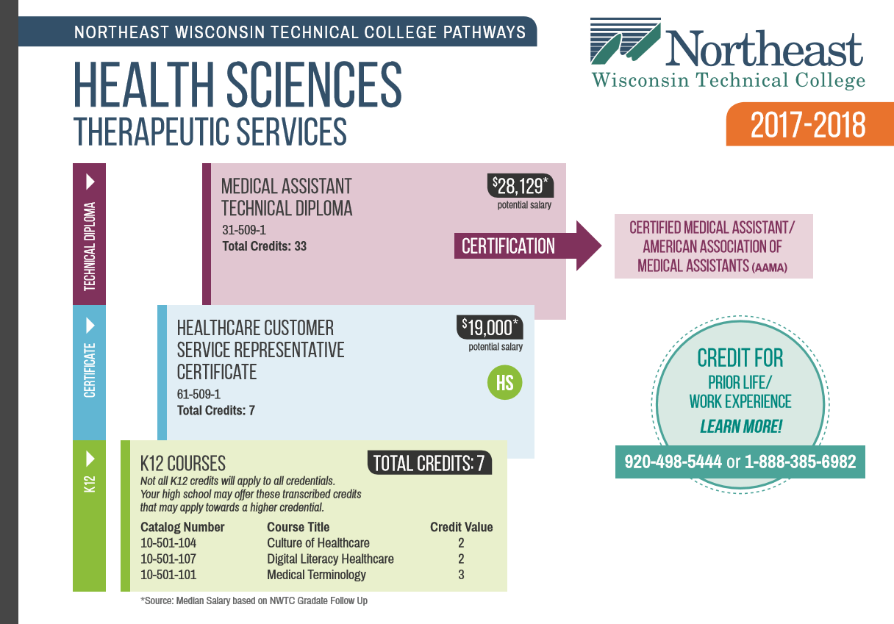

**Figure 3:**

There is also an additional pathway option for those students that complete the Medical Assistant Technical Diploma. **Figure 4** shows how additional postsecondary pursuits continue to be available in this progression:

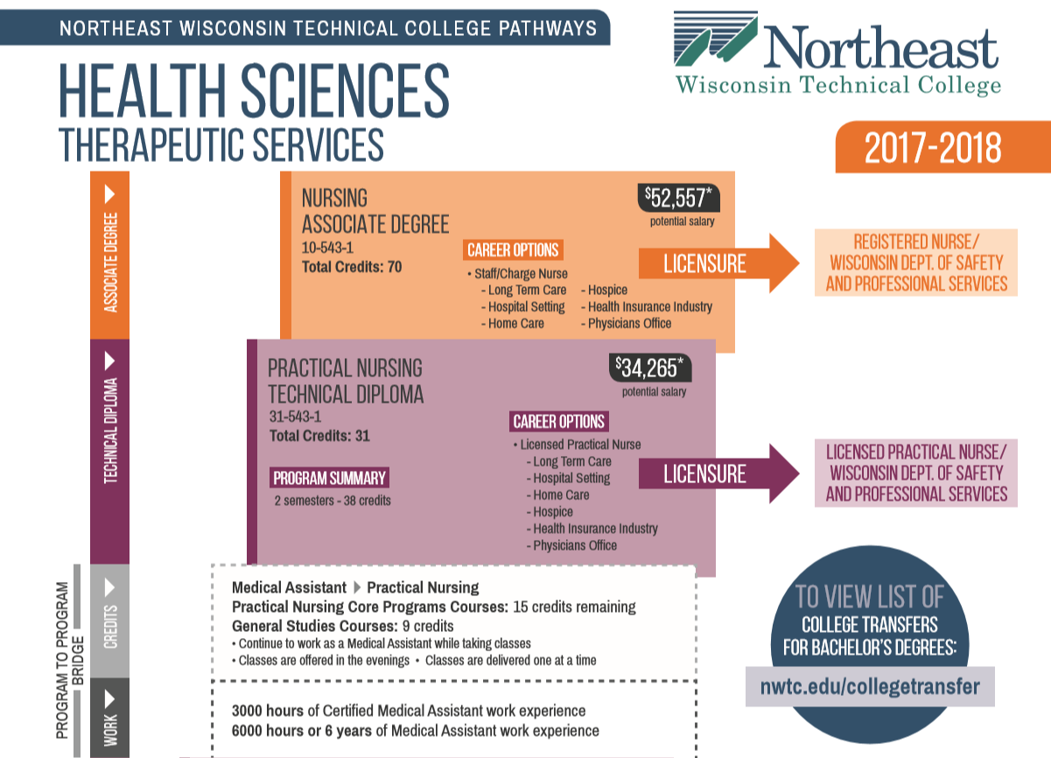

**Figure 4:**

1. **How do you ensure that CTE instruction and coursework is integrated with core academics? Please provide one, specific example.**

Nursing Assistant Program and Healthcare Business Representative Certificate coursework are postsecondary courses delivered by NWTC Faculty and/or trained high school teachers. Many of the students are introduced to the topic areas within their CTE instruction, specifically Family and Consumer Education. Early on, pathway students are made aware that strength of knowledge in the natural sciences area (i.e., Chemistry, Biochemistry, Human Anatomy & Physiology, and Microbiology) is essential for success. Before students can ladder into the Early College Practical Nursing Program, they must complete their Chemistry requirement for proper progression. Other core subject areas of English, Communications and Social Sciences are also specifically identified in the program. In addition, both Math and Written Communication are covered across all NWTC curriculum, which contributes to greater success with pharmacology determinations, charting requirements and case planning for patients.

1. **List the opportunities for learners to earn articulate and/or transcript dual enrollment credit across K-12 and postsecondary, such as AP/IB, dual and concurrent enrollment, capstone experiences and/or transcripted credit articulation agreements. (250 word limit)**

**Nursing Assistant Program**

* Postsecondary/secondary dual credit offered
* Taught by NWTC faculty
* Student gains three postsecondary credits

**Healthcare Customer Service Representative Certificate**

* Postsecondary/secondary dual credit offered
* Taught by NWTC instructors and/or high school teachers that meet qualifications and are trained by College faculty
* Student gains seven postsecondary credits

**Early College Practical Nursing Program**

* Postsecondary/secondary dual credit offered
* Nursing coursework is taught by NWTC instructors, and high school teachers that meet qualifications and are trained by NWTC faculty can teach the general studies coursework
* Student gains 23 postsecondary credits, with ten credits to credential remaining post high school

1. **Please provide information on at least three partnerships with *education institutions and groups* your program of study has, and describe how these partnerships have been built, maintained and sustained over time. Use this space to specifically address the secondary and postsecondary partners that contribute to and maintain this program of study.**

The chart below describes the K12 Healthcare Pathways offered by NWTC in partnership with its K12 districts. Grants from the Wisconsin Technical College System and the Wisconsin Department of Workforce Development (DWD) - Fast Forward, as well as business/industry contributions and College support have all contributed to the success of several of the partnerships described below.

|  |  |  |
| --- | --- | --- |
| **Education Partnership Name** | **What role does this partner have in directly supporting your program of study?** | **How many years has this partnership been active, and how was this partnership developed?** |
| Turbocharge | A collaboration between Green Bay Area Public Schools (GBAPS), NWTC, and the University of Wisconsin - Green Bay (UWGB) aimed at enhancing PK-16 education in the Green Bay area. It is focused on ensuring career, college and community readiness for ALL high school students by creating successful transitions to postsecondary education and completion of a credential or degree that will enable the graduate to engage in a life supporting career. | The partnership has been active since July of 2015 **(3 years)**. NWTC began its Nursing Assistant Program offerings with GBAPS in Fall 2016, with section and sites growing. NWTC will begin the Healthcare Customer Service Representative Certificate in 2019-20. |
| NWTC and Bonduel and Shawano School Districts | NWTC partners with Bonduel and Shawano School Districts to offer a variety of career pathways through dual credit options. The healthcare pathway has grown within the last few years and Bonduel and Shawano were the first two districts to participate in the Early College Practical Nursing Program. | With a well-established relationship with Theda Care Hospital, identified healthcare labor market need and interested students, the partnership developed. The Early College Practical Nursing Program began in 2015-16and has been steady since **(3 years)**. Students begin this pathway with the completion of the Nursing Assistant program. |
| Northwoods Regional Technical Academy | A collaborative effort among three rural school districts (Wausaukee, Crivitz, and Pembine) that started in 2010 to offer CTE pathways through dual credit options. | In fall of 2011 Northwoods began offering both Nursing Assistant and Healthcare Customer Service Representative Certificate to all three districts at a shared location **(7 years)**. |
| Woodland Regional Technical Academy | A collaborative effort among four rural school districts (Florence, Niagara, Goodman, and Pembine) that started in 2012 to offer CTE pathways through dual credits options. | In fall of 2017 Woodland began offering both Nursing Assistant and Healthcare Customer Service Representative Certificate to all districts at a shared location **(1 year)**. |
| Marinette High School | Partnership with this school district to enhance CTE offerings through dual credit. | Since Fall of 2014, the Marinette High School has had an onsite NWTC Nursing Assistant lab where students can complete coursework **4 years)**.  Current conversations are focused on adding another school district (i.e., Peshtigo) and a business/industry partner to expand to the Early College Practical Nursing program. |
| Pulaski High School | Partnership with this school district to enhance CTE offerings through dual credit. | Since Fall of 2016, Pulaski High School has had an onsite NWTC Nursing Assistant lab where students can complete coursework **(2 years)**. The Healthcare Customer Service Representative Certificate is also offered onsite via dual credit. |
| Door County High Schools and Door County Medical Center | Partnership includes four school districts (Southern Door, Sturgeon Bay, Sevastopol and Gibraltar), NWTC, and Door County Medical Center. | This partnership began in Fall 2018, due to labor market needs and student interest **(less than a year)**. The Nursing Assistant lab/classroom is onsite at Door County Medical Center and students attend clinical at this site and another skilled nursing facility. |
| Ashwaubenon & Woodside Senior Living | Partnership with this school district to enhance CTE offerings through dual credit. | This partnership began in Fall 2018, due to labor market needs and student interest **(less than a year)**. The Nursing Assistant lab/classroom and clinical is onsite at Woodside Senior Living. |
| Ahnapee Regional Technical Academy | This partnership serves four rural school districts (Denmark, Kewaunee, Algoma and Luxemburg/Casco) in efforts to enhance CTE offerings. | Starting in Fall 2014, Nursing Assistant and Healthcare Customer Service Representative Certificate are offered to students at a common location **(4 years)**. |
| Wrightstown High School | Partnership with this school district to enhance CTE offerings through dual credit. | This partnership is scheduled to launch in Fall 2019, due to labor market needs and student interest. The Nursing Assistant lab/classroom will be onsite at the high school, with clinical at a local skilled nursing home. |

# **ALIGNMENT WITH INDUSTRY AND BUSINESS NEEDS**

1. **Describe how your program of study is aligned with the needs of the workforce and industry in your community. Make sure to include information on how the program of study helps meet workforce demand identified by business and industry. What labor market data does your program of study use to align to workforce needs? (250 word limit)**

NWTC conducts an annual analysis of its credential offerings and program design. Programs are reviewed based on job placement, job demand, salary, and applicant quarterly data using College graduate follow-up data and local workforce demand data from Emsi and Burning Glass.

As part of the Wisconsin Technical College System, NWTC has longstanding employer advisory committees for each occupation program to provide recommendations, feedback, and support to the programs about the relevance and currency of its educational programming. Leaders from nursing homes, hospitals, clinics, and educational institutions meet twice annually to provide feedback on industry trends, hiring trends, and reflection on the state of the industry; give input on practical skills needed in the workplace; and suggest needed changes. Members serve two-year terms. Their input is used to verify program curriculum and to recommend appropriate equipment, software, and technology purchases. Through their involvement, members serve as public advocates for the program and, through their employers, provide resources, internship sites, donations, guest speakers, and tours for students.

1. **Are ALL learners in the program of study required to participate in a work-based learning opportunity? Please describe the work-based learning opportunities available to learners who participate in this program of study. (250 word limit)**

All students completing the Nursing Assistant and/or Practical Nursing program participate in a work-based learning opportunity identified as a clinical experience. Nursing Assistant students complete 48 hours of instructor led clinical practice. This learning opportunity takes place in a skilled nursing facility. Nursing Assistant students work in pairs to provide cares to the facility residents. The cares provided have already been taught and practiced in the classroom/lab setting. The cares include bathing, dressing, feeding, toileting, and transferring. The Practical Nursing students complete three separate clinical experiences. The first clinical is held in a long-term care setting. The PN students complete 90 hours of providing primary care to a resident. In this first clinical they are focusing on building their assessment skills, communication skills, and learning what the PN role looks like. The second clinical is completed in a physician medical office setting. Another 90 hours is completed by working with an LPN and a medical provider to complete patient office visits. Students are typically placed in a family practice setting, pediatric office, or a specialty area if necessary. During this experience the students are often exposed to caring for patients across the lifespan. In the third and final clinical the students complete 90 hours of an instructor led clinical in an acute care setting. This clinical is held in a medical-surgical unit in a hospital setting. The PN student will be assigned a patient who is considered to be in stable condition. All cares provided by a PN student are overseen by a Registered Nurse.

**Please list the industry-recognized credentials/certifications/licenses offered/required. If your program of study does not include industry-based credentials/certifications, please explain why. (200 word limit)**

|  |  |
| --- | --- |
| **Offered** | **Required** |
| Nursing Assistant | Nursing Assistant State Registry Examination to become a Certified Nursing Assistant in Wisconsin |
| Early College Practical Nursing | NCLEX-PN Examination for licensure as a Licensed Practical (LPN) |
| Healthcare Business Services Representative Certificate | Wisconsin Technical College System Career Pathway Certificate |

1. **Please provide information at least three *business, industry and/or labor* partnerships your program of study has, and describe how these partnerships have been built, maintained and sustained over time.**

|  |  |  |
| --- | --- | --- |
| **Business/Industry Name** | **What role does this partner have in directly supporting your program of study?** | **How many years has this partnership been active, and how was this partnership developed?** |
| Woodside Senior Living | Originally partnered to offer clinical rotations for NWTC Healthcare Programs, but relationship/partnership has grown to include an onsite location for the Ashwaubenon High School, NWTC, and Woodside Nursing Assistant collaboration. Woodside also contributed equipment to this lab space. | Ashwaubenon/NWTC/Woodside partnership for Nursing Assistant began in Fall 2018, but they have been contracted as a clinical site for health programs since 2004. |
| Door County Memorial Center (DCMC) | Originally partnered to offer clinical rotations for NWTC Healthcare Programs, but relationship/partnership has grown to include an onsite location for the Door County schools’ Nursing Assistant program. DCMC has also contributed equipment to the lab space. | Door County Schools/NWTC/DCMC partnership for Nursing Assistant began in Fall 2018, but they have been contracted as a clinical site for health programs since 1999. |
| Rennes Health & Rehab Center  De Pere, WI | Rennes provides NA and PN students clinical opportunities each semester. Their staff is very welcoming to all students. | NWTC has been utilizing Rennes for clinical experiences since 2004. The facility has remodeled and expanded over the years which has allowed them to take even more clinical students. |

1. **Please feel free to use the space below to share any other information or evidence of success of your program of study and the learners who participate. (Optional)**

A review of the data for NWTC’s Nursing Assistant Program, the first step in the K12 Healthcare Pathway, shows a 93% program success rate for the last two years. The College has seen significant growth with the involvement of new school districts from Fall 2016 forward, with 24 of NWTC’s 32 school districts being served by this model. The success of the Nursing Assistant Program has given cause to extend the pathway with offering the Healthcare Customer Service Representative Certificate and the Early College Practical Nursing Program.

NWTC’s first Early College Practical Nursing Graduate, who began in 2015-16, is an excellent story of success. She was enrolled in the Youth Apprenticeship (YA) Program at her high school and used the College’s partnership to access the healthcare pathway. Highly motivated, this student completed the Practical Nursing Program the December after she graduated from high school. She is now employed at Aurora Hospital (locally) as a Practical Nurse. She is continuing her along the pathway with the Associate Degree Nursing Bridge Program at NWTC, and tuition reimbursement support from her employer. This is a great example of a high school student that leveraged her district’s support of this early pathway option. Not only did she successfully complete the credential post-graduation, she secured employment and is continuing on for a higher credential.

1. **If applicable, please provide more detail on any partnerships your program of study has that have not been mentioned already. This includes community groups, non-profits, volunteer organizations, etc. Describe how these partnerships have been built, maintained and sustained over time. (Optional)**

|  |  |  |
| --- | --- | --- |
| **Additional Partnerships** | **What role does this partner have in directly supporting your program of study?** | **How many years has this partnership been active, and how was this partnership developed?** |
| Larsen Winchester Lions Club Medical Equipment Loan Locker | This Lions Club has been assisting with medical equipment donations to help outfit the development of the Nursing Assistant labs for our high schools. | This partnership began in Fall 2016 and has continued **(2 years)**. |
|  |  |  |
|  |  |  |

# **SUBMIT YOUR APPLICATION**

**SUBMIT YOUR APPLICATION**

* Fill out this application.
* Once you have finished, complete [this form](https://careertech.org/2019-excellence-action-application) and upload the following:
* Your full application saved as a Word document (.docx)
* All of your supplemental documents or evidence consolidated as one PDF document.

**THANK YOU!**

Thank you for completing this application! You will know the status of your application by January 22, 2019. The programs of study will be evaluated based on their effective leveraging of partnerships, alignment to rigorous and relevant college- and career-ready expectations, clear progression of knowledge and skills across secondary and postsecondary systems, integration of successful career guidance/advisement, and key indicators of learner success.

Don’t forget to use the Excellence in Action award submission checklist to make sure you’ve completed your application in its entirety.

We look forward to learning more about your program!

For questions, concerns please contact [awards@careertech.org](mailto:awards@careertech.org).

1. Emsi. (2017). *Emsi Q4 2017 Data Set*. Available from www.economicmodeling.com
2. U.S. Census Bureau. (2017). *ACS Demographic and Housing Estimates*. Available from 2012-2016 American Community Survey 5-Year Estimates.
3. United States Department of Agriculture Economic Research Service. (May, 10, 2013). *2013 Rural-Urban Continuum Codes*. Retrieved from <https://www.ers.usda.gov/data-products/rural-urban-continuum-codes/>.
4. Haverman, R., Witte, J., Stupar, R., & Wood, S. “Strategic Employment Growth in Wisconsin.” (April 2015). Robert M. La Follette School of Public Affairs at the University of Wisconsin-Madison. Retrieved from <http://www.lafollette.wisc.edu/images/publications/workingpapers/bebold2015-004.pdf>.
5. “Occupations with the Most Openings. Office of Economic Advisors, Wisconsin Department of Workforce Development. Retrieved from <http://worknet.wisconsin.gov/worknet/joblist_mostopen.aspx?menuselection=js>.
6. *The Long-Term Care Workforce Crisis: A 2016 Report*. Retrieved from <http://www.whcawical.org/files/2016/04/Workforce-Report-2016.pdf>.
7. “Long Term Industry Occupational Projections, 2014-2024.” (November 2016). Office of Economic Advisors, Wisconsin Department of Workforce Development. Retrieved from <http://worknet.wisconsin.gov/worknet/downloads.aspx?menuselection=da&pgm=occprj>.
8. Egan-Robertson, David. *Wisconsin’s Future Population: Projections for the State, Its Counties and Municipalities, 2010-2040.* December 2013. UW-Madison Applied Population Laboratory. Retrieved from <http://www.doa.state.wi.us/documents/DIR/Demographic%20Services%20Center/Projections/FinalProjs2040_Publication.pdf>.
9. Wisconsin Hospital Association (2013). Wisconsin’s Health Care Workforce: 2013 Report.
10. Wisconsin Hospital Association, ibid.
11. *Be Bold 2: Growing Wisconsin’s Talent Pool*. (2012). Competitive Wisconsin. Retrieved from <http://wiroundtable.org/resources/BeBold2_Study_October2012.pdf>.