# **ADVANCE CTE EXCELLENCE IN ACTION AWARD**

**PROGRAM SUMMARY**

Advance CTE is pleased to announce a call for applications for the sixth annual Excellence in Action awards, through which we recognize and honor superior Career Technical Education (CTE) programs of study from across the nation.   
  
**CRITERIA FOR JUDGING**

Selected programs will exemplify excellence in:

* Implementing Career Cluster®-based [programs of study](https://careertech.org/programs-study);
* Maintaining effective employer and business partnerships;
* Demonstrating alignment to rigorous and relevant college- and career-ready expectations;
* Demonstrating a clear progression of knowledge and skills and learner transitions across secondary and postsecondary systems;
* Integrating successful career guidance and advisement;
* Integrating high-quality work-based learning experiences;
* Highlighting alignment to workforce and employer needs in the community;
* Providing concrete data on the program of study’s impact on learner achievement, success at both the secondary and postsecondary levels and meeting the needs of underserved populations; and
* Delivering high-quality and effective instruction.

**ELIGIBILITY**

* This award is open to any public secondary or postsecondary schools or colleges in the United States. Your school or institution may submit one application per [Career Cluster](http://careertech.org/career-clusters);
* The program of study must have at least one full graduating class;
* Your program must be eligible to receive funding from the Carl D. Perkins Career and Technical Education Act;
* Applications that do not include data to demonstrate positive impact on learner achievement will not be eligible for consideration.
* If your program has received in an Excellence in Action award from Advance CTE in the past, you may not apply for that same Career Cluster. However, your school or institution may apply in a different Career Cluster.

**AWARD SUBMISSION REQUIREMENTS**

Complete applications will contain the following:

* A completed application including supplemental materials by the application deadline of **November 21, 2018 at 5 p.m. ET.**
* At least one letter of support from an employer or business partner supporting the program of study; and
* At least one additional letter of support from a partner (education, community or business) of your choosing.
* *Optional:* Supplemental materials including photos, videos, news articles, etc., are welcome but not required.

The application must be submitted using [this form](https://careertech.org/2019-excellence-action-application). The application must be submitted in a Microsoft Word format. Supplemental materials, including the letters of recommendation, must be combined and submitted as **one** PDF document.

*Please note:*

* Submissions should **not** include any personally identifiable learner data.
* The application does not have a page limit, however, many questions do have a word limit. Please do not submit responses that go beyond this limit. Also, submissions that do not contain all the required materials (a completed application, two letters of support and supplemental materials in the correct formats) will not be advanced for consideration.

**WINNERS WILL RECEIVE**

* A banner to hang in their school or institution;
* A digital banner to use in email and print materials as they so choose;
* Travel and one hotel room for one night in Washington, DC for a representative to be recognized at an awards ceremony to be held the week of April 8-10, 2019 at the Advance CTE Spring Meeting; and
* Discounted rate to the Advance CTE Spring Meeting

**WINNERS WILL ALSO BE FEATURED IN**

* A national press release, which will be distributed to national media.
* A winner-specific press release to distribute to local media;
* A standalone one-pager;
* A standalone blog on the [Learning that Works blog](http://blog.careertech.org/);
* Representation on the Advance CTE [website](http://www.careertech.org).
* Many past winners have been featured in national conferences, in briefs and reports, on webinars and in the media.

**HOW TO APPLY**

* Fill out the following application.
* Once you have finished, complete [this form](https://careertech.org/2019-excellence-action-application) and upload the following:
* Your full application saved as a Word document (.docx)
* All of your supplemental documents or evidence consolidated as one PDF document.

# **BACKGROUND INFORMATION**

1. Program of study name: Peoria Unified School District’s Software Development Program of Study
2. Point of Contact  
    Name: Patti Beltram, Ed.D.

Email Address: pbeltram@pusd11.net

Phone Number: 623-412-5333 or 602-882-2817 (cell)  
Address: 6330 W Thunderbird, Glendale, AZ 85306

1. Applicant’s School/College: Seven PUSD High Schools (District-wide):

* Cactus High School
* Centennial High School
* Ironwood High School
* Liberty High School
* Peoria High School
* Raymond S Kellis High School
* Sunrise Mountain High School

1. State: Arizona
2. Type of institution (click the box to check)

☐ Area technical center

☐ Career academy

Comprehensive high school

☐ Community college

☐ Technical college

Other (please specify)

|  |
| --- |
|  |

1. Career Cluster in which your program of study should be considered (Follow this link for a further explanation of each Career Cluster [careertech.org/career-clusters](http://careertech.org/career-clusters)) **(Select only ONE):**

☐ Agriculture, Food & Natural Resources Career Cluster

☐ Architecture & Construction Career Cluster

☐ Arts, A/V Technology & Communications Career Cluster

☐ Business Management & Administration Career Cluster

☐ Education & Training Career Cluster

☐ Finance Career Cluster

☐ Government & Public Administration Career Cluster

☐ Health Sciences Career Cluster

☐ Hospitality & Tourism Career Cluster

☐ Human Services Career Cluster

Information Technology Career Cluster

☐ Law, Public Safety, Corrections & Security Career Cluster

☐ Manufacturing Career Cluster

☐ Marketing Career Cluster

☐ Science, Technology, Engineering & Mathematics Career Cluster

☐ Transportation, Distribution & Logistics Career Cluster

1. In three sentences or less, describe your program of study, including the secondary and postsecondary components and how long the program of study has been in place.

Peoria Unified School District’s Software Development Program was started over 20 years ago to address the employment needs of the community and train future employees through its stackable credential (See Appendix C in Supplemental Materials) in Information Technology Career Cluster. The Peoria Software Development programs provide students with stackable credentials - meaning college credit and various industry certifications - to provide students with a head start before attending Community College and/or University programs. The stackable credential starts with nine (9) to fifteen (15) dual enrollment credits or AP credit(s) that can lead to three Certificates of Completion and/or two Associates Degrees with Maricopa County Community College District and two Bachelors Degrees with Arizona State University.

1. Please check the geographical and demographic setting for your program of study and describe the geographic and economic conditions of the region served by the school.

☐ Urban

Suburban

☐ Rural

☐ Other

1. Please describe how your program of study was developed and how it ensures learners are academically and technically prepared for both postsecondary education and careers. Please also address the following:
   1. How were employers involved in the development and continue to be involved in the maintenance of your program of study?
   2. How does this program of study meet the economic needs of your community?
   3. How does this program prepare learners for postsecondary education? (if applicable)
   4. How were both secondary and postsecondary educators involved in the development and/or maintenance of the program of study? (500 word limit)

Over the last 20+ years, the Software Development Program has evolved. Over 20 years ago, the program was a basic computer programming program that focused on C++ and Basic languages plus PC maintenance. About 10 years ago, the Software Development Advisory Council (various business partners and college partners) gave the advice to add Website Development, Droid and Apple based applications, Coding, Lynix and Windows platforms and Game and Simulation Designs to the program. One AP class has been offered to PUSD students over 20 years; Peoria has had national AP assessment reviewers. With advice from the Advisory Council, an additional AP class was added.

Maricopa County Community College District (MCCCD) provides advise on the 9-15 dual enrollment credits offered, plus transferability of AP classes to post-secondary institutions (theirs and others). MCCCD uses Labor Demand Data to assist with program transformations; two of the top ten jobs in demand in Maricopa County are Software Developers and Computer Occupations. This data, in tantum with Advisory Council member advice, showed a strong need for the transformation of the Peoria Software Development programs – creating two career pathways with multiple programs of study. One pathway is for students wishing to pursue Industry Certification and degrees in Arizona versus our Advanced pathway is designed for AP credit for students to have out-of-state university transferability credits. Business partners provide advice on content for their CTE Interns and future employees skills needed, as well as current trends for curriculum implementation.

# **LEARNER POPULATION & DATA**

1. Please describe your program of study’s demographic and outcome data for the most recent academic year(s). It is our strong preference to have data from both secondary and postsecondary levels. If this is not available, please provide an explanation as to why the data from the other learner level is not available. Applications that do not include data to support positive impact on learner achievement will not be eligible for consideration. (100 word limit)  
     
   The Software Development Programs are located in the Northwest Valley as a suburban community of Phoenix, AZ. The Software Development Programs includes students from all seven PUSD high schools. From the data table below, 100% of program concentrations graduate high school.

**NOTE**: Please specify if and when you are using a percentage with a different denominator (e.g., seniors) than the one listed.

**When completing the data section, please only use percentages and include data that is from your program of study. Additionally, only include data where learners are eligible to participate (e.g., only seniors in high school will be eligible for the section asking for percent of seniors who graduated high school, so only seniors should be included in that data; if your work-based learning only occurs within a specific grade level, only include them in your data for that category.)**

|  |  |  |  |
| --- | --- | --- | --- |
| SCHOOL YEAR | 2015-16 | 2016-17 | 2017-18 |
| **SECONDARY-LEVEL DATA** | | | |
| **What is the total number of learners served by your school/institution?** | ##35,400 | #35,283 | ^36,418 |
| What is the total number of minority learners served by your school/institution? | N/A | N/A | N/A |
| What is the total number of low-income learners served by your school/institution? | ##14% | #14% | N/A |
| What is the total number of learners with disabilities served by your school/institution? | N/A | #12% | ^13.4% |
| What is the total number of English language learners served by your school/institution? | N/A | N/A | ^2.76% |
| **What is the total number of learners served by your program of study?** | **1,009 | **1,005 | **957 |
| % minority learners program of study | **16.8% | **18.4% | **18.4% |
| % low-income learners program of study | **11.6% | **39.4% | **34.7% |
| % learners with disabilities program of study | **8.8% | **9.7% | **7.5% |
| % English language learners program of study | **0.3% | **0.8% | **0.9% |
| Other relevant *demographic* data from your **program of study** | *84.27% of the 2016 concentrators were placed in education, job or military related to Software Development.  *98.8% of the students graduated high school and completed secondary education | *88% of the 2017 concentrators were placed in education, job or military related to Software Development.  *100% of the students graduated high school and completed secondary education | *100% of the students graduated high school and completed secondary education  # 8 Liberty students took the AP exam and 5 passed with 3 or higher |
| % of learners in program of study who earned postsecondary credit (dual enrollment, AP, etc.) | N/A | N/A | N/A |
| % of learners in program of study who earned an industry-recognized credential | N/A | N/A | N/A |
| % of learners in program of study who participated in work-based learning | N/A | N/A | N/A |
| % of seniors in program of study who graduated high school (who were eligible/seniors) | N/A | N/A | N/A |
| % of graduates in program of study who enrolled in postsecondary education (who were eligible/seniors) | N/A | N/A | N/A |
| % of graduates in program of study who entered the workplace and/or military (who were eligible/seniors) | N/A | N/A | N/A |
| **POSTSECONDARY-LEVEL DATA** |  | | |
| **What is the total number of learners served by your school/institution?** | + Student who took CIS (105, 151, 159 and/or 163AA) as dual enrollment and then matriculated to an MCCCD college and graduated between 2013-2017 from Peoria Unified School District | | |
| What is the total number of minority learners served by your school/institution? | | | |  |  |  |
| What is the total number of low-income learners served by your school/institution? | +84 | | |
| What is the total number of learners with disabilities served by your school/institution? | +N/A | | |
| What is the total number of English language learners served by your school/institution? | +N/A | | |
| **Total number of learners served by your program of study** | +89 | | |
| % male learners in program of study | +N/A | | |
| % female learners in program of study | +N/A | | |
| % minority learners in program of study | +N/A | | |
| % low-income learners in program of study | +N/A | | |
| % learners with disabilities in program of study | +N/A | | |
| % English language learners in program of study | +N/A | | |
| **Other relevant *demographic* data from your program of study** |  | | |
| % of learners in program of study who completed postsecondary/earned a degree or certificate (who were eligible) | +50% Arizona General Education Curriculum (AGEC-A or AGEC-S)  +30% Associate in Arts  +20% Associate in Science | | |
| % of learners in program of study who earned an industry-recognized credential (who were eligible) | +N/A | | |
| % of graduates in program of study who entered the workplace and/or military (who were eligible) | +N/A | | |
| % of graduates in program of study who transitioned to further postsecondary education (who were eligible) | +N/A | | |

1. Provide links to the source of the above data. If the links are not publicly accessible, please explain the source of the data. If you are missing any data, please explain why and how you measure success.

The following is a key to the data provided in the above table:

* These data elements are provided to ADE annually for performance measures inclusive of post-secondary, military and workplace. This is an intranet at the Arizona Department of Education called their Data Portal and provided by CTE, Special Education and attendance from districts.

** indicates Peoria Unified School District data, the secondary data, was provided through our annual placement survey data instruments disaggregated for Software Development program. Link is not available, it is a propriety software of PUSD, with student information, that information is provided, but numbers provided to ADE for Performance Measures.

*** Work based learning activities as defined by Arizona Department of Education.

+ Data provided by Glendale Community College Planning & Research Analyst (as of 11/15/2018) Glendale Community College, through Micheile Ujke, provided the post-secondary data above – number of students who obtained Community College Certificate and Associate Degrees.

# Arizona Attorney General: <https://www.azauditor.gov/sites/default/files/Peoria_USD.pdf>

## Arizona Attorney General: <https://www.azauditor.gov/sites/default/files/Peoria_USD_12.pdf>

^ National Center for Education Statistics: <https://nces.ed.gov/ccd/districtsearch/district_detail.asp?ID2=0406250>

N/A – Not available

1. How does your school or institution ensure equitable access for learners with diverse backgrounds? (150 word limit)

Peoria Unified School District CTE uses the non-discrimination statement on all materials (Appendix G, K, L, O). Non-traditional genders and various ethnicities and populations are depicted in pictures for publications (Appendix H, N, O). Peoria CTE encourages students to travel to the high school campus that features unique programs, like AP Computer Science. Transportation is provided for students, if they do not drive and upon request though the co-enrollment process. During the annual Career & College Day and MyLife days, students are encouraged to explore their career. TLC (Technology Life Careers), Peoria Unified School District’s Junior High CTE Program, required for all students seventh and eighth grade students to take interest inventories and have hands-on experiences in all career clusters. New for the 2018-2019 school year are a Big Picture Booklet (Appendix Q), an Application Booklet (Appendix R), and School and District Program Quick Reference Guides (Appendix S) are provided.

1. How do you ensure learner success, especially of those who from diverse backgrounds? Please provide examples of what supports you offer learners. (150 word limit)  
     
   Peoria Unified School District CTE uses the non-discrimination statement on all materials (Appendix G, K, L, O). Non-traditional genders and various ethnicities and populations are depicted in pictures for publications (Appendix H, N, O). Peoria CTE encourages students to travel to the high school campus that features unique programs, like AP Computer Science. Transportation is provided for students, if they do not drive and upon request though the co-enrollment process. During the annual Career & College Day and MyLife days, students are encouraged to explore their career. TLC (Technology Life Careers), Peoria Unified School District’s Junior High CTE Program, required for all students seventh and eighth grade students to take interest inventories and have hands-on experiences in all career clusters. New for the 2018-2019 school year are a Big Picture Booklet (Appendix Q), an Application Booklet (Appendix R), and School and District Program Quick Reference Guides (Appendix S) are provided.
2. Is your program of study associated with a Career Technical Student Organization (CTSO)? If so, which one(s) and in what way(s)? (Check the [approved list](http://www.ctsos.org/ctsos/) of CTSOs) (50 word limit)

Software Development programs are affiliated with FBLA with six State Officers in the last ten years. Centennial FBLA housed the 2013-2014 Western Region Vice President and 2018 CTE Presidential Scholar. Ironwood FBLA has the 2018-2019 National Treasurer. Liberty FBLA had the 2016 ACTEaz Community Service Teacher of the Year.

1. Describe how career guidance/advisement is integrated into your program of study to support learners’ completion of the program of study and entry into additional education/training and/or a successful career. Describe how you recruit students into CTE programs. Where applicable, describe the tools (individual career and academic plans, career exploration websites, etc.) that are provided to learners and how they are used. (200 word limit)

Western Maricopa Programs of Study (WMPOS) Consortia ensures that the 13 school districts, including Peoria, are included on annual Guidance Counselor training of the Programs of Study. All seven campuses Guidance Departments of the Peoria Unified School District have been represented at the annual WMPOS Training on Programs of Study. Counselors in attendance received a guidance toolkit that included the Arizona Programs of Student Guide, Binder Dividers, general AzPOS postcards, six Career Field postcards, six examples of Stackable Credentials, sample programs of study, student folder, and a fold-out Arizona Programs of Study wheel (Appendix O). The wheel can be used to guide students to their desired career/CTE program. The hostess of this training is one of the guidance counselors from Deer Valley District. Guest Speakers have included Arizona Transfer, and Maricopa County Community College District guidance and dual enrollment coordinators. The Consortia conducted the Arizona Dual Enrollment Conference in partnership with NACEP and MCCCD in April 2018. Please see Appendices C, G, I, Q, R, and S in Supplemental Materials for Programs of Study guidance materials from stackable credentials, dual enrollment, student graduation endorsements and handouts utilized at Career & College Day.

1. Which technical, academic and/or employability standards does your program of study incorporate at the secondary and/or postsecondary level and how? (Please list the standards you use and be specific regarding how your program uses industry, national, state and/or locally-developed standards) (250 word limit)

|  |  |
| --- | --- |
| **Standard Types** | **Please list the standards your program of study uses and how it uses them below:** |
| Academic Standards | * Arizona English Language Arts Standards * Arizona Mathematics Standards * Arizona Science Standards |
| Career Cluster or Technical Standards | * Arizona CTE Software Development Standards * College Board AP Standards for both Computer Science Principle and Computer Science courses |
| Employability Standards | * Arizona Workplace Employability Standards/Professional Standards |
| Other | * GCC Dual Enrollment toward Certificates and AAS |

# **SEQUENCE OF COURSES & CREDIT TRANSFER**

1. Please fill out the chart below, and describe your program of study’s course sequence by grade level, including the relevant or required academic and technical courses, as well as other required activities.   
     
   **Make sure to highlight the course sequence that bridges secondary and postsecondary education.** Explain how your program of study ensures learners gain the broader Career Cluster-level knowledge/skills and, over time, gain the more specific occupation-level knowledge/skills as they progress through the program of study. You can also include graphics or [plans of study](https://cte.careertech.org/sites/default/files/PlanPathways-CareerCluster-AG-AgribusinessSystem.pdf) of the course sequence in lieu of filling out the chart below.

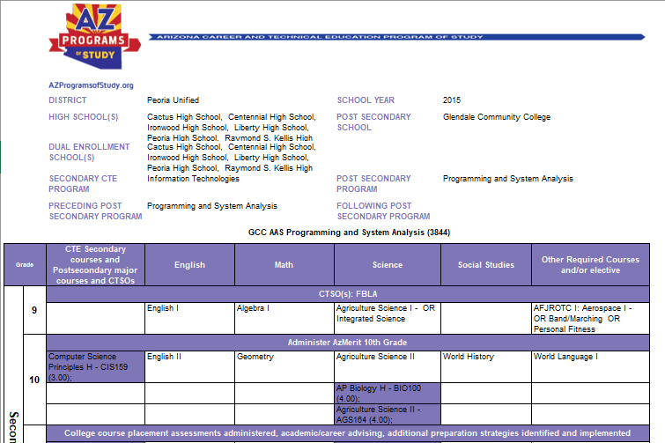

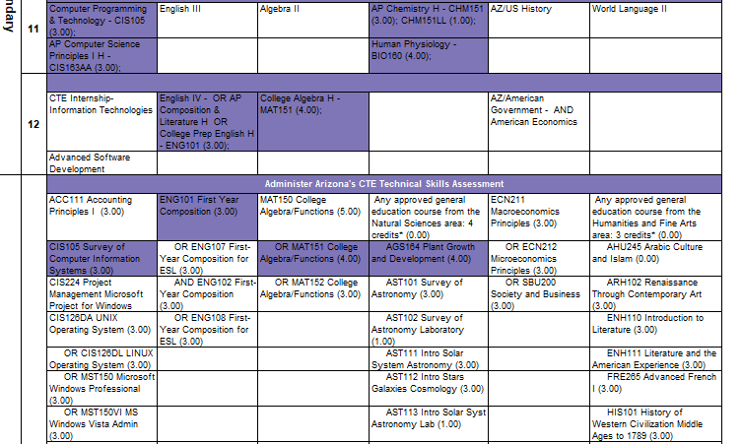

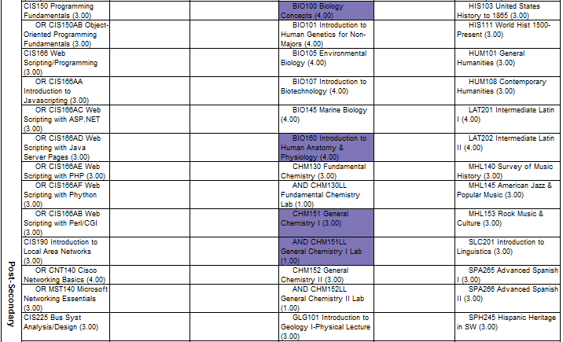

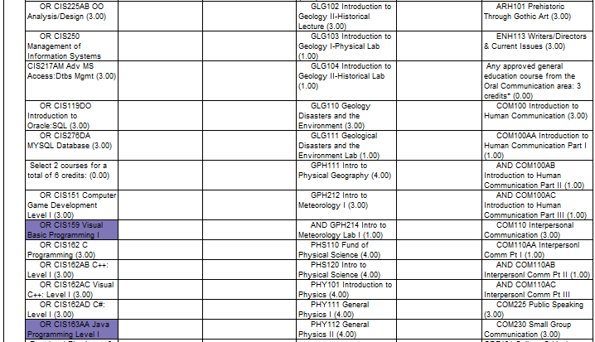

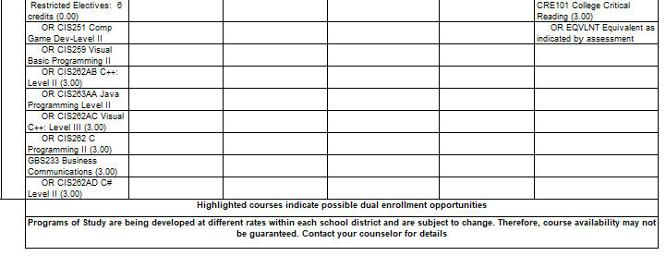

1. How do you ensure that CTE instruction and coursework is integrated with core academics? Please provide one, specific example.

All instructors participate in Peoria CTE Professional Development. Instruction is provided during district-wide professional development and Modified Mondays on how to ensure alignment with Arizona core standards – Language Arts, Mathematics and Science. During advisory council meetings that focus on curriculum, our business partners highlight activities where students are to use written skills for technical reports, verbal skills to present project to community members, math skills in programming. A specific example is one where our advisory board members provide instruction on a case study using a published true novel based on cyber security. The students have an opportunity to write a description of the situation/problem, gather background information discovered that describes why there is a problem, discuss the solution and thought processes that lead up to the problem, provide an evaluated response to the solution, and then verbally present the problem with evidence used to create a solution.

1. List the opportunities for learners to earn articulate and/or transcript dual enrollment credit across K-12 and postsecondary, such as AP/IB, dual and concurrent enrollment, capstone experiences and/or transcripted credit articulation agreements. (250 word limit)

The program offers twelve (12) dual enrollment credits through Glendale Community College.

* Computer Programming and Technology = CIS105 (3 credits)
* Computer Science Principles H = CIS159 (3 credits)
* Game Design & Development = CIS151 (3 credits)
* AP Computer Science A = CIS163AA (3 credits)
* AP Computer Science Principles = AP College Credit
* **Option 1**: GCC Certificate of Completion in Computer Information Systems (5671 Major Code) 21 credits (Appendix D) 12 of 24 credits obtained as dual enrollment
* **Option 2:** GCC Associates of Science in Computer Information Systems (3152 Major Code) 61-67 credits (Appendix D) 12 credits obtained through Software Development **and/or** the Completion of the 21 credits of the Certificate of Completion in Computer Information Systems (Appendix D), plus additional credits obtained through core classes (see question #17)
* **Option 3**: GCC Certificate of Completion in Game Technology (5637 Major Code) 28 credits (Appendix E1) 6 of 28 credits obtained as dual enrollment
* **Option 4:** GCC Associates of Science in Game Technology (3145 Major Code) 62 credits; 6 credits obtained through Software Development program **and/or** the Completion of the 28 credits of the Certificate of Completion in Game Technology
* **Option 5**: GCC Certificate of Completion in Program & System Analysis (5048 Major Code) 24 credits (Appendix E2) 12 of 24 credits obtained as dual enrollment
* **Option 6:** GCC Associates of Science in Program & System Analysis (3844 Major Code) 64-70 credits (Appendix D) 12 credits obtained through Software Development **and/or** the Completion of the 24 credits of the Certificate of Completion in Computer Information Systems (Appendix E2)
* **Option 7:** AP Course credit to Universities (see Appendix E1 and E2)
* **Option 8**: Bachelors of Science in Computer Information Systems from Arizona State University (Appendix D)

1. Please provide information on **at least three partnerships** with *education institutions and groups* your program of study has, and describe how these partnerships have been built, maintained and sustained over time. Use this space to specifically address the secondary and postsecondary partners that contribute to and maintain this program of study.

|  |  |  |
| --- | --- | --- |
| **Education Partnership Name** | **What role does this partner have in directly supporting your program of study?** | **How many years has this partnership been active, and how was this partnership developed?** |
| Maricopa County Community College District – Coordinating College is Glendale Community College | Serves on the CTE Software Development Advisory Council. Coordinates the Dual Enrollment for the program including certifying the teacher of their eligibility to teach Dual Enrollment and coordinates the Associates Degree program for students. Coordinates partnership with Arizona Universities. Post-Secondary Partner on Rigorous Programs of Study Grant. GCC certifies instructor, shares facility, curriculum advice, certification advice, stackable credential advice, etc. | * This partnership has been active for over 20 years * The partnership started with the CCTI grant, continued through mutual strategic planning and advisory councils and continues for the benefit of students – shares facilities, GCC facility for Saturday classes and dual enrollment. |
| Arizona Programs of Study | Support Stackable Credentials for all programs of studies in Arizona. Has had Peoria present to CTE Local Directors. | Since 2012 AzPOS provides information dissemination materials and collaboration day resources. |
| Arizona Department of Education | Supports CTE Software Development Program of Study and Stackable Credentials. | Over 50 years, ADE CTE has provided state blocked grants and fiscal overlook of Perkins funds. ADE CTE manages the updating of the standards with industry partners, plus the administration of the State Technical Assessments. |
| West-MEC (Western Maricopa Education Center) | Peoria CTE is a Satellite District for West-MEC, a Joint Technical Education District (JTED). Through West-MEC funds, Software Development has specialized equipment, supplies and supports stipends for teachers. | Since 2003 Arizona voters agreed to a JTED to expand CTE options to students. |
| Grand Canyon University | Guidance on curriculum content | Over 5 years |
| Peoria Unified School District – Information Management Technology Department | * Provides Advisory Council members * Guest Speaker * Curriculum recommendations * Internship Opportunities | Over 20 years |

# **ALIGNMENT WITH INDUSTRY AND BUSINESS NEEDS**

1. Describe how your program of study is aligned with the needs of the workforce and industry in your community. Make sure to include information on how the program of study helps meet workforce demand identified by business and industry. What labor market data does your program of study use to align to workforce needs? (250 word limit)

Peoria Unified School District Software Development programs were started to address the employment needs of the community and train future employees. According to the Bureau of Labor Statistics, April 2018 data, Software Developers are growing higher than average at 24% as a Job Outlook, 2016-20126. According to Burning Glass, an MCCCD predictive software based on Maricopa County demand, Software Developers are in the top 5 occupations needed. The Software Development Advisory Council constantly assesses the need for additional standards, revising standards and what skills students will need to be successful in the workforce. The advisory council members provide constant feedback for student Industry Certifications, Certificates, Associates of Science degrees and Bachelor of Science degrees. The Advisory Council provides work based learning experiences for students and externships for teachers.

1. Are ALL learners in the program of study required to participate in a work-based learning opportunity? Please describe the work-based learning opportunities available to learners who participate in this program of study. (250 word limit)

Not required, but 10% students participate in CTE Internship – Software Development – and obtain a minimum of 100 hours of unpaid work experience. 100% of students participate in work based learning experiences – like shadowing professionals, project based learning, coding, webpage creation, etc.

CTE Internship – Software Development is a capstone class in this program.

* The pre-requisites for the course are minimum of 1 credit in the Software Development program; ability to provide own transportation to internship site.
* Course description: This course is a coordinated occupational employment approach to teaching and practicing the concepts in the industry. This course helps the student to practice and improve employability skills in the industry.
* Students participate in a minimum of 100 hours of unpaid internship, job shadow and/or projects including:
  + Internships with companies and Advisory Council members
  + Create software programs of student announcements

Work based learning experiences include:

* Hands on training and scenarios with business partners:
  + Cleaning computer memory
  + Installing new software
  + Installing hardware and computer components
* Departmental functions, interdepartmental relationships, management of buildings and equipment and technical aspects of information technology will also be emphasized. Plus, written application processes, requirements, preparations of resumes and their effect on employment prospects.
* Preparation for the interview is to include communication skills, mental preparation techniques, personal presentations and behaviors, in addition to the importance of the interview in the pre-employment process.
* FBLA standards are integral part of this class.

1. Please list the industry-recognized credentials/certifications/licenses offered/required. If your program of study does not include industry-based credentials/certifications, please explain why. (200 word limit)

|  |  |
| --- | --- |
| **Offered** | **Required** |
| Certificate of Completion in Computer Information Systems | N/A |
| Associates of Applied Sciences in Computer Information Systems |  |
| Certificate of Completion in Game Technology |  |
| Associates of Applied Sciences in Game Technology |  |
| Certificate of Completion in Program & System Analysis |  |
| Associates of Applied Sciences in Program & System Analysis |  |
| Bachelors of Applied Sciences in Computer Information Systems |  |

1. Please provide information **at least three** *business, industry and/or labor* partnerships your program of study has, and describe how these partnerships have been built, maintained and sustained over time.

|  |  |  |
| --- | --- | --- |
| **Business/Industry Name** | **What role does this partner have in directly supporting your program of study?** | **How many years has this partnership been active, and how was this partnership developed?** |
| Matt Bullock (Former PUSD Governing Board Member) Nova Mesa Computer | * Provides Advisory Council members * Guest Speaker * Curriculum recommendations * Internship opportunities | Over 5 years |
| American Express;  Kerry Kane (Council Chair and 2017 CTE Volunteer of the Year) | * Provides Advisory Council members * Guest Speaker * Curriculum recommendations * Internship Opportunities * Job Shadow and Conversations | Over 15 years |
| Emerald Computers | * Provides Advisory Council members * Guest Speaker * Curriculum recommendations | Over 10 years |
| Recruit Bit | * Provides Advisory Council members * Guest Speaker * Curriculum recommendations * Internship Opportunities | Over 5 years |
| Computer Troubleshooters | * Provides Advisory Council members * Guest Speaker * Curriculum recommendations * Internship Opportunities | Over 5 years |
| Acciente LLC; Valor Global; IBM Cloud Shared Services; APS; PetSmart; Terra Verde; Simple2Serious, City of Peoria IT Department, CSAA and Promineotech | * Provides Advisory Council members * Guest Speaker * Curriculum recommendations * Internship Opportunities | Over 10 years for each company |

1. Please feel free to use the space below to share any other information or evidence of success of your program of study and the learners who participate. (Optional)

City of Peoria IT Department provided an excellent opportunity for an intern who was trying to decide on an area to specialize in for technology. He started his internship with a passion for networking and slowly discovered the vast areas of IT with a city structure. The opportunity provided outlets to discover security, networking, hardware and software development and realized multiple areas of specialization would created more demand and opportunity of his IT skills and talent. He is now enrolled at the collegiate level in several overlapping IT degree programs and is progressing with great success towards his future goals.

One of our information technology interns was a lead researcher for large IT company, where she helped developed a program processing tradeshow information. The program helped manipulate lead retrievals, which occurred daily, then combined research of related organizations and their websites. Thus, creating additional pertinent information related to specific leads to help assist future sales efforts.

Software Development students are attending Glendale Community College and Arizona State University, in the highest numbers. Some students are attending ITT Technical Institute.

Employers for graduates of this program include:

* Phoenix Medical Group
* Staples
* Chad Scott
* Walmart
* Baffled Escape Rooms
* VyondCloud
* Kutta Technologies
* The Forum at Desert harbor
* Liquidation Center
* Game Stop
* Viatek Solutions
* Click in Cent Media
* Fry’s Electronics
* State of Arizona Department of Education
* Fry’s Good and Drug

1. If applicable, please provide more detail on any partnerships your program of study has that have not been mentioned already. This includes community groups, non-profits, volunteer organizations, etc. Describe how these partnerships have been built, maintained and sustained over time. (Optional)

|  |  |  |
| --- | --- | --- |
| **Additional Partnerships** | **What role does this partner have in directly supporting your program of study?** | **How many years has this partnership been active, and how was this partnership developed?** |
| Science Foundation Arizona | * Provides Advisory Council members * Guest Speaker * Curriculum recommendations | Over 10 years |
| Peoria Chamber of Commerce | * Provides Advisory Council members * Guest Speaker * Curriculum recommendations * Internship Opportunities | Over 20 years |
| Year Up | * Provides Advisory Council members * Guest Speaker * Curriculum recommendations | Over 5 years |

# **SUBMIT YOUR APPLICATION**

**SUBMIT YOUR APPLICATION**

* Fill out this application.
* Once you have finished, complete [this form](https://careertech.org/2019-excellence-action-application) and upload the following:
* Your full application saved as a Word document (.docx)
* All of your supplemental documents or evidence consolidated as one PDF document.

**THANK YOU!**

Thank you for completing this application! You will know the status of your application by January 22, 2019. The programs of study will be evaluated based on their effective leveraging of partnerships, alignment to rigorous and relevant college- and career-ready expectations, clear progression of knowledge and skills across secondary and postsecondary systems, integration of successful career guidance/advisement, and key indicators of learner success.

Don’t forget to use the Excellence in Action award submission checklist to make sure you’ve completed your application in its entirety.

We look forward to learning more about your program!

For questions, concerns please contact [awards@careertech.org](mailto:awards@careertech.org).