# **ADVANCE CTE EXCELLENCE IN ACTION AWARD**

**PROGRAM SUMMARY**

Advance CTE is pleased to announce a call for applications for the sixth annual Excellence in Action awards, through which we recognize and honor superior Career Technical Education (CTE) programs of study from across the nation.   
  
**CRITERIA FOR JUDGING**

Selected programs will exemplify excellence in:

* Implementing Career Cluster®-based [programs of study](https://careertech.org/programs-study);
* Maintaining effective employer and business partnerships;
* Demonstrating alignment to rigorous and relevant college- and career-ready expectations;
* Demonstrating a clear progression of knowledge and skills and learner transitions across secondary and postsecondary systems;
* Integrating successful career guidance and advisement;
* Integrating high-quality work-based learning experiences;
* Highlighting alignment to workforce and employer needs in the community;
* Providing concrete data on the program of study’s impact on learner achievement, success at both the secondary and postsecondary levels and meeting the needs of underserved populations; and
* Delivering high-quality and effective instruction.

**ELIGIBILITY**

* This award is open to any public secondary or postsecondary schools or colleges in the United States. Your school or institution may submit one application per [Career Cluster](http://careertech.org/career-clusters);
* The program of study must have at least one full graduating class;
* Your program must be eligible to receive funding from the Carl D. Perkins Career and Technical Education Act;
* Applications that do not include data to demonstrate positive impact on learner achievement will not be eligible for consideration.
* If your program has received in an Excellence in Action award from Advance CTE in the past, you may not apply for that same Career Cluster. However, your school or institution may apply in a different Career Cluster.

**AWARD SUBMISSION REQUIREMENTS**

Complete applications will contain the following:

* A completed application including supplemental materials by the application deadline of **November 21, 2018 at 5 p.m. ET.**
* At least one letter of support from an employer or business partner supporting the program of study; and
* At least one additional letter of support from a partner (education, community or business) of your choosing.
* *Optional:* Supplemental materials including photos, videos, news articles, etc., are welcome but not required.

The application must be submitted using [this form](https://careertech.org/2019-excellence-action-application). The application must be submitted in a Microsoft Word format. Supplemental materials, including the letters of recommendation, must be combined and submitted as **one** PDF document.

*Please note:*

* Submissions should **not** include any personally identifiable learner data.
* The application does not have a page limit, however, many questions do have a word limit. Please do not submit responses that go beyond this limit. Also, submissions that do not contain all the required materials (a completed application, two letters of support and supplemental materials in the correct formats) will not be advanced for consideration.

**WINNERS WILL RECEIVE**

* A banner to hang in their school or institution;
* A digital banner to use in email and print materials as they so choose;
* Travel and one hotel room for one night in Washington, DC for a representative to be recognized at an awards ceremony to be held the week of April 8-10, 2019 at the Advance CTE Spring Meeting; and
* Discounted rate to the Advance CTE Spring Meeting

**WINNERS WILL ALSO BE FEATURED IN**

* A national press release, which will be distributed to national media.
* A winner-specific press release to distribute to local media;
* A standalone one-pager;
* A standalone blog on the [Learning that Works blog](http://blog.careertech.org/);
* Representation on the Advance CTE [website](http://www.careertech.org).
* Many past winners have been featured in national conferences, in briefs and reports, on webinars and in the media.

**HOW TO APPLY**

* Fill out the following application.
* Once you have finished, complete [this form](https://careertech.org/2019-excellence-action-application) and upload the following:
* Your full application saved as a Word document (.docx)
* All of your supplemental documents or evidence consolidated as one PDF document.

**BACKGROUND INFORMATION**

1. Program of study name: Horticulture
2. Point of Contact  
    Name: Brian Clement

Email Address: [clement@cod.edu](mailto:clement@cod.edu)

Phone Number: (630) 942-2526  
Address: 425 Fawell Blvd Glen Ellyn, IL 60137

1. Applicant’s School/College: College of DuPage, District 502
2. State: Illinois
3. Type of institution (click the box to check)

☐ Area technical center

☐ Career academy

☐ Comprehensive high school

☐X Community college

☐ Technical college

Other (please specify)

|  |
| --- |
|  |

1. Career Cluster in which your program of study should be considered (Follow this link for a further explanation of each Career Cluster [careertech.org/career-clusters](http://careertech.org/career-clusters)) **(Select only ONE):**

☐X Agriculture, Food & Natural Resources Career Cluster

☐ Architecture & Construction Career Cluster

☐ Arts, A/V Technology & Communications Career Cluster

☐ Business Management & Administration Career Cluster

☐ Education & Training Career Cluster

☐ Finance Career Cluster

☐ Government & Public Administration Career Cluster

☐ Health Sciences Career Cluster

☐ Hospitality & Tourism Career Cluster

☐ Human Services Career Cluster

☐ Information Technology Career Cluster

☐ Law, Public Safety, Corrections & Security Career Cluster

☐ Manufacturing Career Cluster

☐ Marketing Career Cluster

☐ Science, Technology, Engineering & Mathematics Career Cluster

☐ Transportation, Distribution & Logistics Career Cluster

1. In three sentences or less, describe your program of study, including the secondary and postsecondary components and how long the program of study has been in place.

The Horticulture Program at College of DuPage started in 1970, offers Associate in Applied Science degrees in Horticulture, Landscape Contracting and Management, and Sustainable Urban Agriculture as well as nine specialized certificates. It is the largest horticulture program in the state of Illinois with over 270 students. The horticulture program also offers seven high school program of studies and dual credit with districts in 502 that also offer horticulture.

1. Please check the geographical and demographic setting for your program of study and describe the geographic and economic conditions of the region served by the school.

☐ Urban

☐x Suburban

☐ Rural

☐ Other

1. Please describe how your program of study was developed and how it ensures learners are academically and technically prepared for both postsecondary education and careers. Please also address the following:
   1. How were employers involved in the development and continue to be involved in the maintenance of your program of study?
   2. How does this program of study meet the economic needs of your community?
   3. How does this program prepare learners for postsecondary education? (if applicable)
   4. How were both secondary and postsecondary educators involved in the development and/or maintenance of the program of study? (500 word limit)

College of DuPage’s Horticulture program dates back to 1970. DuPage County, with a population of over 600,000 at the time was in the path of tremendous population expansion. In addition, being adjacent to the most populous segment of the state, there was the obvious current as well as future need for personnel trained in the many areas of the field of horticulture. The Ornamental Horticulture program was approved by the Illinois Junior College Board and the Board of Higher Education on October 12, 1970. An Associate Degree and a Certificate program was developed to fit the specific needs and interests of students. The major objectives of the program included: providing a broad base of occupational courses for a student to explore the field, providing a cooperative program which allowed students to receive specialized training in their particular field of endeavor, and to ultimately provide sufficient occupational information to assist the student in securing a position in the job market. The idea was that providing greenhouse facilities and experimental plots of lands from the inception of the program, would allow the occupational program to operate in a manner consistent with the philosophy of the Vocational Act of 1968, the Illinois Junior College Act, and the prevailing philosophy of the institution, “prepare students for entry into gainful occupations, to either improve their present skills or to teach them new proficiencies.”

The College sought to provide curriculum to reflect the rapidly changing demands of the society. As in all occupational programs at the time, an advisory committee was established, comprised of the most prominent leaders of the community, representing a cross-section of occupational areas within the field of ornamental horticulture and including a secondary level horticulture educator. This committee continues to meet regularly providing valuable input and feedback regarding the skills necessary for success in the industry and providing evaluation of COD’s Horticulture courses, certificates and degree programs. This evaluation helps maintain the quality and professional relevance of the Horticulture program.

In 2015, the Horticulture department sought out national accreditation that is based on meeting all provisions of a model curriculum, through the National Association of Landscape Professionals (NALP). Accreditation is the NALP’s endorsement of colleges and universities with outstanding landscape contracting or horticulture degrees. Accreditation provides guidance to create and/or improve current program curricula, while providing both local and national recognition. That same year, the program added two degrees in Landscape Contracting and Management and Sustainable Urban Agriculture, two certificates in Sustainable Urban Agriculture and Power Equipment Technology and 15 classes to the curriculum. The program continues to grow and evolve to meet the increasing demand of qualified workers. It also works closely with industry to help fill the 300,000 positions that open up annually with people who love the outdoors, have a passion for the environment, and want to make a difference in their lives and the lives of those around them.

# **LEARNER POPULATION & DATA**

Please describe your program of study’s demographic and outcome data for the most recent academic year(s). It is our strong preference to have data from both secondary and postsecondary levels. If this is not available, please provide an explanation as to why the data from the other learner level is not available. Applications that do not include data to support positive impact on learner achievement will not be eligible for consideration. (100 word limit)  
  
Our program is unique in we have students seeking Associate Degrees and/or Certificates, presently employed in the industry updating their skills in certain areas, or taking specific classes to fulfill their own interests. Very few students go on to complete a postsecondary degree, since industry prefers just an associate degree. Completion rates are low due to the number of students working in the industry full-time who take a few years to finish. Secondary level data is for Metea Valley High School, our largest program of study. Numbers for the other six programs of study are included in our supporting documents.

**NOTE**: Please specify if and when you are using a percentage with a different denominator (e.g., seniors) than the one listed.

**When completing the data section, please only use percentages and include data that is from your program of study. Additionally, only include data where learners are eligible to participate (e.g., only seniors in high school will be eligible for the section asking for percent of seniors who graduated high school, so only seniors should be included in that data; if your work-based learning only occurs within a specific grade level, only include them in your data for that category.)**

|  |  |  |  |
| --- | --- | --- | --- |
| SCHOOL YEAR | 2015-16 | 2016-17 | 2017-18 |
| **SECONDARY-LEVEL DATA – METEA VALLEY HIGH SCHOOL** | | | |
| **What is the total number of learners served by your school/institution?** | 2,915 | 2,853 | 2,887 |
| What is the total number of minority learners served by your school/institution? (estimates based on percentages) | 1,516 | 1,541 | 1,646 |
| What is the total number of low-income learners served by your school/institution? (estimates based on percentages) | 554 | 571 | 578 |
| What is the total number of learners with disabilities served by your school/institution? (estimates based on percentages) | 350 | 257 | 260 |
| What is the total number of English language learners served by your school/institution? (estimates based on percentages) | 30 | 58 | 87 |
| **What is the total number of learners served by your program of study?** | 51 | 48 | 61 |
| % male learners in program of study | 55% | 46% | 44% |
| % female learners in program of study | 45% | 54% | 56% |
| % minority learners program of study | 60% | 59% | 37% |
| % low-income learners program of study (NA) | NA% | NA% | NA% |
| % learners with disabilities program of study | 2% | 2% | 0% |
| % English language learners program of study (NA) | NA% | NA% | NA% |
| Other relevant *demographic* data from your **program of study** |  |  |  |
| % of learners in program of study who earned postsecondary credit (dual enrollment, AP, etc.) | 100% | 96% | 98% |
| % of learners in program of study who earned an industry-recognized credential | 0% | 0% | 0% |
| % of learners in program of study who participated in work-based learning | NA% | NA% | NA% |
| % of seniors in program of study who graduated high school (who were eligible/seniors) (data is limited to COD student data records) | 98% | 100% | 98% |
| % of graduates in program of study who enrolled in postsecondary education (who were eligible/seniors) (data is limited to those attending COD post-graduation) | 43% | 46% | 41% |
| % of graduates in program of study who entered the workplace and/or military (who were eligible/seniors) | NA% | NA% | NA% |
| **POSTSECONDARY-LEVEL DATA – College of DuPage** | | | |
| **What is the total number of learners served by your school/institution?** | 46,651 | 45,176 | 43,702 |
| What is the total number of minority learners served by your school/institution? | 18,686 | 19,076 | 18,975 |
| What is the total number of low-income learners served by your school/institution? | 4,760 | 4,476 | 4,874 |
| What is the total number of learners with disabilities served by your school/institution? | 1,989 | 2,193 | 2,225 |
| What is the total number of English language learners served by your school/institution? | 3,761 | 3,325 | 3,230 |
| **Total number of learners served by your program of study *(only includes HORT academic programs)*** | 124 | 166 | 173 |
| % male learners in program of study | 49% | 48% | 56% |
| % female learners in program of study | 51% | 52% | 45% |
| % minority learners in program of study | 15% | 15% | 15% |
| % low-income learners in program of study | 13% | 11% | 10% |
| % learners with disabilities in program of study | 6% | 4% | 5% |
| % English language learners in program of study | 0% | 1% | 1% |
| **Other relevant *demographic* data from your program of study** (only includes HORT academic programs) |  |  |  |
| % of learners in program of study who completed postsecondary/earned a degree or certificate (who were eligible) | 37% | 19% | 13% |
| % of learners in program of study who earned an industry-recognized credential (who were eligible) | 59% | 24% | 34% |
| % of graduates in program of study who entered the workplace and/or military (who were eligible) | 98% | 90% | 91% |
| % of graduates in program of study who transitioned to further postsecondary education (who were eligible) | 5% | 10% | 9% |

1. Provide links to the source of the above data. If the links are not publicly accessible, please explain the source of the data. If you are missing any data, please explain why and how you measure success.

**COD Planning and Reporting Documents**

* <http://www.cod.edu/about/office_of_the_president/planning_and_reporting_documents/index.aspx>
* Secondary data source: <https://www.illinoisreportcard.com> and COD A1 submissions and institutional data records
* Postsecondary sources: COD ICCB A1 submissions and institutional data records
* COD Horticulture Graduate Survey administered by Research and Analytics Department
* Industry credentials maintained in horticulture department data collected each semester

1. How does your school or institution ensure equitable access for learners with diverse backgrounds? (150 word limit)

College of DuPage endorses the right of each person to accessible and affordable opportunities to learn and affirm the innate value of the pursuit of knowledge and its application to life. Our primary commitment is to facilitate and support student success in learning. We seek to reflect and meet the educational needs of the residents of our large, multicultural district by recognizing the importance of embracing individual differences and cultures and value the contributions made to the College by people of all ethnic and cultural backgrounds. We support participatory governance and the involvement of the College community in the development of a shared vision and that all students, staff and residents can make meaningful contributions within a respectful environment that encourages meaningful discourse. We strive to build an organizational climate in which freedom of expression is defended and civility is affirmed.

1. How do you ensure learner success, especially of those who from diverse backgrounds? Please provide examples of what supports you offer learners. (150 word limit)

College of DuPage values diversity and seeks to assist all students in a way that embraces their individual needs and supports them in their academic ventures to achieve their academic goals and enhance student’s learning strategies to be successful, independent learners. The College accomplishes this by providing many services to assist students in making appropriate academic and career plans, addressing other issues and enriching their college experience through co-curricular activities. Key services include: counseling and advising, access and accommodations, veteran and military personnel student services, international student services, career services, learning commons (free tutoring), library, student life and leadership council, 90 student clubs, Latino outreach center and the center for student diversity and inclusion. Specifically, the center for student diversity and inclusion encourages all students to participate in curricular learning and co-curricular activities. Full-time faculty outreach to students to ensure they are in the correct academic program.

1. Is your program of study associated with a Career Technical Student Organization (CTSO)? If so, which one(s) and in what way(s)? (Check the [approved list](http://www.ctsos.org/ctsos/) of CTSOs) (50 word limit)

FFA and Skills USA are part of the program of study. The Horticulture Department hosts an annual Floral Career Development Event for high schools in Illinois. Secondary programs that we have dual credit agreements with and programs of study participate in numerous FFA and Skills USA events.

1. Describe how career guidance/advisement is integrated into your program of study to support learners’ completion of the program of study and entry into additional education/training and/or a successful career. Describe how you recruit students into CTE programs. Where applicable, describe the tools (individual career and academic plans, career exploration websites, etc.) that are provided to learners and how they are used. (200 word limit)

The mission of Counseling and Advising Services at College of DuPage is to provide students with developmental support services that are transformational and promote academic excellence. Support in reaching educational goals and career aspirations is provided to all admitted students with free confidential services in academic advising, career and personal counseling. Students in the Horticulture Department meet with an advisor each semester to review their individual and academic career plans, review degree audits, and plan internships to ensure the student is on the right path to a successful career. The department also produces an advising newsletter twice a year.

The Horticulture department is very active in recruitment into the CTE program. The Business and Technology division hosts its annual TEC Spotlight each spring where students and parents meet with faculty, tour the College’s cutting-edge CTE labs and explore careers. The department participates in the College’s STEM Career Day, numerous middle school career exploration and high school career fairs throughout the year, provide over 60+ tours of the department each year and host a horticulture career fair with over 50 companies in attendance. Faculty follows up with each student who expresses interest in Horticulture through the registration department and the website.

1. Which technical, academic and/or employability standards does your program of study incorporate at the secondary and/or postsecondary level and how? (Please list the standards you use and be specific regarding how your program uses industry, national, state and/or locally-developed standards) (250 word limit)

|  |  |
| --- | --- |
| **Standard Types** | **Please list the standards your program of study uses and how it uses them below:** |
| Academic Standards | Horticulture Department Program Learning Outcomes for each of our 3 Degrees and 9 Certificates at the Postsecondary level are aligned to our national accreditations. These are used for program assessment. Each student submits an internship portfolio towards completion of their degree and/or certificate with documentation. Programs of Study at the Secondary level are aligned to state Goals in Science, Math, Fine Arts, and Social Science and Secondary to Postsecondary Transition & Alignment for dual enrollment from secondary to postsecondary. |
| Career Cluster or Technical Standards | Illinois Career Cluster Framework which maintains five “college and career ready” CTE Program areas, under which the 16 Career Clusters fit, Alignment of the Illinois Pathway Initiative with the National Career Cluster Initiative. Each CTE Program at College of DuPage are aligned to these standards as well as our Programs of Study with our partner high schools. |
| Employability Standards | Illinois Essential Employability Skills Framework – integrated into curriculum, internships, co-curricular activities and reviewed annually by our advisory committee. |
| Other | Illinois Pathway Initiative- Currently being implemented here at College of DuPage. This will further provide additional intensive, individualized coaching to ensure students are learning while staying on the correct path to success. Additional intervention strategies and counseling will be available to students in the program of study. |

# **SEQUENCE OF COURSES & CREDIT TRANSFER**

1. Please fill out the chart below, and describe your program of study’s course sequence by grade level, including the relevant or required academic and technical courses, as well as other required activities.   
     
   **Make sure to highlight the course sequence that bridges secondary and postsecondary education.** Explain how your program of study ensures learners gain the broader Career Cluster-level knowledge/skills and, over time, gain the more specific occupation-level knowledge/skills as they progress through the program of study. You can also include graphics or [plans of study](https://cte.careertech.org/sites/default/files/PlanPathways-CareerCluster-AG-AgribusinessSystem.pdf) of the course sequence in lieu of filling out the chart below.

The Horticulture Program at College of DuPage has seven programs of study and dual credit agreements that bridge secondary and postsecondary education with local high schools in our district including Addison Trail, Neuqua Valley, Waubonsie Valley, West Chicago, Metea Valley, Naperville Central and Naperville North high schools. One example is included below for the three degrees we offer within the department. Each high school’s secondary requirements are different. The other six programs of study with our district high schools are posted on our website <http://www.cod.edu/programs/horticulture/horticulture-pathways.aspx> . We are in the process of translating these programs of studies into Spanish per the request of the high schools due to their large Hispanic population. We have also developed agreements with Oakton, Harper, Elgin, Waubonsee and Moraine Valley Community Colleges to offer dual credit and programs of study in high schools with horticulture programs in their districts. Those community college districts currently do not offer a horticulture program. We are in the process of working with East Aurora, Reavis and Rolling Meadows high schools to develop additional agreements.   
 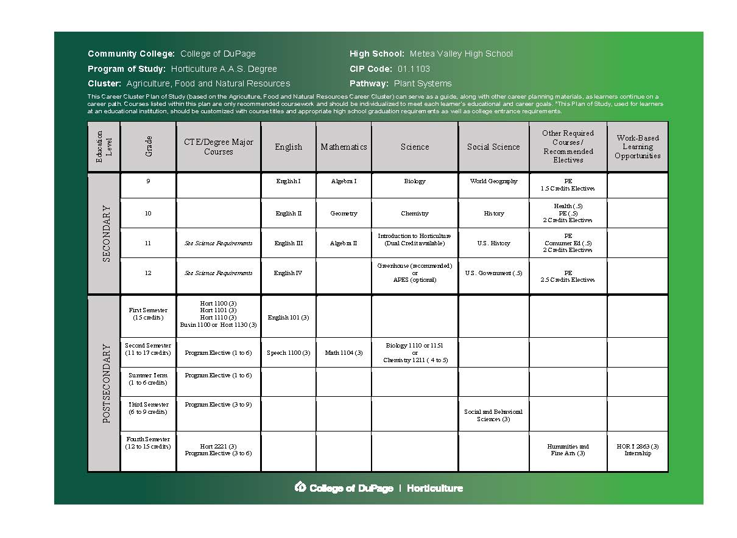

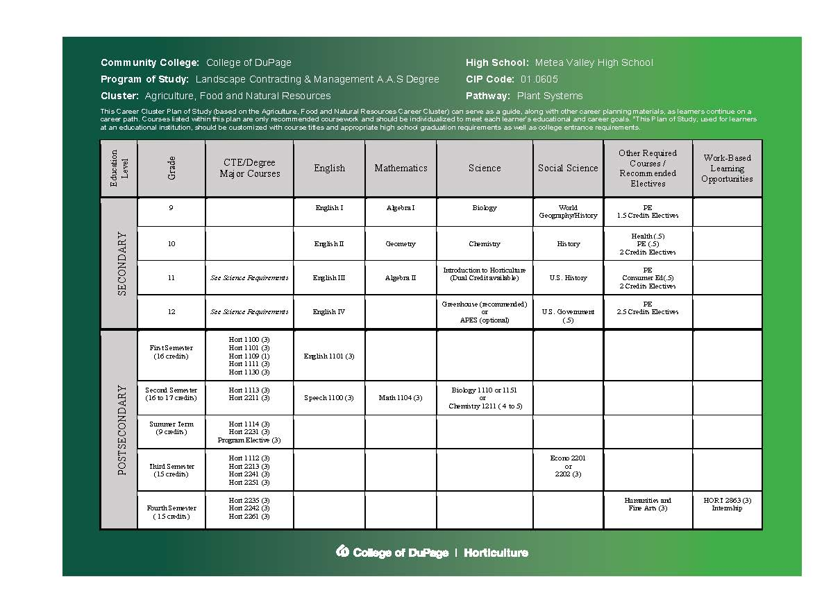

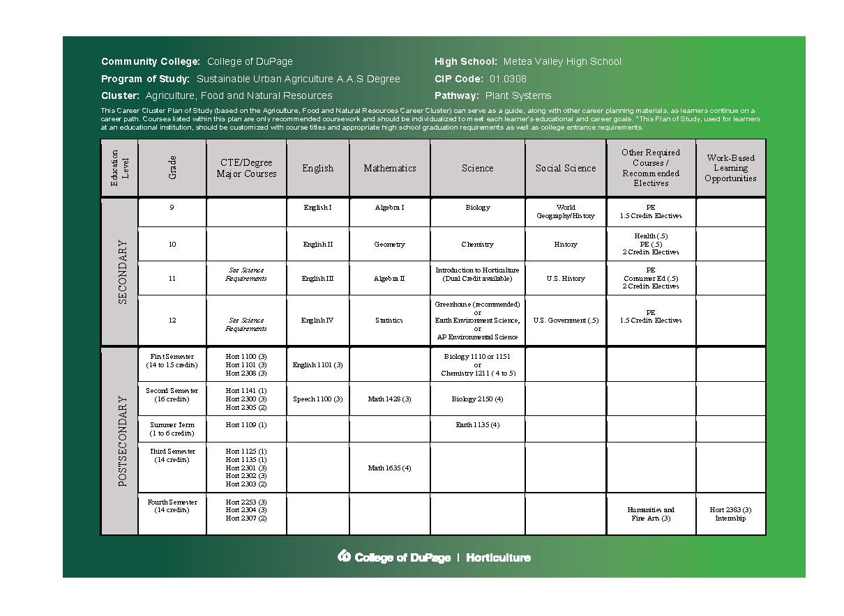

1. How do you ensure that CTE instruction and coursework is integrated with core academics? Please provide one, specific example.

The horticulture program at College of DuPage provides students with opportunities to acquire the competencies valued in today’s workplace such as critical thinking, collaboration, problem solving, innovation, teamwork and communication. The program addresses the goals of college and career readiness and provides learning options that are appealing to students. The program is aligned to rigorous academic standards and postsecondary expectations and it uses applied, contextual and experiential learning to help students see the relevance of what they are learning in the classroom and its connections to careers in the industry. Our advisory board reviews this on an ongoing basis and makes recommendations based on industry needs. One specific example in the horticulture program is horticulture math. Each student that completes a degree in horticulture and many of our certificates is required to take horticulture math as their degree requirement. Horticulture math is aligned to rigorous academic math standards and teaches the relevant and applied information students would be using in a career in the field.

1. List the opportunities for learners to earn articulate and/or transcript dual enrollment credit across K-12 and postsecondary, such as AP/IB, dual and concurrent enrollment, capstone experiences and/or transcripted credit articulation agreements. (250 word limit)

College of DuPage’s Dual Credit Program is an opportunity for qualified high school students to enroll in a college-level course and, upon successful completion, earn both college and high school credit. The college courses are taught at the high school during the regular school day by high school teachers who are credentialed as adjunct faculty at College of DuPage. Currently there are seven dual credit agreements worked out with Addison Trail, Neuqua Valley, Waubonsie Valley, West Chicago, Metea Valley, Naperville Central and Naperville North high schools. Students have the option to enroll in seven dual credit courses (data shown below). We have also developed agreements with surrounding community college districts including Oakton, Harper, Elgin, Waubonsee and Moraine Valley to offer dual credit and programs of study in high schools with horticulture programs in those districts. Those surrounding community college districts currently do not offer a horticulture program. Additional programs of study agreements with East Aurora, Reavis and Rolling Meadows high schools are in development. The College is looking into dual enrollment classes for high school students in the future.

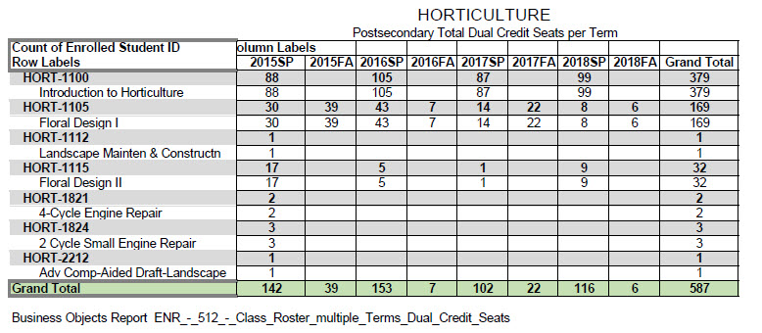

1. Please provide information on **at least three partnerships** with *education institutions and groups* your program of study has, and describe how these partnerships have been built, maintained and sustained over time. Use this space to specifically address the secondary and postsecondary partners that contribute to and maintain this program of study.

|  |  |  |
| --- | --- | --- |
| **Education Partnership Name** | **What role does this partner have in directly supporting your program of study?** | **How many years has this partnership been active, and how was this partnership developed?** |
| DeVry University | Option for students graduating with an Associate Degree in Applied Science in Horticulture to obtain a Bachelor Degree in Technical Management with an emphasis in Horticulture. Students are able to transfer in up to 80 credit hours from College of DuPage including their horticulture classes. | 3 years  Both College of DuPage and DeVry University sat down and worked out this degree option for students seeking to transfer to obtain a bachelor degree. |
| Southern Illinois University | An articulation agreement is currently being developed that would allow a student to apply credits earned in the Horticulture Program at College of DuPage towards a bachelor degree and specialization in production horticulture, landscape horticulture, or production horticulture turfgrass management. | 1st year – in progress  Both College of DuPage and Southern Illinois University have been working out an articulation agreement option for students seeking to transfer to obtain a bachelor degree. This agreement should be finalized within the next month or so. Option for students to pursue if they do decide to transfer to obtain a bachelor degree in the field of horticulture |
| Illinois Green Industry Association, H.O.P.E. Program, Horticultural Occupational & Professional Experience | Provide students with an opportunity to experience the Illinois Green Industry with a "hands-on" approach, demonstrating the potential career opportunities that exist within the field of Horticulture. From September through mid-spring students are provided business work experiences and educational opportunities that will give them an advance start on their career. It also provides them a better understanding of the inner workings of a typical green industry business. <https://www.illinoisgreen.net/hope-program> | 39 years  Since 1979, the Illinois Green Industry Association has been administering the H.O.P.E. program with College of DuPage faculty support and numerous students participating. |

# **ALIGNMENT WITH INDUSTRY AND BUSINESS NEEDS**

1. Describe how your program of study is aligned with the needs of the workforce and industry in your community. Make sure to include information on how the program of study helps meet workforce demand identified by business and industry. What labor market data does your program of study use to align to workforce needs? (250 word limit)

According to the Department of Labor Statistics, College of DuPage is situated in a Chicago metropolitan area with the highest employment level of landscaping and grounds workers in the U.S. employing over 20,030, with one of the highest annual mean wages. The National Association of Landscape Professionals produces labor market data and recruitment materials that are used to help align our program to the needs of the workforce and industry.

Employment in the Landscape Industry is projected to grow as fast as or faster than most occupations in DuPage County:

* Grounds Workers is projected to grow 13.20 percent from 2012 to 2022 with 238 annual job openings in DuPage County. Nationally, employment is projected to grow 18.2%.
* Landscaping and Grounds Workers is projected to grow 13.05 percent from 2012 to 2022 with 213 annual job openings in DuPage County. Nationally, employment is projected to grow 18%
* Pesticide Handlers & Applicators is projected to grow 2 percent from 2012 to 2022 with 6 annual job openings in DuPage County. Nationally, employment is projected to grow 17.7%.
* Tree Trimmers & Pruners is projected to grow 5 percent from 2012 to 2022 with 11 annual job openings in DuPage County. Nationally, employment is projected to grow 26.3%.
* Grounds Maintenance Workers, All Others is projected to grow 3 percent from 2012 to 2022 with 9 annual job openings in DuPage County. Nationally, employment is projected to grow 11.8%.

Employment projections for surrounding DuPage Counties are also very high, enforcing the need for qualified workers.

1. Are ALL learners in the program of study required to participate in a work-based learning opportunity? Please describe the work-based learning opportunities available to learners who participate in this program of study. (250 word limit)

As an important link between job seekers and the business community, Career Services and the Horticulture Department at College of DuPage offers a variety of resources to help students with their short and long-term career goals and help business with staffing needs. Pursuing an internship or work-based learning opportunity is a great way for students to gain valuable experience in their chosen career path. All horticulture students are required to complete an internship towards the completion of their studies; requiring 225 hours on the job. Students seek out the internship and work with the employer to develop learning goals or outcomes. Students also work with their employer to develop a project or research paper that relates to their internship, which could include developing marketing materials, coordinating an event, being a lead designer on a project, compiling educational materials, data collection, analysis, etc. Upon completion of the internship, students must turn in a portfolio documenting their experience that includes a current resume, short-term and long-term goals, applied, acquired and additional skill sets, internship documentation including work samples and other evidence of achievement in the horticulture program. The portfolio indicates the level of expertise in the subject matter, shows proof of skills and abilities learned, shows evidence of their abilities, and contains personal and professional goals. The horticulture department currently uses data from portfolios for program review and to assess the student learning outcomes in the program.

1. Please list the industry-recognized credentials/certifications/licenses offered/required. If your program of study does not include industry-based credentials/certifications, please explain why. (200 word limit)

|  |  |
| --- | --- |
| **Offered** | **Required** |
| National Association of Landscape Professionals Department Accreditation | Yes |
| OSHA 10-Hour Safety Certification and Card | Yes, for Landscape Contracting and Management Degree and Sustainable Urban Agriculture Degree, optional Horticulture Degree |
| STIHL 2-Cycle Small Engine Bronze Certification | Yes |
| Briggs and Stratton Master Service Technician | Yes |
| Equipment & Engine Training Council (EETC) Certifications | Recommended, students are encouraged to take certification exams in two-stroke, four-stroke, compact diesel, electrical, generators, and drivelines. Seeking EETC School accreditation this year. |

1. Please provide information **at least three** *business, industry and/or labor* partnerships your program of study has, and describe how these partnerships have been built, maintained and sustained over time.

|  |  |  |
| --- | --- | --- |
| **Business/Industry Name** | **What role does this partner have in directly supporting your program of study?** | **How many years has this partnership been active, and how was this partnership developed?** |
| Illinois Landscape Contractors Association (ILCA) | Executive Director serves on Horticulture Advisory Committee and as Committee Chairman. Faculty serve on FLIP (recruitment) and Education Committees at ILCA | This partnership has been in existence for 20+ years. |
| Russo Power Equipment | Representative serves on our Advisory Committee, provides field trips, guest speakers, internships and financial support to the program | This partnership has been in existence for 12 years |
| Unilock | Provides field trips, guest speakers, and financial support/materials to the program | This partnership has been in existence for 10 years |
| Midwest Ground Covers/Midwest Trading | Provides field trips, guest speakers, internships and financial support to the program | This partnership has been in existence for 30+ years |
| STIHL | Provides guest speakers, curriculum support and financial support to the program | This partnership has been in existence for 12 years |
| Acres Landscape Company | Provides guest speakers, internships, faculty externships and financial support to the program. One of their employees is an adjunct instructor in the program and teaches Horticulture Business | This partnership has been in existence for 10+ years |
| Ball Horticulture | Provides guest speakers, internships, and financial support to the program | This partnership has been in existence for 30+ years |
| Platt Hill Nursery | Provides guest speakers, internships, and financial support to the program | This partnership has been in existence for 15+ years |
| The Morton Arboretum | Provides field trips, guest speakers, various partnerships, advisory board representation, and internships to the program | This partnership has been in existence for 25+ years |
| The Growing Place | Representative serves on our Advisory Committee, provides guest speakers, internships, and financial support to the program | This partnership has been in existence for 20+ years |

***Note:***  *All of our partnerships with business, industry and/or labor partnerships have developed as a result of industry reaching out to our department to help fill the huge labor shortage our industry is facing and to help train qualified employees in the industry. We have a very close relationship with industry and work together to try to find ways to improve the education students are receiving and recruit students to fill the huge labor shortage gaps.*

1. Please feel free to use the space below to share any other information or evidence of success of your program of study and the learners who participate. (Optional)

* The horticulture department offers 53 classes that comprise our core curriculum with additional courses developed as needed covering special topics of interest to meet the student, community and industry needs.
* Various student outreach efforts have been implemented in the horticulture department to ensure students are enrolled in the correct academic programs and are taking the correct classes. An advising update and department newsletter are distributed to all horticulture students during the fall and spring semesters. Faculty advisors review student academic programs with students and provide advising sessions throughout the year.
* Each fall the department submits an updated program review. Faculty reviews demographic profiles and disaggregated data to ensure students are performing well across all population groups and various strategies are implemented to address any gaps including recruitment efforts, retention, additional counseling and advising, and making changes to the program with feedback and support of the advisory committee. The Business and Technology Division is fortunate to have a student retention specialist in the building that meets with the introductory classes each semester and surveys the students. The student retention specialist works with students based on the survey results by applying intensive motivational and case management strategies to encourage satisfactory academic performance and engagement in the program.
* The Horticulture Department has a Horticulture Alumni Group with 300+ former students to help keep them informed of the Horticulture Department events and offering various ways for them to get involved either by attending events, serving as guest speakers for classes, mentoring students, volunteering, donating to scholarships etc. <https://alumni.cod.edu/alumni-groups>
* The Business and Technology Division including Horticulture will be spotlighted in the annual Engage Magazine that is produced by the College and sent out to all residential households in District 502. The Engage Magazine is a periodic report on what a difference the community member’s tax dollars have made demonstrating a return on investment at the college. This issue will be released sometime in November 2018. <http://www.cod.edu/about/office_of_the_president/engage/index.aspx>
* Fall 2018 enrollment in the Horticulture Department is up around 12% based on 10th day fall 2018 enrollment numbers. Overall numbers in the horticulture department are the highest they have been since fall 2012 and continue to grow with industry connections, recruitment efforts and the demand to fill a labor shortage in the industry.

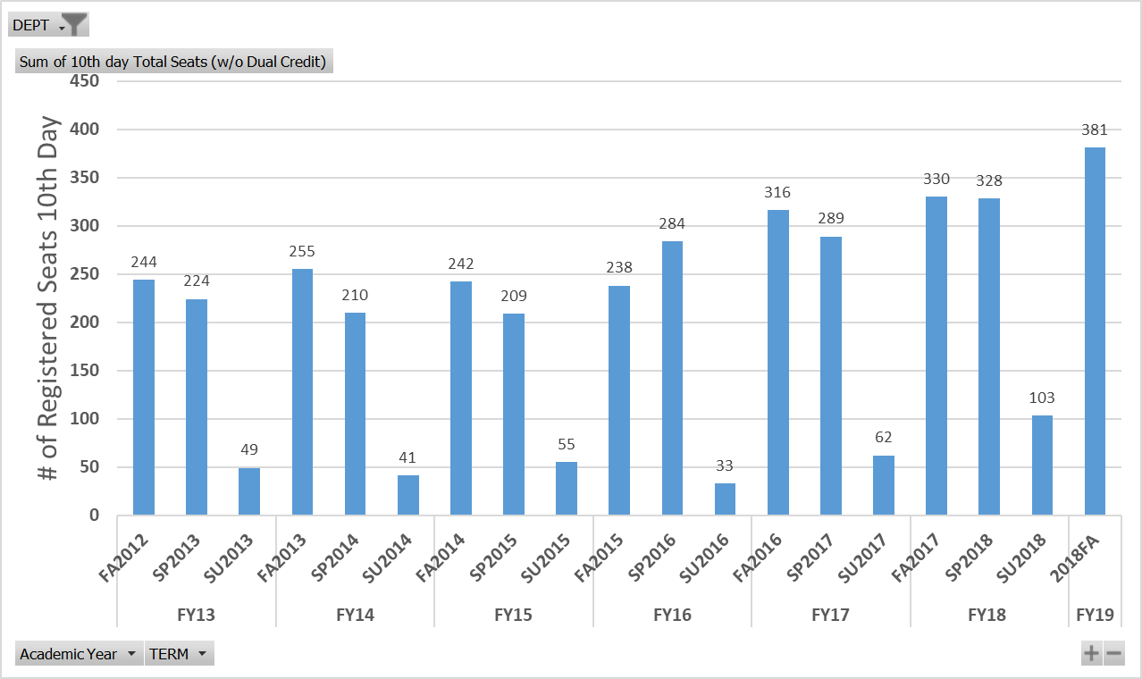



* The National Collegiate Landscape Competition (formerly Student Career Days) took place March 14-17, 2018 at Alamance Community College in North Carolina. The National Collegiate Landscape Competition is the largest national competition and career recruitment event for college students studying horticulture and landscaping, with approximately 700 students from 65 colleges competing each year in 30 events. This year, more than 710 horticulture and landscape students from 62 schools demonstrated their skills in real-world, competitive events and interviewed with landscape, lawn-care, tree care, irrigation, and other companies at the annual Career Fair that was held at the event. As a leading recruitment event for the $80 billion dollar landscape industry, landscape companies travel from across the nation to recruit these future employees. There continues to be a very high demand for graduating students from some of the nation’s top landscape companies and equipment manufacturers. Demand is at an all-time high for graduating horticulturalists and landscape designers and is projected to continue through 2022. The National Collegiate Landscape Competition combines education with competitive events in which students get to show off their skills in tree climbing, patio building, identifying horticultural specimens, sales, business management, skid steer operation, exterior/interior landscape design, irrigation, wood construction, and many more. Thirteen horticulture students represented College of DuPage and competed this year in all 30 events. As a team, the COD students did very well placing 17th overall in the competition out of 62 Community Colleges and Universities. COD placed 4th out of all the Community Colleges in the country. COD students Rafael Zavala (Aurora) placed 14th overall in the nation, Jorge Castillo (Elk Grove Village) placed 55th overall in the nation and Joseph Christian (Hinsdale) placed 62nd in the nation.

**College of DuPage placed in the Top Ten overall in six of the competitions out of 62 College and Universities...**

* + Tractor Loader Backhoe Operation – 2nd place overall - Rafael Zavala
  + Small Engine Repair – 6th place overall – Daniel Stantz
  + Employee Development – 7th place overall – Steven (Tony) Eyer and Debbie Erber
  + Computer Aided Landscape Design – 8th place overall – Jorge Castillo
  + Irrigation Design – 8th place overall - Daniel Stantz
  + Business Management – 8th place overall – Brandon Spencer

The team would also like to thank their local Chicagoland Industry Sponsors for helping fund the trip this year. Through generous donations from these companies, the team raised close to $6,500 to pay for part of their trip to North Carolina. Companies include Illinois Landscape Contractors Association, Hunter Irrigation, Russo Power Equipment, Mississippi Valley Stihl, Sebert Landscaping, Ball Horticulture, The Growing Place, Midwest Ground Covers, Midwest Trading, Landscape Design Association, Acres Group, Platt Hill Nursery, Unilock, and De Vroomen Flowers, Bulbs, and Perennials, and Coventry Gardens, LTD.

1. If applicable, please provide more detail on any partnerships your program of study has that have not been mentioned already. This includes community groups, non-profits, volunteer organizations, etc. Describe how these partnerships have been built, maintained and sustained over time. (Optional)

|  |  |  |
| --- | --- | --- |
| **Additional Partnerships** | **What role does this partner have in directly supporting your program of study?** | **How many years has this partnership been active, and how was this partnership developed?** |
| COD Cares | COD Cares is a campus-wide program for students and staff to participate together in service activities that benefit communities within College of DuPage’s district. The COD Horticulture department participates in the service activities each year and is a way to give back to the community. Students can apply what they learn in class through various service activities in the community.  http://www.cod.edu/about/cod_cares/index.aspx  <https://www.youtube.com/watch?v=L5BNoIFvIKU> | This partnership has been active for 6+ years and is growing. Faculty, staff and students encouraged to participate. |
| The Garden Works Project | The Garden Works Project empowers, educates, and promotes organic suburban agriculture to improve the wellbeing of our community, the environment, and families facing food insecurity. They support all gardeners in their efforts to grow and prepare food for themselves and their neighbors in need. They teach organic vegetable gardening in a way that promotes self-sufficiency, pride and good stewardship of the Earth. Many of our students in the program participate in volunteer activities. 200+ volunteer team and board of directors help make their mission and vision reality helping over 87 families each year impacting 332 individuals. Students in the horticulture department grow and donate plants for this project. Executive Director serves on our Advisory Board.  <http://www.gardenworksproject.org/about> | This partnership developed 6 years ago when a former horticulture student and now alumni, Tina Koral, founded the organization to serve the western Chicagoland suburbs |
| DuPage County Farm Bureau Ag Literacy Coalition | The DuPage County Farm Bureau Ag Literacy Coalition is made up of various organizations from the agriculture industry including one of our secondary dual credit teachers and a faculty member from College of DuPage Horticulture Department. The coalition meets 4 times a year to help promote Agriculture in the Classroom and with a goal to help students and teachers gain awareness of agriculture in their daily lives. The coalition works together and cooperates with others to strengthen agriculture’s role and influence as a vital part of a strong, prosperous economy in a free America. The mission is to “promote agriculture through educational and informational programming to enhance the quality of life for its members, while preserving our agricultural heritage.” The Ag Literacy Coalition supports the horticulture program of study through educational and informational programming and aids in recruitment. | This partnership has been active for 12 years. Coalition asked for horticulture department faculty member representation on committee |
| Wheaton-Warrenville Community Unit School District 200 Transition Program | Program is designed for students aged 18-22 years old, who are enrolled in the Wheaton-Warrenville Community Unit School District. The transition program focuses on creating opportunities for students to build on post-secondary goals in the classroom, vocational, and community settings. These outcome-based goals and objectives are the foundation for each student’s IEP and drive their activities throughout the day. The IEP team gathers this information from the individual student’s preferences, interests, needs and strengths. The COD Horticulture Department partners with the transition program in providing them hands-on learning and activities in the labs and greenhouse at College of DuPage.  <https://www.cusd200.org/Page/14151> | This partnership has been active for 20 + years and is growing, providing students with IEPs, the acquisition of skills that lead to adult independence. |
| COD COACH (Career Opportunity ACHievement) Program | COACH is a two-year cohort program for adults with intellectual or developmental disabilities. In addition to an academic focus on reading, writing, math and computer literacy, COACH also promotes social skills, independence and career exploration. COACH has been developed to provide post-transition students with engaging educational and life-skills training to help prepare for meaningful employment. College of DuPage Horticulture department has collaborated with the COACH program to provide students on campus job-shadow experiences and internship placement in horticulture, working in the labs and greenhouse on campus. This allows students to explore career options to help identify a career path, gain horticulture skills, practice appropriate workplace behavior and gain work experience.  <http://www.cod.edu/academics/conted/vocational/coach.aspx> | This partnership began this year. Eight vocational areas at the College were determined by the COACH program that included horticulture. Designed to develop workplace skills that can lead students to competitive, entry-level employment and enhance everyday living skills. |

# **SUBMIT YOUR APPLICATION**

**SUBMIT YOUR APPLICATION**

* Fill out this application.
* Once you have finished, complete [this form](https://careertech.org/2019-excellence-action-application) and upload the following:
* Your full application saved as a Word document (.docx)
* All of your supplemental documents or evidence consolidated as one PDF document.

**THANK YOU!**

Thank you for completing this application! You will know the status of your application by January 22, 2019. The programs of study will be evaluated based on their effective leveraging of partnerships, alignment to rigorous and relevant college- and career-ready expectations, clear progression of knowledge and skills across secondary and postsecondary systems, integration of successful career guidance/advisement, and key indicators of learner success.

Don’t forget to use the Excellence in Action award submission checklist to make sure you’ve completed your application in its entirety.

We look forward to learning more about your program!

For questions, concerns please contact [awards@careertech.org](mailto:awards@careertech.org).