# **ADVANCE CTE EXCELLENCE IN ACTION AWARD**

**PROGRAM SUMMARY**

Advance CTE is pleased to announce a call for applications for the fifth annual Excellence in Action awards, through which we recognize and honor superior Career Technical Education (CTE) programs of study from across the nation.   
  
**CRITERIA FOR JUDGING**

Selected programs will exemplify excellence in:

* Implementing Career Cluster®-based [programs of study](https://careertech.org/programs-study);
* Maintaining effective employer and business partnerships;
* Demonstrating alignment to rigorous and relevant college- and career-ready expectations;
* Demonstrating a clear progression of knowledge and skills and student transitions across secondary and postsecondary systems;
* Integrating successful career guidance and advisement;
* Integrating high-quality work-based learning experiences;
* Highlighting alignment to workforce and employer needs in the community; and
* Providing concrete data on the program of study’s impact on student achievement and success at both the secondary and postsecondary levels.

**ELIGIBILITY**

* This award is open to any secondary or postsecondary schools or colleges in the United States. Your school or institution may submit one application per [Career Cluster](http://careertech.org/career-clusters);
* The program of study must have at least one full graduating class;
* Your program must be eligible to receive funding from the Carl D. Perkins Career and Technical Education Act;
* Applications that do not include data to demonstrate positive impact on student achievement will not be eligible for consideration.
* If your program has received in an award in the past, you may not apply for that same Career Cluster. However, your school or institution may apply in a different Career Cluster.

**AWARD SUBMISSION REQUIREMENTS**

Complete applications will contain the following:

* A completed application including supplemental materials by the application deadline of **November 15, 2017 at 5 p.m. ET.**
* At least one letter of support from an employer or business partner supporting the program of study; and
* At least one additional letter of support from a partner (education, community or business) of your choosing.
* *Optional:* Supplemental materials including photos, videos, news articles, etc., are welcome but not required.

The application must be submitted using [this form](https://careertech.org/2018-excellence-action-application). The application must be submitted in a Microsoft Word format. Supplemental materials, including the letters of recommendation, must be combined and submitted as **one** PDF document.

*Please note:*

* Submissions should **not** include any personally identifiable student.
* The application does not have a page limit, however, many questions do have a word limit. Please do not submit responses that go beyond this limit. Also, submissions that do not contain all the required materials (a completed application, two letters of support and supplemental materials in the correct formats) will not be advanced for consideration.

**WINNERS WILL RECEIVE**

* A banner to hang in their school or institution;
* A digital banner to use in email and print materials as they so choose; and
* Travel and one hotel room for one night in Washington, DC for a representative to be recognized at an awards ceremony to be held the week of April 4-6, 2018.

**WINNERS WILL ALSO BE FEATURED IN**

* A national press release, which will be distributed to national media.
* A winner-specific press release to distribute to local media;
* A standalone one-pager;
* A standalone blog on the [Learning that Works blog](http://blog.careertech.org/);
* Representation on the Advance CTE [website](http://www.careertech.org).
* Many past winners have been featured in national conferences, in briefs and reports, on webinars and in the media.

**HOW TO APPLY**

* Fill out the following application.
* Once you have finished, complete [this form](https://careertech.org/2018-excellence-action-application) and upload the following:
* Your full application saved as a Word document (.docx)
* All of your supplemental documents or evidence consolidated as one PDF document.

# **BACKGROUND INFORMATION**

1. Program of study name: Operations Engineering and Technician
2. Point of Contact  
    Name: Amy Murphy

Email Address: amurphy@jjc.edu

Phone Number: (815) 280-1418  
Address: 1215 Houbolt Road, Joliet IL 60431

1. Applicant’s School/College: Joliet Junior College
2. State: Illinois
3. Type of institution (click the box to check)

Area technical center

Career academy

Comprehensive high school

Community college

Technical college

Other (please specify)

|  |
| --- |
|  |

1. Career Cluster in which your program of study should be considered (Follow this link for a further explanation of each Career Cluster [careertech.org/career-clusters](http://careertech.org/career-clusters)) **(Select only ONE):**

Agriculture, Food & Natural Resources Career Cluster

Architecture & Construction Career Cluster

Arts, A/V Technology & Communications Career Cluster

Business Management & Administration Career Cluster

Education & Training Career Cluster

Finance Career Cluster

Government & Public Administration Career Cluster

Health Sciences Career Cluster

Hospitality & Tourism Career Cluster

Human Services Career Cluster

Information Technology Career Cluster

Law, Public Safety, Corrections & Security Career Cluster

Manufacturing Career Cluster

Marketing Career Cluster

Science, Technology, Engineering & Mathematics Career Cluster

Transportation, Distribution & Logistics Career Cluster

1. In three sentences or less, describe your program of study, including the secondary and postsecondary components and how long the program of study has been in place.

Joliet Junior College’s Operations Engineering and Technician (OET) degree program provides individuals through a cohort approach for an opportunity to pursue a pre-engineering or industrial maintenance Associates of Applied Science (AAS) degree. This pathway prepares students for careers in the petrochemical, nuclear, and manufacturing field. The OET program began in August 2015, and at the same time, a dual-enrollment program, Advanced Integrated Maintenance (AIM) was added as an educational track for the high school seniors, which would serve as an entry point into the OET program.

1. Please check the geographical and demographic setting for your program of study and describe the geographic and economic conditions of the region served by the school.

Urban

Suburban

Rural

Other

JJC is the only public postsecondary institution within District 525 boundaries. JJC is located approximately 45 miles south of Chicago, the third largest city in the United States. Today, the 1,442-square mile district serves over 700,000 residents in Will, Grundy, Kendall, LaSalle, Kankakee, Livingston, and Cook counties. Multiple locations exist to serve residents throughout the district. The College consists of one (1) main campus (2) extended campuses, three (3) education centers, and multiple satellite locations throughout the district.

JJC District 525 encompasses an economically diverse population from rural and urban settings.  Twenty-seven percent the population over 25 years of age has only a high school degree, while 39% of this age group has attained an Associate’s Degree or higher.  Although the US unemployment rate is a low 4.4%, the unemployment rate within JJC’s service area is 7.9%.  The top five industries in the counties served by JJC are retail trade, health centers/social assistance, government, manufacturing, and accommodation/food service.  Many of these industries pay minimum wage with few salaried positions. Additionally, the poverty rate within the JJC District is 10.18%, running just below the national average of 14.3%.

# 

# **STUDENT POPULATION & DATA**

1. Please describe your program of study’s demographic and outcome data for the most recent academic year(s). It is our strong preference to have data from both secondary and postsecondary levels. If this is not available, please provide an explanation as to why the data from the other learner level is not available. Applications that do not include data to support positive impact on student achievement will not be eligible for consideration. (100 word limit)  
     
     
   The AIM program started with low numbers, and the following year, we doubled our enrollment. We have 100% success rate for students completing the entire program. This is a pathway into the OET program.

OET Cohort One retained all 10 students of which 100% graduated with an AAS degree in May 2017. In addition, Cohort One has a 100% job placement rate for those who chose to enter the workforce with salaries ranging from $58,000-$82,000. Cohort Two has 13 students enrolled, and the retention rate is 100%. All students completed the work-based learning and will graduate in May 2018.

**NOTE**: Please specify if and when you are using a percentage with a different denominator (e.g., seniors) than the one listed.

**When completing the data section, please only use percentages and include data that is from your program of study, not the entire school/institution. Additionally, only include data where students are eligible to participate (e.g., only seniors in high school will be eligible for the section asking for percent of seniors who graduated high school, so only seniors should be included in that data; if your work-based learning only occurs within a specific grade level, only include them in your data for that category.)**

|  |  |  |  |
| --- | --- | --- | --- |
| SCHOOL YEAR | 2014-15 | 2015-16 | 2016-17 |
| **SECONDARY-LEVEL DATA** | | | |
| **Total number of students served by your program of study** | N/A | 6 | 13 |
| % male students |  | 83% | 92% |
| % female students |  | 17% | 8% |
| % minority students |  | 33% | 69% |
| % low-income students |  | N/A | N/A |
| % students with disabilities |  | 0% | 0% |
| % English language learners |  | 0% | 0% |
| Other relevant *demographic* data |  |  |  |
| % of students who earned postsecondary credit (dual enrollment, AP, etc.) |  | 100% | 100% |
| % of students who earned an industry-recognized credential |  | 100% | 100% |
| % of students who participated in work-based learning |  | N/A | N/A |
| % of seniors who graduated high school (who were eligible/seniors) |  | 100% | 100% |
| % of graduates who enrolled in postsecondary education (who were eligible/seniors) |  | 33% | 54% |
| % of graduates who entered the workplace and/or military (who were eligible/seniors) |  | N/A | N/A |
| **POSTSECONDARY-LEVEL DATA** | | | |
| **Total number of students served by your program of study** | N/A | 10 | 13 |
| % male students |  | 90% | 85% |
| % female students |  | 10% | 15% |
| % minority students |  | 20% | 15% |
| % low-income students |  | 80% | 54% |
| % students with disabilities |  | 0% | 0% |
| % English language learners |  | 0% | 0% |
| Other relevant *demographic* data |  |  |  |
| % of students who completed postsecondary/earned a degree or certificate (who were eligible) |  | 100% | N/A |
| % of students who earned an industry-recognized credential (who were eligible) |  | 100% | 100% |
| % of graduates who entered the workplace and/or military (who were eligible) |  | 90% | N/A |
| % of graduates who transitioned to further postsecondary education (who were eligible) |  | 10% | N/A |

1. Provide links to the source of the above data. If the links are not publicly accessible, please explain the source of the data.

Joliet Junior College uses Ellucian as our main data source. The data provided on the college’s website is inclusive of all programs related to enrollment and student demographics. The specific data provided above regarding enrollment has been extracted through course prefixes and section numbers. Information on the student demographics was also provided through Ellucian, and the specific information was extracted based on the academic program code assigned to each student. Some of the data in the secondary-level was not available to Joliet Junior College due to the nature in which the students were enrolled into the dual enrollment classes.

1. How does your school or institution ensure equitable access and outcomes for students with diverse backgrounds? (150 word limit)

Joliet Junior College is a community of lifelong learners that welcomes, values, and respects diversity. The college fosters a climate of mutual respect that celebrates diversity by embracing our differences. Our institution's Core Value of RESPECT is central to our commitment to diversity. We demonstrate this commitment by serving students, faculty, staff and community members with fairness and equality to prepare all lifelong learners to succeed in a global society.

1. If applicable, what strategies or technologies do you use to close access gaps? (e.g. integrated digital learning, virtual work based learning.)

All of the classrooms incorporate hands-on application that reinforces the instructors lecture. In addition, the OET program has integrated essential skills into the overall program. Students simulate a work-environment by scanning in/out on a time clock. In addition, there is a specific dress code required for the program as well as attendance policies. Students are also expected to wear ID badges at all times, and late-assignments are not allowed.

An integral component of the OET program is the internship that is a requirement of the program. The internship is conducted during the summer semester between their freshman and sophomore year. Joliet Junior College works hand-in-hand with our industry partners to secure the students paid-internships that are 40-hours a week for the entire summer. The hands-on internship provides the students with real-world experience that connects what they learned in the classroom to applications in the field.

1. What activities does your school or institution do to recruit elementary, middle, high school students and/or adult learners into the program of study? Please provide examples. (150 word limit)

JJC provides numerous opportunities for children/young adults to learn. Collaboration with our corporate partners who also see the value of educating K-12 students is a primary way we create a pipeline into these career pathways. For example, we have a STEM Academy that provides educational programs to elementary-aged students through high school. Activities includes hands-on workshops, high school competitions, and career exploration fairs. Also, a main component of STEM Academy is Technology Camp for middle schoolers which introduces students to a variety of technical careers. The goal of the STEM Academy is to increase student awareness about STEM-related careers, inspire students and let them know that it’s not too early to start thinking about their future. In addition, high school seniors have the opportunity to get a jump-start on the OET program through dual enrollment in the AIM program by earning 12 credit hours.

1. Is your program of study associated with a Career Technical Student Organization (CTSO)? If so, which one(s) and in what way(s)? (Check the [approved list](http://www.ctsos.org/ctsos/) of CTSOs) (50 word limit)

N/A

1. Describe how career guidance/advisement is integrated into your program of study to support students’ completion of the program of study and entry into additional education/training and/or a successful career. Where applicable, describe the tools (individual career and academic plans, career exploration websites, etc.) that are provided to learners and how they are used. (200 word limit)

Career guidance is an integral part of the program. The program integrates essential skills required to be successful in employment that focuses on time management, dress code, workplace ethics, safety, and communication. These essential skills have been embedded into the curriculum and were areas deemed necessary from our industry partners.

In addition, part of the program provides a course that is dedicated to career development/growth in the industry. This course is designed to help the OET student in preparing for and acquiring employment in the industrial plant industry. The course focuses on the skills necessary to conduct a job search, develop a resume and write a cover letter as well as interview skills with professional industry. The course also covers additional items used in employment selection such as drug testing, background checks, qualifying tests and hiring procedures specific to the industry.

Upon completion of the course, the College sets up interviews for the students for their summer internships. Students interview with all potential companies. As the students are entering their final semester, the College provides them guidance in updating their resumes, shares upcoming employment opportunities, and assists with completing pre-employment paperwork.

# **COLLEGE- AND CAREER-READY STANDARDS/EXPECTATIONS**

1. Please describe how your program of study was developed and how it ensures students are academically and technically prepared for postsecondary education and careers. Please also address the following:
   1. How were employers involved in the development and/or maintenance of your program of study?
   2. How does this program of study meet the economic needs of your community?
   3. How does this program prepare students for postsecondary education? (if applicable)
   4. How were both secondary and postsecondary educators involved in the development and/or maintenance of the program of study? (500 word limit)

With anticipated industry growth and an increasing number of retirees in coming years, many openings for well-paying, stable jobs are expected. The concept and development of the OET program, exemplifies the commitment of our local industry partners to the local community. The OET program, which consists of two new associate degrees, is an innovative idea that originated with Exelon to generate a highly skilled labor pool that meets the rigorous industry standards. Exelon saw the value and the benefit to have an educational program that will prepare students for well-paying careers right here in their local communities. However, Exelon wanted to develop a program that was not specific to nuclear to sustain such a program, and instead bring in other industry partners who have the same type of needs. LyondellBasell and Aux Sable joined the process and provided supplemental information to finalize a program/degree that had more flexibility. The collaborative efforts allows these degrees to serve multiple industries such as nuclear, petrochemical and manufacturing. These industries and others have shown their commitment to excellence and their outreach efforts to give back to their community which sets them apart as an industry leaders!

JJC worked hand-in-hand with our industry partners to design a robust program that will meet the need of providing a skilled-workforce. Other key stakeholders were also involved in the process to develop the curriculum and ensure that students would be learning the precise skills employers would be looking for in future employees. These stakeholders include Grundy Area Vocational Center, Coal City School District, Grundy Economic Development Council, and Senator Sue Rezin.

The program was designed by revamping some of the current classes offered at Joliet Junior College with a special emphasis on math, chemistry and physics. Some new courses were also developed with our industry partner, Exelon. The new courses included Introduction to Operations and Risk, Thermodynamics, and an Internship. To ensure quality, work-ready individuals, we have embedded soft skills into each course. These soft skills include badge IDs worn at all times, attendance, assignments turned in on time – similar to project deadlines.

The purpose of the Operating Engineer Technology program is to graduate students with the skills necessary to succeed as an operating engineer or operating technician in the manufacturing, nuclear or petrochemical industry. The program will also assess and address the continuing education needs of the operating engineers and operating technicians within the JJC service area.

The degrees within the OET program is a closed-track where the students will be required to submit an application and be interviewed to gain acceptance into the program. The program runs as a cohort of students that move together throughout. The two AAS degree tracks target the HS graduates or individuals seeking an entry-level career in the manufacturing, power generation or petrochemical industry with earning potential of a base-salary of $82,000 plus benefits. This program provides students with an opportunity for a stable career with growth opportunity right here in our community.

1. Which technical, academic and/or employability skill standards does your program of study incorporate at the secondary and/or postsecondary level and how? (Please list the standards you use and be specific regarding how your program uses industry, national, state and/or locally-developed standards) (250 word limit)

|  |  |
| --- | --- |
| **Standard Types** | **Please list the standards your program of study uses and how it uses them below:** |
| Academic Standards | Joliet Junior College is committed to academic success. The JJC Academic Standards of Progress Procedure, initiated in fall 2005, establishes criteria that constitute good academic standing and satisfactory academic progress toward attainment of educational goals. The monitoring and prescribed intervention of academic progress allows for the identification of students who may need assistance in setting appropriate educational goals and utilizing resources to achieve academic success. |
| Career Cluster or Technical Standards | The OET Program incorporated the guidelines established through the Illinois Pathways Initiative for the Manufacturing Career Cluster. This standard allows a student to begin their career pathway at the secondary level. Students would receive credit for those courses approved as part of the program of study as they complete their education at the postsecondary level. |
| Employability Standards | The Illinois Community College Board established the Illinois Essential Employability Skills Framework which we embedded into the curriculum of the OET program. The guide focuses on four distinct areas including personal ethics (integrity/respect), work ethic, teamwork, and communication. |
| Other |  |

# **SEQUENCE OF COURSES & CREDIT TRANSFER**

1. Please fill out the chart below, and describe your program of study’s course sequence by grade level, including the relevant or required academic and technical courses, as well as other required activities.   
     
   Make sure to highlight the course sequence that bridges secondary and postsecondary education, and explain how your program of study ensures students gain the broader Career Cluster-level knowledge/skills and, over time, gain the more specific occupation-level knowledge/skills as they progress through the program of study. You can also include graphics or [plans of study](http://careertech.org/sites/default/files/PlanStudy-CareerCluster-AG_0.pdf) of the course sequence in lieu of filling out the chart below.

At the secondary level, Joliet Junior College recommends students take the following sequence of classes in order to be successful in the OET program.

|  |  |  |  |  |  |  |
| --- | --- | --- | --- | --- | --- | --- |
| Grade/Year | English/Language Arts | Math | Science | Social Studies/ Sciences | Other Required Courses/Other Electives/Learner Activities | CTE Courses and/or Degree Major Courses |
| 9 | English 1 | Algebra 1 |  |  |  |  |
| 10 | English 2 | Geometry |  |  |  |  |
| 11 | English 3 | Algebra 2 | Chemistry |  |  |  |
| 12 | English 4 | Pre-Calculus |  |  | HVAC 120 – Electrical Controls for Heating, Ventilation & Air Conditioning | IMT 101 – Industrial Maintenance Fundamentals  EEAS 101 – Basic Wiring & Circuit Design  IMT 121 – Industrial Fluid Power |

See Charts below for Postsecondary Sequence of Courses

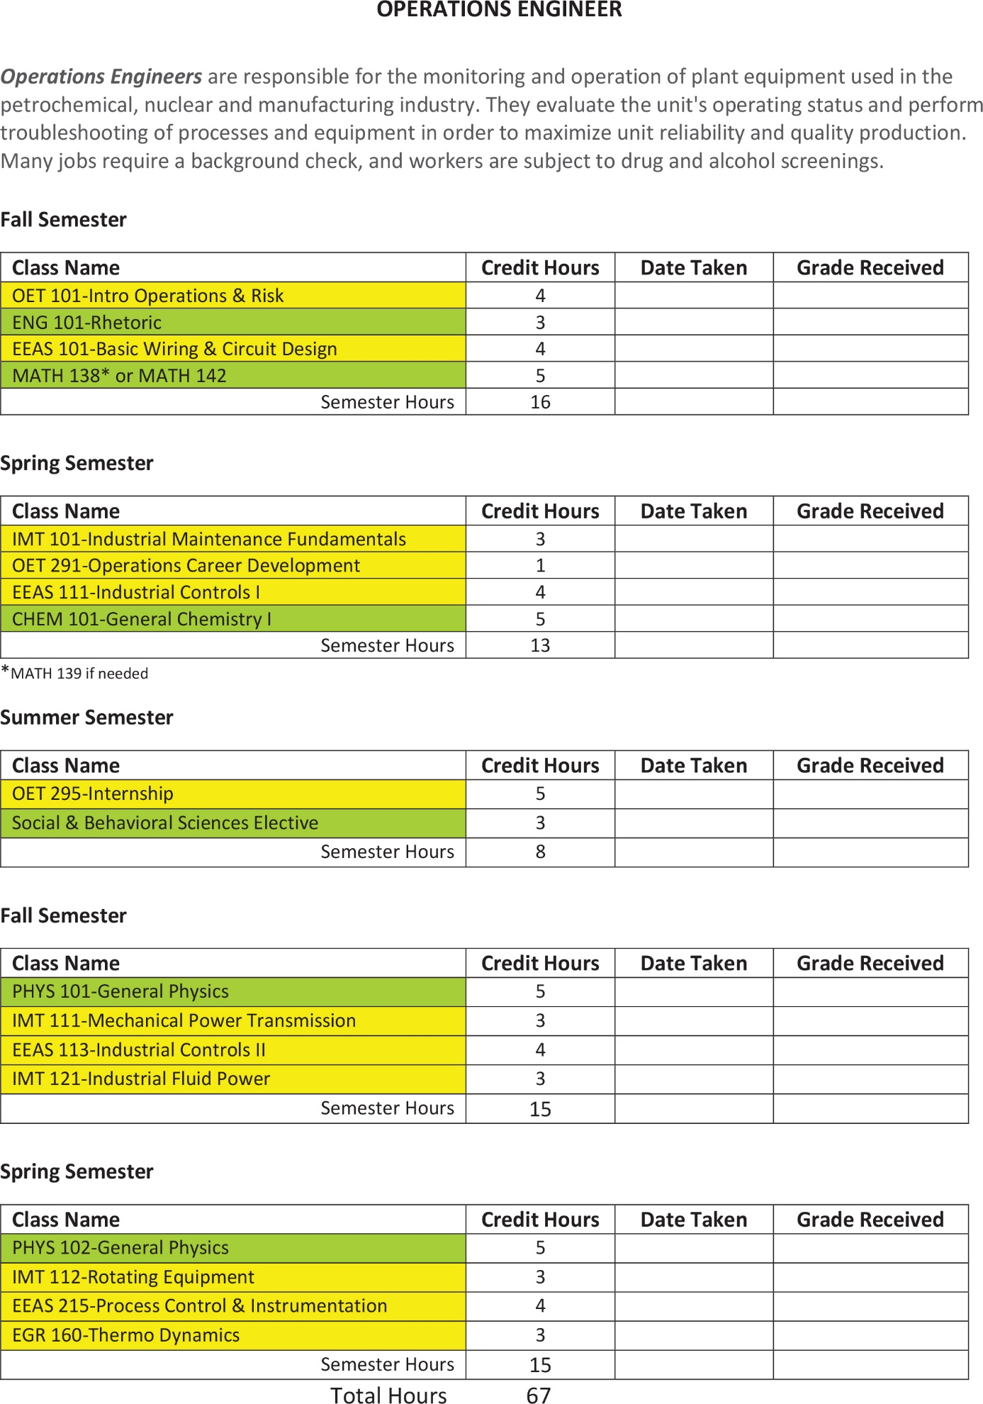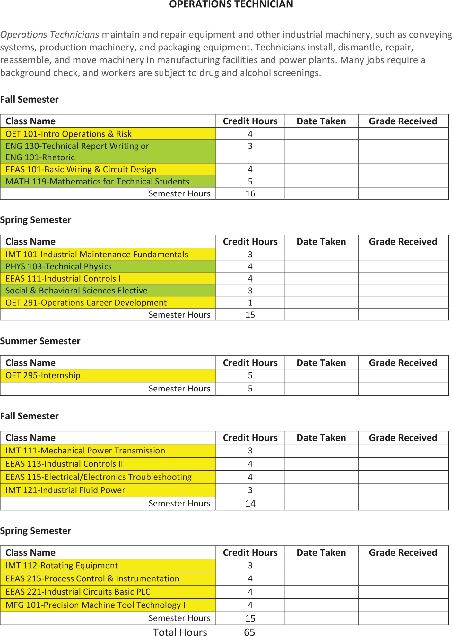

1. How do you ensure that CTE instruction and coursework is integrated with core academics?

The core academic subjects of math and science provide an integral foundation for learning. Once they have an understanding of the basics, students can continue to take their skills to the next level. These skill sets are critical when it comes to CTE career pathways.

Our industry partners helped develop the curriculum and they emphasized the importance of math and science skills that are needed in the workforce. The OET program stresses math and science skills as part of the curriculum. The engineering track has more classes than the technician track, but this is valuable.

In addition, with communication being a need for the workforce, there is an emphasis on reading and writing. These skills are required in order to be a leader.

The goal of our OET program is to get these students workforce ready and employable. Our teachers incorporate real-world examples into the classroom. The instructors provide scenarios where students need to apply their calculations. Our classes are more than just having students recite an answer, it’s really about getting the students to understand ‘Why’. They take great pride in having a student read the gauge, solve the electrical diagrams, and calculate.

The more that students understand the foundation of math, science and reading, the more they’ll be able to excel when they are enrolled in CTE classes. In designing the program, we looked at the career and technical courses, and determined what math and science classes were needed not only for their coursework but also in industry. The core academics were purposely intertwined in the design of this program to continue building the student’s skill set. Nevertheless, it all has to start with a solid foundation, and that’s why we work so hard to stress the importance of math and science in their secondary education.

1. List the opportunities for students to earn articulate and/or transcript dual enrollment credit across K-12 and postsecondary, such as AP/IB, dual and concurrent enrollment, capstone experiences and/or transcripted credit articulation agreements. (250 word limit)

Students in the JJC district have several options of earning transcripted credit through dual enrollment, AP/IB credit, and entering college early through concurrent enrollment. First, the Dual Credit program is a partnership between Joliet Junior College and area high schools and career centers. This program allows students to earn high school and college credit upon successful completion of a dual credit course. Another option to receive college credit is by scoring high enough on Advance Placement (AP) exams. You may also have the opportunity to earn college credit while still in high school through dual enrollment. You’ll receive credit for any transferable college course that appears on an official post-secondary transcript. Finally, early entry to JJC, which may be available to students 17 years of age or younger who obtain prior approval from their high school may earn college credit at the same time as the student is enrolled in high school.

1. Please provide information on **at least three partnerships** with *education institutions and groups* your program of study has, and describe how these partnerships have been built, maintained and sustained over time. Use this space to specifically address the secondary and postsecondary partners that contribute to and maintain this program of study.

|  |  |  |
| --- | --- | --- |
| **Education Partnership Name** | **What role does this partner have in directly supporting your program of study?** | **How many years has this partnership been active, and how was this partnership developed?** |
| Grundy Area Vocational Center | This educational partner provides an opportunity to enter a manufacturing career pathway – Advanced Integrated Maintenance program - that will be the start to the Operations Engineering & Technician degree program. This program is provided to high school seniors who are interested in the maintenance field in manufacturing. | This partnership has been active since the Center opened in 1971. JJC collaborates with GAVC by providing a variety of dual credit opportunities for the high school students in Grundy County. GAVC was instrumental in the development of the OET program, and actively recruits students into the AIM program. |
| Will County Area Career Center | This educational partner provides an opportunity to enter a manufacturing career pathway – Advanced Integrated Maintenance program - that will be the start to the Operations Engineering & Technician degree program. This program is provided to high school seniors who are interested in the maintenance field in manufacturing. | This partnership has been active since 1977. JJC collaborates with Wilco by providing a variety of dual credit opportunities for the high school students in Will County. Wilco actively recruits students into the AIM program. |
| Seneca High School | This educational partner provides an opportunity for Joliet Junior College to come out and do presentations to their students who would like to pursue an education in engineering and/or maintenance. Personalized counseling is done with students to help guide them in what classes they should take at the high school. | This partnership with Seneca High School began in Spring 2015 when we were doing our initial recruitment for the OET program. After the first cohort started, Seneca High School invited not only JJC representatives to come out and speak but also their alumni who were currently in the program. |
| Southern Illinois University | This educational partner provides an opportunity for students who wish to continue their education and obtain a Bachelor’s degree. | Joliet Junior College has partnered with SIU for several decades. The recent development of these new degree programs is another opportunity for students to continue their education, and stay right here in the community. SIU provides a degree titled, “Industrial Management and Applied Engineering” at Joliet Junior College. Students can take classes either online or in the classroom. |

# **ALIGNMENT WITH INDUSTRY AND BUSINESS NEEDS**

1. Please describe how your program of study is aligned with the needs of the workforce and industry in your community. Make sure to include information on how the program of study helps meet workforce demand identified by business and industry. If applicable, what labor market data does your program of study use to align to workforce needs? (250 word limit)

The OET program is designed to increase the skilled labor pool.  Industry reviewed their current workforce along with short and long range employment needs.   They found the higher functioning technicians and technician managers were areas that presented the biggest employment challenge due to the lack of individuals in the labor pool. JJC utilizes the data from the Bureau of Labor Statistics’ Occupational Outlook Handbook, which reinforces the information that our industry partners share with us.

The goal is to graduate students with the skills necessary to succeed as an operating engineer or operating technician in the manufacturing, nuclear or petrochemical industry. The program will also assess and address the continuing education needs of the operating engineers and operating technicians within the JJC service area.

1. Are ALL students in the program of study required to participate in a work-based learning opportunity? YES or NO.

Yes, the students are required to participate in a work-based learning opportunity.

1. Please describe the work-based learning opportunities available to students who participate in this program of study. (250 word limit)

The work-based learning provides students the opportunity to work in industry with a summer internship. The work-based learning is a structured class that allows the student to gain work experience in an actual hands-on environment with supervision and guidance provided by industry professionals and the JJC faculty.

The course has specific learning outcomes for the student, which include recognizing the industrial operating procedures used in the field; recognizing and identifying safety procedures, used in industrial plant operations; using the operational skills learned in their coursework; and preparing the student for a career in an industrial setting.

Throughout the work-based learning, students will be required to submit a weekly report illustrating what the day consisted of, and at the end of the internship, the student will submit a final report. The final report will document the internship experience as well as address the four major learning outcomes. Finally, the student will be required to demonstrate and apply the skills learned in the OET program. Students are encouraged to take full advantage of their internship, and communicate their skills to prospective employers after graduation.

1. Please list the industry-recognized credentials/certifications/licenses offered/required. If your program of study does not include industry-based credentials/certifications, please explain why. (200 word limit)

|  |  |
| --- | --- |
| **Offered** | **Required** |
| Fluke® Digital Multimeter Certification |  |
|  |  |
|  |  |

1. Please describe how you ensure the instructors teaching this program of study keep up-to-date on advancements in the workplace, such as participating in externships and/or requirements to have current industry credentials. (100 word limit)

The instructors have decades of experience in industry prior to teaching at the college. In addition, some classes have instructors who are currently working in industry and through our relationships with our industry partners, they teach during their normal work schedule for the program.

All of our faculty stay apprised with the latest industry trends and regulations especially in the area of safety through professional development, as well as working with industry partners, and serving on advisory committees. Many of our faculty serve as corporate trainers for our industry partners so they are actively engaged in the various industrial environments.

1. Please provide information on **at least three** *business, industry and/or labor* partnerships your program of study has, and describe how these partnerships have been built, maintained and sustained over time.

|  |  |  |
| --- | --- | --- |
| **Business/Industry Name** | **What role does this partner have in directly supporting your program of study?** | **How many years has this partnership been active, and how was this partnership developed?** |
| Exelon | * Provide student scholarships * Develop curriculum * Provide paid internships * Provide instruction and serve as guest speaker for the classes * Advisory committee member * Provides tours of the nuclear industry | Our partnership extends back to the early 1980s when JJC and Exelon worked together to develop an associate’s degree program for their incumbent workers. This relationship has grown over the years, and they were instrumental in the development of the OET program. |
| LyondellBasell | * Provide student scholarships * Develop curriculum * Advisory committee member * Provide paid internships * Provide instruction and serve as guest speaker for the classes * Provides tours of their plant * Donates funding for new equipment purchases * Serve on the JJC Foundation Board * Donates equipment for instructional purposes that came from their facility | We have collaborated with LyondellBasell since the early 1980s. Throughout the years, we have designed and delivered their “New Hire” training. In addition, we are a major training provider for their incumbent workforce. They served on the committee that developed the curriculum for the OET program. They also provide paid internships for students, and they have offered job opportunities for students who have graduated from the program outside their normal hiring period. |
| Aux Sable | * Provide student scholarships * Develop curriculum * Provide paid internships * Provide instruction and serve as guest speaker for the classes * Advisory committee member * Provide tours of their facility | Aux Sable has been with the OET program from the very beginning. They assisted with curriculum development and provided feedback regarding industry needs. They provide paid internships to our students. |
| CITGO | * Provide student scholarships * Provide instruction and serve as guest speaker for the classes * Provides tours of their plant * Serve on the JJC Foundation Board * Donates equipment for instructional purposes that came from their facility | Joliet Junior College’s relationship with CITGO extends back to the early 1980s. JJC provided a major training initiative for CITGO back in the 1990s. CITGO has been a valuable industry partner. They joined the OET program once it was underway when they found out the value of what the training program had to offer. CITGO has set up an endowment fund of $250,000 for student scholarships. They also come to classes and serve as guest speakers. In addition, CITGO is a major contributor to our STEM Academy. |
| TransCanada | * Donates funding for new equipment purchases as well as purchasing all the student textbooks * Advisory committee member * Serve as a guest speaker for the class. | After discussions about the OET program with Senator Sue Rezin, TransCanada became an industry partner in 2015. They have generously provided monetary donations to the program for the purchase of equipment. They provide industry feedback to students during classroom visits. They also serve on the advisory committee. |

1. Please feel free to use the space below to share any other information or evidence of success of your program of study and the students who participate. (Optional)

* Formal congressional recognition of the Operations Engineering and Technician program by Representative Adam Kinzinger in October 2015.
* Awarded the 2015 Innovation Award for the Operations Engineering and Technician program from the Illinois Council of Community College Administrators.
* Industry partners such as Exelon, Aux Sable, LyondellBasell and CITGO Refinery have sponsored scholarships for student’s tuition and fees since the program began.
* Industry partners such as TransCanada and LyondellBasell have generously donated money to purchase equipment and all the student’s textbooks for the program.
* In September 2016, Pearson Career & Technical Education Webinar Series featured Joliet Junior College’s OET program, “Industry & Education: Bridging the Skills Gap”.
* Awarded the 2017 Partnership Award for the Operations Engineering and Technician program from the Grundy Economic Development Council.
* In September 2017, Joliet Junior College presented the OET program at the Illinois Community College Board Forum for Excellence. The presentation was titled, “Bridging the Gap Between Industry and Education.”

1. If applicable, please provide more detail on any partnerships your program of study has that have not been mentioned already. This includes community groups, non-profits, volunteer organizations, etc. Describe how these partnerships have been built, maintained and sustained over time. (Optional)

Joliet Junior College is fortunate to have a strong partnership with the Grundy Economic Development Council (GEDC). GEDC provides opportunities for industry and educational leaders to stay updated about business developments through Bus Tours. On a bus tour in 2014, Joliet Junior College, GAVC, Senator Sue Rezin, and staff from Exelon talked about how there was an increasing demand for more skilled workforce due to the vast number of retirees. This is where the idea for the development of the OET program originated. After the bus tour, the idea became more than just a concept. An advisory committee was formed with key stakeholders, including State Senator Sue Rezin. The group came up with an action plan to develop and implement a new degree program at JJC.

With the program entering the third year, our advisory board continues to meet several times a year, and we have gained additional industry partners who learn how the program is designed and structured. As the program evolves, we continuously look for areas to enhance the curriculum.

|  |  |  |
| --- | --- | --- |
| **Additional Partnerships** | **What role does this partner have in directly supporting your program of study?** | **How many years has this partnership been active, and how was this partnership developed?** |
| Grundy Economic Development Council | The GEDC was at the table when discussions began to develop the OET program. They provided feedback and ideas on how to develop curriculum and train a skilled workforce based on the data they have collected over the years in working with the various industries in Grundy County. They were vital in recognizing the essential skills. | Our partnership with GEDC began in 1985. We have collaborated on numerous projects that have benefited the Grundy County community. Staff at JJC actively are engaged on the GEDC retention visits they conduct every other year with industry partners in the Grundy County area. JJC serves on the GEDC board, and we have representation on several of the subcommittees. |
| Senator Sue Rezin | Senator Sue Rezin was instrumental in the development of the OET program. She received feedback from corporate businesses in her district and brought everyone to the table. | Senator Sue Rezin was with the OET program when discussions began in 2014. She advocated for the program and assisted in moving the process along. To-date, Senator Rezin promotes the career pathways the OET program has to offer. |
| Three Rivers Manufacturing Association | Joliet Junior College partnered with TRMA to host MFG Day for the past 4 years. This annual event serves over 700 high school students and is part of a nationwide grass-roots movement to raise awareness about careers in Manufacturing. Our OET students serve as student ambassadors at the event and have front-line communication with high school students to share their experiences and career opportunities with these prospective students. | Joliet Junior College has been an active partner with TRMA for the past several decades. JJC and TRMA developed a Safety Training Center together which provides contractors with a four-hour general plant safety overview. Over the past several years, our partnerships has evolved into spreading the word about the opportunities available within manufacturing facilities. Since, 2014, JJC and TRMA have held a MFG Day. In addition, we serve on the board of directors for TRMA, and TRMA executive director serves on many of our technical department advisory boards. |

# **SUBMIT YOUR APPLICATION**

**SUBMIT YOUR APPLICATION**

* Fill out this application.
* Once you have finished, complete [this form](https://careertech.org/2018-excellence-action-application) and upload the following:
* Your full application saved as a Word document (.docx)
* All of your supplemental documents or evidence consolidated as one PDF document.

**THANK YOU!**

Thank you for completing this application! The selection committee will convene in December 2017 to review the applications and make final decisions. You will know the status of your application by January 25, 2018. The programs of study will be evaluated based on their effective leveraging of partnerships, alignment to rigorous and relevant college- and career-ready expectations, clear progression of knowledge and skills across secondary and postsecondary systems, integration of successful career guidance/advisement, and key indicators of student success.

Don’t forget to use the Excellence in Action award submission checklist to make sure you’ve completed your application in its entirety.

We look forward to learning more about your program!

For questions, concerns please contact [awards@careertech.org](mailto:awards@careertech.org).